Preparatory Problems for
the 58th International Chemistry Olympiad 2026
Tashkent, Uzbekistan

Theoretical Problems

Contents
Fields of advanced difficulty 14
Problem 1. Khoja Nasreddin is now a chemist 15
Problem 2. Avicenna 17
Problem 3. Unusual inorganic synthesis 18
Problem 4. Nanozymes 20
Problem 5. Haber–Bosch process 22
Problem 6. Hydrogen fuel 25
Problem 7. 150 Years of Urease 27
Problem 8. Step-by-step 30
Problem 9. Host-guest chemistry of cucurbiturils as Uzbek hospitality 33
Problem 10. Prebiotic life 37
Problem 11. Fluorescence, phosphorescence and quenching 43
Problem 12. Photoacids 47
Problem 13. Interested in micelles? 52
Problem 14. The basics of Metal–Organic Frameworks 56
Problem 15. Microscopy in chemistry 58
Problem 16. Kinase inhibitors 61
Problem 17. Carbohydrate chemistry 64
Problem 18. Inositol 67
Problem 19. Carbohydrates as chiral pools 69
Problem 20. Pacman, Hangman, Cageman 72
Problem 21. Catalyst C 74
Problem 22. Transition metals in organometallic catalysis 77
Problem 23. HAT and XAT (HalAT) 82
Problem 24. Anticancer complexes 87
Problem 25. The equilibria in DNA 90
Problem 26. Sensing of acetaldehyde 92
Problem 27. Archaeal metabolism 95
Problem 28. Non-archea-typal form of life 98
Problem 29. Archaea-ology 101
Problem 30. Pilaf ingredients 104

Fields of advanced difficulty
Theoretical
- Mass Spectrometry: molecular ions, mass-to-charge ratio, isotope distribution.
- Kinetics: steady-state and quasi-equilibrium approximations, enzymatic kinetics, interpretation of phase portraits.
- Thermodynamics: heat capacity, temperature dependence of equilibrium constant, entropy and enthalpy change.
- Transition metal catalysis: elementary steps in the catalytic cycles with transition metal complexes; single electron transfer (SET) and hydrogen atom transfer (HAT); cross-coupling reactions.
- Photochemistry: Jablonski and Förster diagrams, fluorescence and phosphorescence, quenching, lifetimes, quantum yield.
- Carbohydrate chemistry: represent chair conformations, carbohydrate reactions and protecting groups, repeating units.

The students are not expected to be specifically trained on the hereunder topics:
- Fragmentation in mass spectrometry.
- Advanced calculations (differentiation, iteration).
- Graph theory.
- 2nd and 3rd order kinetics.
- Cycloaddition reaction mechanisms.
- Memorising the structures of canonical amino acids.
- Archaea metabolism.
- Carothers equation.
- Memorising specific values of bond lengths.
- Memorising mechanisms of transition metal-catalysed coupling reactions.
- Details behind the techniques of STM and AFM.

Problem 1. Khoja Nasreddin is now a chemist
Khoja Nasreddin is a folklore character from the East, the hero of short humorous and satirical stories and anecdotes, and sometimes even everyday tales. In 2022, the tradition of retelling jokes about Khoja Nasreddin was inscribed on the Representative List of the Intangible Cultural Heritage of Humanity.

One day, Khoja Nasreddin decided to become a chemist. He began his journey in chemistry by studying the thermal decomposition of an unknown red salt A, even though such work was quite challenging for beginners.
Khoja Nasreddin carefully decomposed 1.00 g of A at −70 ℃ (Reaction 1) in a closed 1.00 L reactor initially filled with argon at a pressure of 100.0 kPa. After the decomposition, the pressure inside the reactor increased to 106.42 kPa, and the solid residue consisted of two compounds, one of which was identified as salt B.
Following the first stage of decomposition, he gradually heated the reactor to 200 ℃. During heating, the solid residue first turned into a mixture of solid and liquid, then into a solely liquid phase, and finally, at 128 ℃, a solid phase reappeared. At this temperature, the pressure in the reactor was 260.63 kPa.
Upon reaching 200 ℃, B began to decompose (Reaction 2), and after complete decomposition, no solid residue remained in the reactor. The pressure at 200 ℃ was 396.82 kPa. When he introduced a glowing splint into the reactor, it ignited vigorously.
Nasreddin then attempted to synthesise salt C, which differs from A only by its cation. The mass fraction of the metal in C is equal to 12.63%. However, according to various sources, C is difficult to obtain. Instead, he successfully synthesised salt D (containing a complex cation, the same metal as in C, and 9.83% hydrogen by mass) by treating compound E (mass fraction of one of the elements in E is 4.21%) with gas F in liquid ammonia. He noted that at very low temperatures, F exists as a dark blue liquid.
To determine the amount of gas F required for the synthesis of 1.000 g of D, he passed as much F as necessary through 100 mL of potassium iodide solution (Reaction 3). For titration of a 10.00 mL aliquot of the resulting brown solution, 16.30 mL of sodium thiosulfate solution (Reaction 4) with a concentration of 0.0998 M was used. He also noted that when he was passing gas F through the iodide solution, another colourless gas was produced in the same amount as gas F.
- Identify substances A–F.
- Write the balanced equations of Reactions 1–4.

Problem 2. Avicenna
The philosopher Avicenna took a vial with a strange brownish-bronze mineral inside. Avicenna performed many reactions with this mineral and created a scheme to help to clearly identify the composition of the mineral.
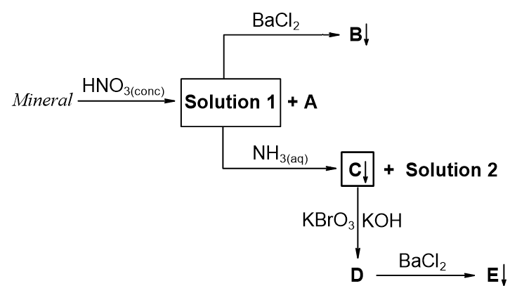
Avicenna dissolved 1.00 g of the mineral in an excess of concentrated nitric acid and observed a release of a brown gas A with a volume of 1.65 L under standard conditions (0 ℃, 1 atm). The solution formed (Solution 1) was divided into two equal parts for further analysis. To the first half of Solution 1, he added an excess of BaCl₂, which led to 0.929 g of white precipitate B. He added excess aqueous ammonia solution to the second half of Solution 1, causing the formation of brown precipitate C and deep-blue Solution 2. C was filtered off, dissolved in an alkaline solution of KBrO₃, giving a purple solution of compound D. D reacted with BaCl₂ to form 0.256 g of the red precipitate E.
- Determine the possible elemental composition of the mineral.
- Determine the molecular formula of the mineral and compounds A–E. Show your calculations where necessary.
- Write all the reaction equations described in the scheme.

Problem 3. Unusual inorganic synthesis
Until 1968, it was believed that anion A1 and its salts were unstable. However, in 1968, Evan H. Appelman performed an unusual synthesis of A1. A 90% enriched isotope of element X was first irradiated with thermal neutrons, then dissolved in nitric acid and oxidised by ozone in alkaline solution, giving anion B, which within a few minutes spontaneously turned into A1 without absorbing or releasing any chemical substances. 1.613 g of anion B was obtained from 1.000 g of X.
After the first unusual but successful attempt, scientists managed to oxidise anion А2 to А1 using electrolysis. For this purpose, Pt electrodes were immersed into 3.0 mL of the solution containing A2 (solution S0) and into HClO₄ solution. Electrolysis was carried out with a current strength of 10 A/cm² for 1 hour. The work surface of each Pt electrode was 0.785 mm², the current yield for A1 was 11.5%.
- Write the equation of the half-reaction occurring at the cathode and calculate the total volume (in mL at 0 ℃, 1 atm) of the gas released at the cathode during electrolysis.
After electrolysis, the analyte contained a mixture of anions A1 and A2 (colourless solution S1). The Pt electrode was removed from the analyte, an excess of diluted (~1 M) acidic solution containing anion A3 was added, and a yellow solution S2 (containing elemental substance A4) was obtained. A4 was removed by bubbling argon through S2, and a colourless solution S3 was obtained. An excess of saturated (~10 M) acidic solution containing A3 was added to solution S3, and a yellow solution S4 (also containing elemental substance A4) was obtained. The whole volume of S4 was diluted to 100.0 mL, and thus solution S5 was obtained. An excess of acidified KI solution was added to a 10.0 mL aliquot of solution S5, and the I₂ formed was titrated with 0.100 M Na₂S₂O₃ solution. A titre of 1.35 mL of Na₂S₂O₃ solution was obtained.
Another 3.0 mL sample of solution S0 was not subjected to electrolysis. Instead, it was diluted to 500.0 mL giving solution S6. An excess of acidified KI solution was added to a 10.0 mL aliquot of S6, and the I₂ formed was titrated with 0.100 M Na₂S₂O₃ solution. A titre of 10.10 mL of Na₂S₂O₃ solution was obtained.
- Write the equation of the reaction occurring during titration between I₂ and Na₂S₂O₃.
- Determine the chemical composition of A1–A4, B, and X (with atomic mass of enriched isotope). Note: A1–A4 contain the same element.
- Calculate the molar concentration (in M) of A2 in solution S0.
A1, formed within a few minutes from anion B, spontaneously decomposes within a few hours into gaseous elemental substances C and D in a molar ratio 1:2. The reaction scheme shows the formation and decay of A1 with the corresponding rate constants
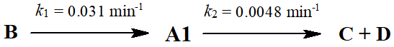
- Determine the detailed chemical composition of C and D. Both reactions shown in the scheme above are first order with respect to the corresponding reactants.
- Calculate the time (t, in min) after the start of the decomposition of B, which corresponds to the maximum concentration of A1.
It was subsequently discovered that XeF₂ also oxidises A2 to A1. Interestingly, another binary compound, E, of xenon (which does not contain fluoride) was also obtained by exactly the same unusual method (like B → A1) from a potassium-containing salt F with a mass fraction of potassium of 12.62%.
- Determine the detailed chemical composition of compounds E and F.

Problem 4. Nanozymes
Nanozymes are nanoparticles (NPs) that exhibit enzymatic activities under different physiological conditions, offering advantages such as high stability, low cost, and tunable activity compared to natural enzymes. Nanozyme X_{n}O_{m} NPs can be obtained by co-precipitation of salts S1 and S2, both containing element X, in alkaline media. 2.7025 g of S1 and 1.3901 g of S2 were dissolved in an acidic solvent and treated with tetramethylammonium hydroxide, and 1.1578 g of X_{n}O_{m} NPs were formed as a result as the only substance containing X. The electrospray ionisation mass spectrometry of S1 revealed positive ion [XHal₂(H₂O)₄]⁺ with m/z 198 and negative ion [XHal₄]⁻ with m/z 196 being the most intense peaks. S2 lost 45.36% of the total of the original mass and changed colour from green to white above 300 ℃. Elemental analysis revealed a mass fraction of 20.09% of element X in S2.
- Find element X, and salts S1 and S2.
- Determine the values of n and m for X_{n}O_{m} NPs.
- Write the equation of the co-precipitation reaction of X_{n}O_{m} NPs in ionic form.
Peroxidases are enzymes that catalyse the oxidation of substrates with H₂O₂ as an electron acceptor. Horseradish Peroxidase (HRP) catalyses a typical colourimetric reaction involving H₂O₂ and a chromogenic substrate (H₂TMB_{red}):
$${H_{2}TMB}_{red}+H_{2}O_{2} \underset{→}{HRP} TMB_{ox}+2H_{2}O$$
X_{n}O_{m} NPs behave like peroxidase due to their ability to participate in the following reaction:
$$X^{(n-1)+}+H_{2}O_{2}→X^{n+}+{OH}^{*}+{OH}^{-}$$
- The peroxidase activity of X_{n}O_{m} NPs is short-lived. After a certain time, X_{n}O_{m} NPs are converted into another oxide NPs of element X and lose their catalytic activity. Determine the chemical formula of the latter, if the mass fraction of X in them is smaller than that in X_{n}O_{m}.
- Which of the following reagents can be used to sustain the catalytic activity of X_{n}O_{m} NPs? Choose the correct answer(s).
a) NaIO₄ b) NaBH₄ c) Na₃C₆H₅O₇ (sodium citrate) d) Na₃PO₄
In contrast, another Y_{p}-based nanozyme can act not only as a peroxidase or catalase (converts hydrogen peroxide into water and oxygen) but also can exhibit hydrolase and phosphomonoesterase-like activities without being consumed during the reaction. Y_{p} has a spherical structure, in which the Y atoms are linked together by covalent bonds. The covalent spherical framework Y_{p} has a volume of 1.128 × 10⁻⁴ m³·mol^{–1} and a surface area of 1.324 × 10⁶ m²·kg⁻¹.
- Identify element Y and number p.
The catalytic activity of Y_{p}-based nanozymes fits Michaelis-Menten kinetics.
The effect of functionalised Y_{p}-nanozyme was tested with para-nitrophenyl phosphate at
pH = 7.4 and T = 37 ℃. The analysis showed K_{M} = 1.03 mM and r_{max} = 3.73 nM·s⁻¹.
- The substrate’s concentration should be high enough to saturate catalytic sites in nanozymes. If the recorded rate was 0.001 µM·min⁻¹, calculate the corresponding substrate concentration (in µM).
- If the reaction mixture contained 0.025 mM substrate, calculate the time (in min) needed to produce 0.025 µM product.

Problem 5. Haber–Bosch process
Note: Necessary thermodynamic data are at the end of the problem.
In the Haber–Bosch process, ammonia (NH₃) is synthesised directly from the corresponding elements using an iron-based catalyst.
- Write the equation for ammonia synthesis.
- Determine the temperature, T (K), of the ammonia synthesis reaction, at which K_{p} = 1, assuming Δ_{r}H° and Δ_{r}S° do not depend on temperature.
In reality, Δ_{r}H° and Δ_{r}S° depend on temperature.
- Calculate the value of K_{p} at 300 ℃, assuming that heat capacities of the gases remain constant while enthalpy and entropy depend on temperature.
- Determine the minimum amount (moles) of hydrogen required to achieve 90% conversion of 1 mol of nitrogen.
Ammonia synthesis is exothermic. Thus, low temperatures favour higher equilibrium yields, but the reaction rate decreases significantly. Industrially, the process is conducted at high temperatures and pressures to achieve optimal rate and conversion.
- a) Calculate the equilibrium yield, η (%), of ammonia at 300 ℃ and a final total pressure of 150 bar from a stoichiometric mixture of reactants.
b) Explain qualitatively how the equilibrium yield would change if the total pressure were increased while keeping the temperature constant.

Ammonia formation proceeds via adsorption of gases on the catalyst surface, as shown in the diagram:
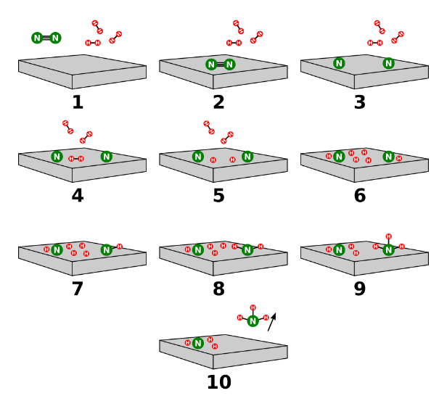
- Suggest the possible rate-determining step of the mechanism.
The iron catalyst is produced from finely ground iron powder, which is usually obtained by reduction of high-purity magnetite (Fe₃O₄). The pulverised iron is oxidised to give magnetite particles of a specific size. The magnetite particles are then reduced. The catalyst maintains most of its bulk volume during the reduction, resulting in a highly porous high-surface-area material, which increases its catalytic efficiency.
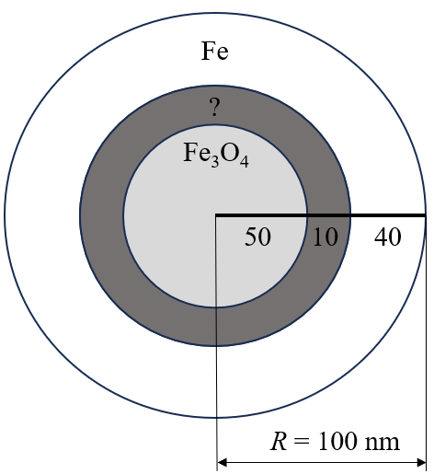
The catalyst synthesised from 10 g of iron consists of nanoparticles with a radius, R = 100 nm, as shown in the diagram on the right.
- Choose the composition of the “?” layer in the nanoparticle:
a) Fe₂O₃ b) FeO c) FeOOH d) Fe(OH)₃
- Calculate the total surface area of the catalyst, assuming all nanoparticles are spherical and uniform in size and composition.
- Calculate how many times faster the ammonia synthesis reaction proceeds on the synthesised catalyst compared to a 10 g iron cube if the rate is directly proportional to the surface area.
Thermodynamic data (T = 298 K, p = 1 bar):
Substance | Δ_{f}H° / kJ·mol⁻¹ | S° / J·mol⁻¹·K⁻¹ | C_{p} / J·mol⁻¹·K⁻¹
H₂(g) | 0 | 130.7 | 28.8
N₂(g) | 0 | 191.6 | 29.1
NH₃(g) | −46.2 | 192.7 | 35.1

Substance | Fe | FeO | Fe₃O₄ | Fe₂O₃ | FeOOH | Fe(OH)₃
ρ / g·cm⁻³ | 7.9 | 5.7 | 5.0 | 5.3 | 4.3 | 3.9

Problem 6. Hydrogen fuel
Note: Necessary thermodynamic data are at the end of the problem.
Hydrogen is an environmentally clean fuel which is, in principle, ideal for powering the millions of vehicles on our roads.
- Write the combustion reaction equations and calculate Δ_{c}H° at T = 298 K, P = 1 bar for:
- Hydrogen
- Methane
- Isooctane
- Determine the energy density (MJ·kg⁻¹) for these fuels at T = 298 K and P = 1 bar. Choose the substance that is the best fuel, considering the energy-to-mass ratio?
For the rest of this problem, assume that air consists of 20% O₂ and 80% N₂ by mole fraction.
- Determine the volume of air at T = 298 K and P = 1 bar required for an internal combustion engine (ICE) operating on hydrogen fuel (η = 36%) with a power of 1 kW to work for 1 hour.
Hydrogen-fuelled cars do not release CO₂, in contrast to both gasoline and methane engines, which emit CO₂ as a direct product of fuel combustion. Uzbekistan maintains a national fleet of approximately 3.75 million cars. 65% of them operate on methane, while 35% run on gasoline (assume that isooctane is used). An average vehicle in the country travels 22 000 km per year.
Note:
- Gasoline engines consume 9 dm³ of fuel per 100 km (ρ_{gasoline} = 0.72 kg·dm⁻³).
- Methane engines consume 5 m³ of fuel per 100 km (T = 298 K and P = 1 bar).
- Estimate the amount of CO₂ emissions (in million tons) from cars that would be avoided annually, if every vehicle in Uzbekistan operated solely on hydrogen.
- Calculate the amount (in moles) of nitrogen contained in an isolated system with initial temperature, T_{initial} = 298 K, and constant pressure (P = 1 bar), containing 1 mol of H₂ and excess air, if after combustion, the temperature of the system reached T = 800 K.
When stoichiometric mixtures undergo combustion, the system temperature increases to such a high level that the combustion reaction begins to proceed in the reverse direction. As a result, a situation arises in which both the composition of the mixture and the final temperature after combustion are unknown.
- In another isolated reactor, the process takes place under a constant pressure (P = 1 bar) and an initial temperature, T_{initial} = 298 K, with the assumption that only the combustion reaction takes place.
    - Determine the final temperature for combustion of a stoichiometric mixture of hydrogen and oxygen, assuming that the reaction proceeds quantitatively.
    - Determine the mole fractions of gases in the mixture using K_{p} at the temperature from question 6-a).
    - Determine the final temperature for the system using an energy balance, if after combustion the mixture composition corresponds to the mixture from question 6-b). Compare the final temperature with the temperature in 6-a).
    - Determine the real final temperature (T_{f}, with an accuracy of ~20 K) for the combustion of a stoichiometric H₂ and O₂ mixture. Choose the nearest temperature value for T_{f} :
i) 3900 K | ii) 3850 K | iii) 3800 K | iv) 3750 K | v) 3700 K | vi) 3650 K
Combustion in air at high temperatures may lead to side reactions, such as NO formation.
- Calculate the mole fraction of NO after the stoichiometric combustion of H₂ in air at equilibrium (T = 3200 K, P_{total} = 1 bar). Assume that only two reactions that reach equilibrium occur, and use reasonable assumptions where necessary.
- Choose the option(s) which help to decrease NO formation in ICE operating on H₂ and air:
a) Lower the combustion temperature.
b) Increase the excess air ratio significantly.
c) Raise the compression ratio in the engine.
d) Increase the fuel flow speed.
For this problem, assume that C_{p} does not depend on temperature, while enthalpy and entropy do depend.
Thermodynamic data (T = 298 K, p = 1 bar):
Substance | Δ_{f}H° / kJ·mol⁻¹ | S° / J·mol⁻¹·K⁻¹ | C_{p} / J·mol⁻¹·K⁻¹
H₂(g) | 0 | 130.7 | 28.8
O₂(g) | 0 | 205.2 | 29.4
N₂(g) | 0 | 191.6 | 29.1
H₂O(g) | –241.8 | 188.7 | 37.4
H₂O(l) | –285.8 | 70.0 | 75.4
CH₄(g) | –74.8 | 186.3 | 35.3
C₈H₁₈(l) | –260.2 | 361.2 | 254.7
CO₂(g) | –393.5 | 213.8 | 37.1
NO(g) | 90.3 | 210.8 | 29.9

Problem 7. 150 Years of Urease
Urease is an important enzyme because of its role in the nitrogen cycle as a key catalyst in the reaction converting urea to NH₃ and CO₂:
CO(NH₂)₂ + H₂O $\underset{→}{Urease}$ CO₂ + 2NH₃
Urease activity as a soluble enzyme was first identified in 1876 by Frédéric Alphonse Musculus. Urease was the first enzyme crystallised in 1926 by James Batcheller Sumner. For his discovery that enzymes could be crystallised, Sumner was awarded the Nobel Prize in Chemistry in 1946.
The active centre of Urease behaves as a diprotic acid both in the free state and the substrate-bound state, with the following equilibrium constants at 25 ℃:
H₂U$_{\overset{←}{ } }^{\underset{→}{K_{a1}}}$ HU⁻ + H⁺, pK_{a1} = 5.62
HU⁻$_{\overset{←}{ } }^{\underset{→}{K_{a2}}}$U²⁻ + H⁺, pK_{a2} = 9.07
Only the HU⁻ form exhibits enzymatic activity, which obeys Michaelis–Menten kinetics as shown below:
Urease + CO(NH₂)₂ $_{\overset{←}{k_{-1}}}^{\underset{→}{{ k}_{1 }}}$[Urease·CO(NH₂)₂] $\underset{→}{{ k}_{2 }}$Urease + CO₂ + 2NH₃
- Using the steady-state approximation, derive the dependence of the rate of the above enzymatic reaction on the total concentrations of Urease, CO(NH₂)₂ and H⁺. Note: [CO(NH₂)₂]_{total} ≫ [Urease]_{total}.
- Determine the reaction orders with respect to Urease and CO(NH₂)₂ in the buffer solutions when:
a) $\frac{k_{-1}+k_{2}}{k_{1}}$ ≫ [CO(NH₂)₂]_{total}
b) $\frac{k_{-1}+k_{2}}{k_{1}}$ ≪ [CO(NH₂)₂]_{total}
- The dependence of the rate of these enzymatic reactions on pH forms bell-shaped graphs with the maximum rate when the total concentrations of Urease and CO(NH₂)₂ are unchanged. Calculate the pH value when Urease demonstrates the maximum rate.
- In the absence of any buffer, the decomposition products of CO(NH₂)₂ change the pH of the solution, thereby reducing the activity of Urease. Calculate:
  - The pH of the solution after decomposition of 0.005 M CO(NH₂)₂. Neglect the contribution of Urease to the acid-base equilibrium and the dissolution of atmospheric CO₂.
pK_{b}(NH₃) = 4.75; pK_{a1}(H₂CO₃) = 3.75; pK_{a2}(HCO₃⁻) = 10.33 at 25 ℃.
  - The factor by which the rate of the enzymatic reaction decreases when the pH of the solution changes from neutral to the value obtained in question 4-a), if the total concentrations of Urease and CO(NH₂)₂ are the same in both conditions.
- Match the following conditions (1)–(3) with the phase portraits (a)–(c):
- Urease in buffer solution with CO(NH₂)₂;
- Urease in neutral solution with CO(NH₂)₂ without any buffer;
- Urease in liposomes with a permeable membrane with CO(NH₂)₂ and without any buffer inside. Assume that Urease doesn’t leave the liposome, while CO(NH₂)₂ and products can pass through the membrane.
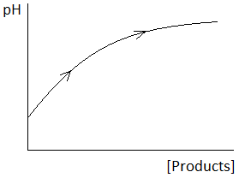 | 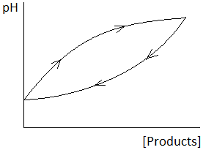 | 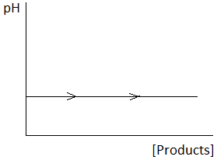
(a) | (b) | (c)
Biocatalytic calcification by Urease shows potential in innovative engineering applications, such as preparation of advanced carbonate materials, cleaning wastewaters/groundwaters of Ca²⁺ and ⁹⁰Sr²⁺, and most excitingly, sealing cracks and fissures in buildings and other historical stone monuments of cultural heritage during their restoration.
- Calculate the minimum concentration of Ca²⁺, at which CaCO₃ begins to precipitate from solution in question 4-a)? Ignore the dissolution of atmospheric CO₂.
K_{sp}(CaCO₃) = 3.36 × 10⁻⁹ at 25 ℃.
In agriculture, Urease in soil plays a crucial role in nitrogen uptake by plants in the form of NH₃ produced from the hydrolysis of the fertiliser CO(NH₂)₂. However, if too rapid, the hydrolysis may lead to overproduction of NH₃ resulting in detrimental effects, such as losses of nitrogen by ammonia volatilisation, and ammonia- and alkaline-induced plant damage. One way to counteract this is to suppress the ureolytic activity of soil with the use of Urease inhibitors. Urease inhibition can also be exploited as an analytical technique in Urease-based biosensors for the analysis of substances that act as inhibitors of the enzyme.
Boric acid is a competitive inhibitor of Urease and their complex, [Urease·B(OH)₃], also behaves as a diprotic acid with the same acidity constants:
[Urease·B(OH)₃]$_{\overset{←}{ } }^{\underset{→}{{ K}_{I} }}$ Urease + B(OH)₃
- Rederive the dependence of the rate of the enzymatic reaction on the total concentrations of Urease, CO(NH₂)₂, B(OH)₃, and H⁺. Note: [CO(NH₂)₂]_{total} and [B(OH)₃]_{total} ≫ [Urease]_{total}. Ignore the acid-base properties of B(OH)₃.

- According to the kinetic equation obtained in question 7, the function $\frac{1}{r}=f\left(\frac{1}{{\left[CO{\left(NH_{2}\right)}_{2}\right]}_{total}}\right)$ is linear. Calculate K_{I} if the slope of this function with [B(OH)₃]_{total} = 0.300 mM is 2.48 times greater than the slope with [B(OH)₃]_{total} = 0.075 mM at 25 ℃. The total concentration of Urease and pH values are equal in both cases.
- Calculate Δ_{r}H° and Δ_{r}S° values for the binding of boric acid with Urease, if they are independent of temperature and K_{I} = 1.57 × 10⁻⁴ at 35 ℃.

Problem 8. Step-by-step
Uzbekistan's polymer industry is a growing sector, driven by domestic demand in construction, packaging, and agriculture. Polycondensation, also known as condensation polymerisation, leads to multiple important polymeric products and is known to proceed by a stepwise mechanism.
Let’s consider a polymer produced by polycondensation of HO–A–OH and HOOC–B–COOH monomers. Such polymers, obtained via esterification reactions, are called polyesters. It is generally assumed that the reactivity of functional groups is independent of the length of the corresponding molecular chain.
nHO–A–OH + nHOOC–B–COOH $\underset{→}{Cat}$ H[O–A–O–CO–B–CO]_{n}OH + (2n − 1)H₂O
$$-\frac{d\left[OH\right]}{dt} = -\frac{d\left[COOH\right]}{dt}=k{\left[OH\right]}^{x}{\left[COOH\right]}^{y}$$
The Initial Rate Method was used to determine the kinetic order of the reaction.
Initial Rate / M·s⁻¹ | [OH]₀ / M | [COOH]₀ / M
2.70 × 10⁻⁴ | 0.100 | 0.100
1.08 × 10⁻³ | 0.200 | 0.200
1.62 × 10⁻³ | 0.300 | 0.200
- Using the information above, calculate the values of k, x and y.
It is reasonable to consider that the concentrations of the functional groups are equal, that is
[OH] = [COOH] = C. Thus, the kinetic equation can be further simplified as:
$$-\frac{dC}{dt}=kC^{z}$$
- Give the value of z in this case. Write the integrated kinetic equation.
The Carothers equation relates the average degree of polymerisation (DP) of polymers with the degree of conversion, p, where C is the concentration of functional groups at a particular time and C₀ is the initial concentration of those groups in monomers.
$$DP=\frac{C_{0}}{C}$$
- Derive the Carothers equation DP = f(p).
- Find the dependence of DP on time, DP = f(t).
- Using the functions DP = f(t) and DP = f(p), present the relationship between p and t in a linear form.
Polycondensation reactions typically have an overall reaction order of 2. However, this can be different in particular cases. Thus, aryl halide–bisphenol A polycondensation systems are unusual because they show different kinetic behaviours depending on whether the halide is chlorine or fluorine. The following mechanism of polycondensation kinetics was found for DCDPS (dichlorodiphenylsulfone, 2-body pathway) and for DFDPS (difluorodiphenylsulfone,
3-body pathway):
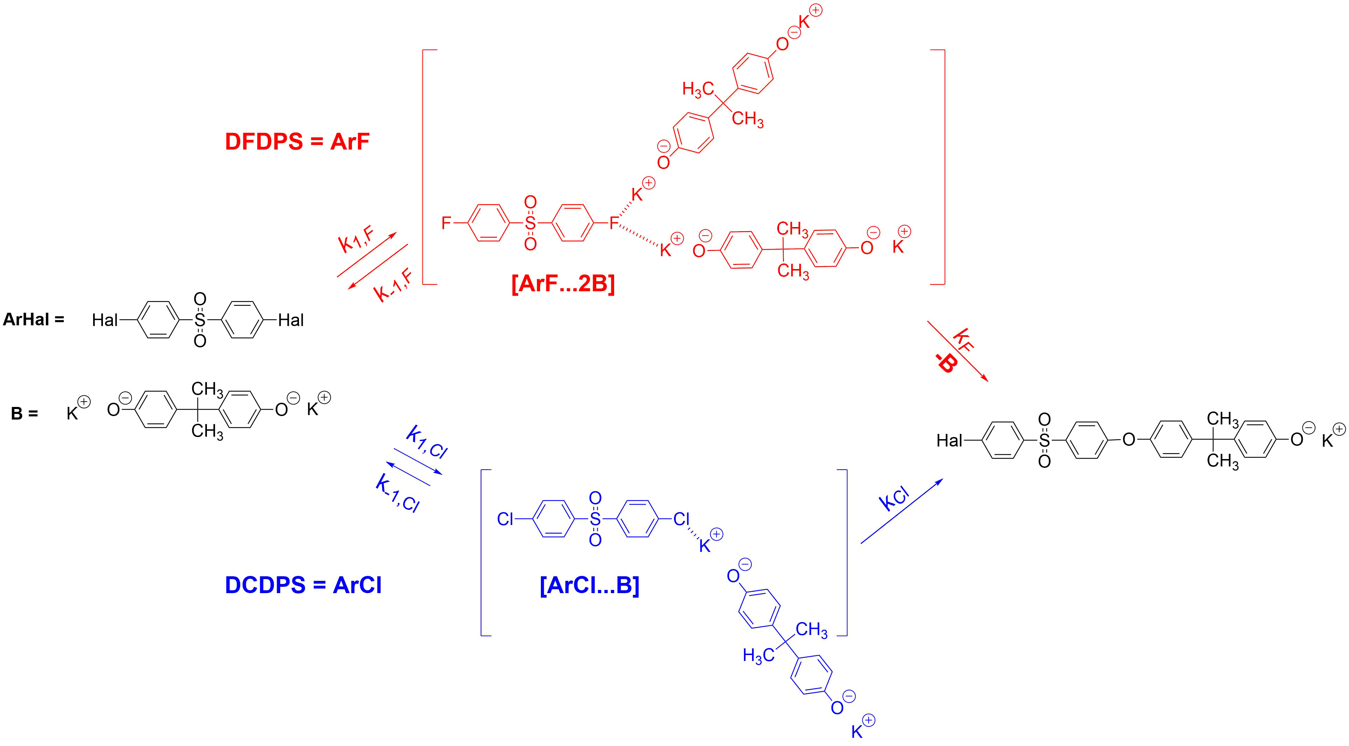
Figure 1. Substrate-dependent mechanisms of reaction for DFDPS (ArF) and DCDPS (ArCl)
- Based on the above mechanisms, find the expressions for the equilibrium constants K_{F} and K_{Cl} of the formation of intermediates [ArF…2B] and [ArCl…B], respectively.
- Assuming that equilibrium is established very quickly in the first step, find the overall reaction rate law r = k_{obs}[ArHal]^{m}[B]^{n} for both halides, using K_{F} and K_{Cl}, respectively.
Polymerisation of DFDPS can be schematically shown as follows:
Assume that [ArF]₀ = [B]₀ and [ArF] = [B] at any time.
- Deduce the relationship between the degree of polymerisation and time for DFDPS polymerisation. Calculate the average degree of polymerisation after 1 hour, if the initial concentration [ArF]₀ = [B]₀ = 0.1633 M and k_{obs} = 7023 L²·mol⁻²·h⁻¹.
So far, we’ve considered a model in which the rate constant is independent of the degree of polymerisation (DP). However, reactions are known that don’t conform to this model. Consider the more complicated model where every propagation step of the step-growth reaction accelerates by a factor ξ.
- Sketch qualitatively DP = f(t) curves for ξ = 1 (common case, already done in question 4) and ξ > 1 in one graph.
- Derive the relationship DP = f(t) for ξ > 1.

Problem 9. Host-guest chemistry of cucurbiturils as Uzbek hospitality
The cucurbiturils are a family of macrocyclic compounds, which, incidentally, resemble pumpkins. They are doughnut-shaped molecules with functional groups within their voids that can bind small guest molecules.
Fortunately, the synthesis of cucurbiturils is extremely simple. The scheme below shows the synthesis of cucurbit[6]uril (X), the [6] indicating a macrocycle with six repeating units.
Сucurbit[6]uril (X)
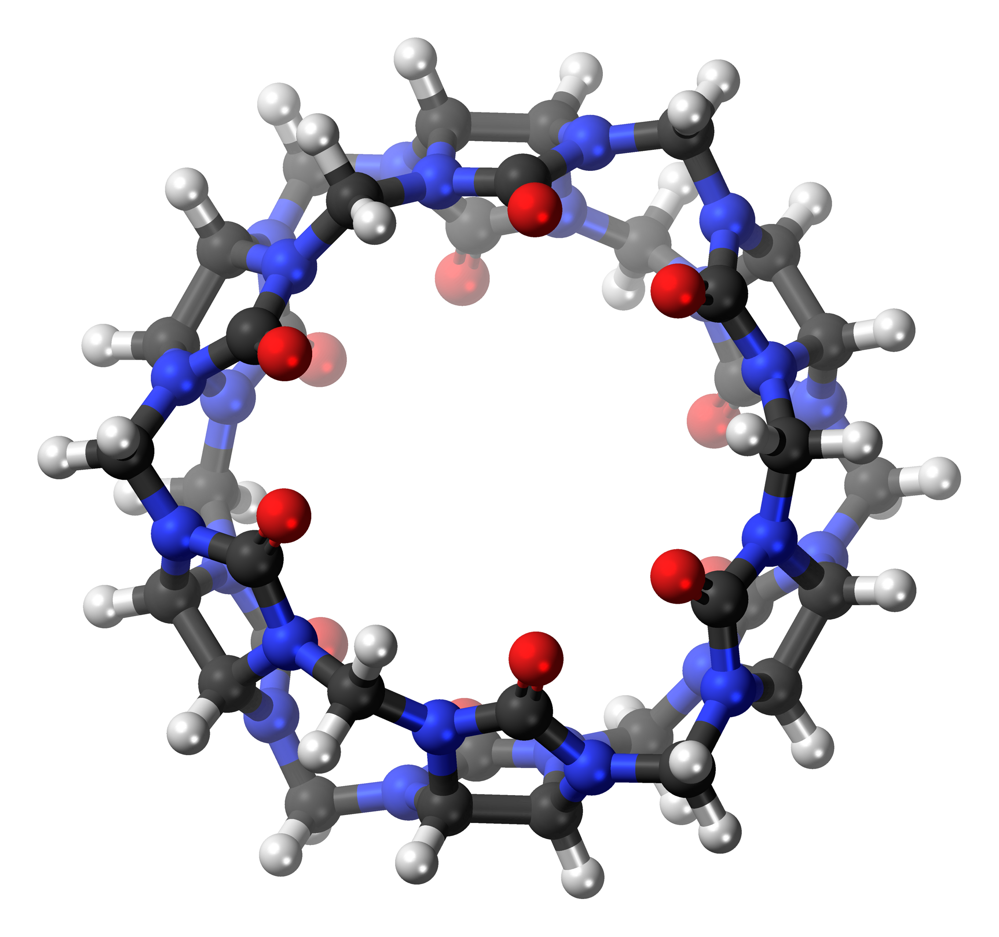 | 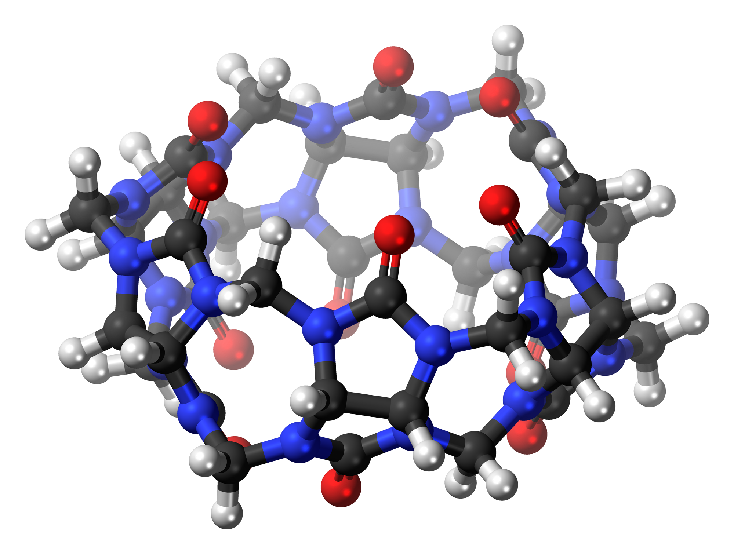
Top view | Side view
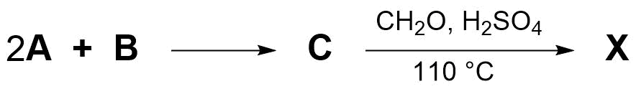
Hints:
- A is obtained by heating an inorganic salt of Y, which happens without mass loss;
- In the mass spectrum, B has peaks at m/z 58 and 29. B gives a positive Tollens reaction and has only one type of hydrogen atoms and one type of carbon atoms;
- Compound C is not polymeric, and C is the main building block for constructing cucurbiturils.

      - Draw structures A–C and the repeating unit of X. Determine Y.

Cucurbiturils form host-guest type complexes. For example, the host cucurbit[n]uril (CB_{n}) can stabilise the ocular drug tropicamide (TR – C₁₇H₂₀N₂O₂). The four-state complexation model of neutral and protonated TR with CB_{n} is shown below:
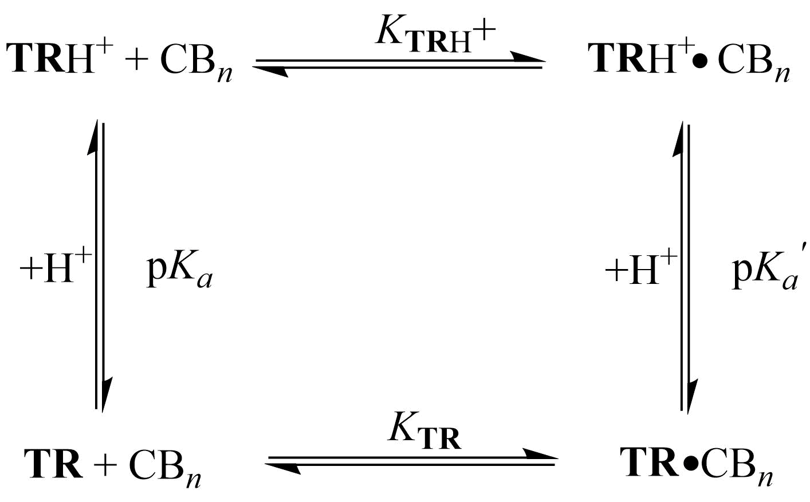
The [TR‧CB₈] complex was studied using mass spectra. Peaks at m/z 285, 665, and 807 were detected in the spectrum.
- Determine the species to which these peaks correspond.
For the [TR‧CB₈] complex, the formation constant, K_{TR} = 1.4 × 10⁴. pH titrations monitored by UV-spectrophotometry of pure TR ( ○ ), and of TR with CB₈ ( ▲ ) are shown below. The concentration of the host was sufficient to ensure virtually quantitative complexation of TR over the investigated pH range.
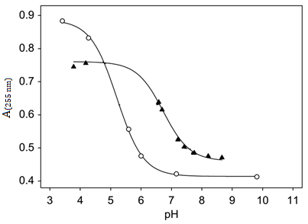
- Determine the approximate values of pK_{a}, pK_{a}’ and K_{TRH⁺}.
Tropicamide is an anticholinergic drug commonly used as eye drops for mydriatic effect (pupil dilation) in preparation for ophthalmological examinations and surgical procedures. The drug is available as an aqueous solution with рН = 4.0. Since this value is significantly lower than the physiological pH of the eye (pH = 7.0), topical application of the drug causes significant, albeit temporary, discomfort in patients. Using tropicamide with the CB₈ complex allows the drug to be used at physiological pH.
- Indicate whether TR or TRH⁺ is the biologically active form of tropicamide.
- Calculate how many times the molar fraction of the biologically active form of tropicamide increases at pH = 7.0 if its complex with the CB₈ is used.
Cucurbiturils are also used as supramolecular catalysts. For example, cucurbit[7]uril (CB₇) catalyses the dimerisation reaction of cyclopentadiene (CPD) to dicyclopentadiene (DCPD):
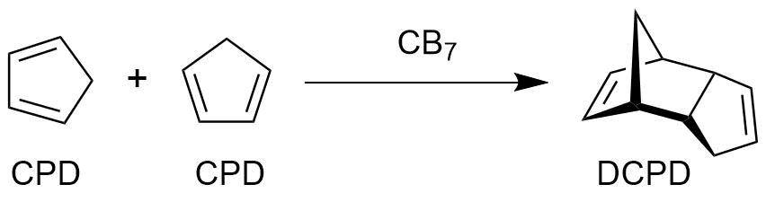
The plot of 1/[CPD] (M⁻¹) versus reaction time (s), monitored in the presence of CB₇, is as follows:
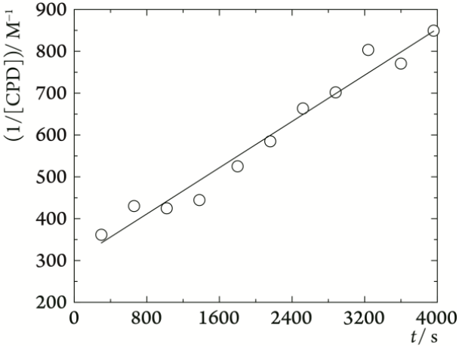
- Determine the reaction order for CPD and the observed rate constant.
The following equations describe the kinetics based on the binding equilibria:
CPD + CB₇ ⇌ CPD·CB₇, K₁
CPD + CPD·CB₇ ⇌ (CPD)₂·CB₇, K₂
(CPD)₂·CB₇ → DCPD·CB₇, k
- Derive the dependence of the rate of the dimerisation reaction on the equilibrium concentrations of CPD and CB₇, which agrees with the experimental data from question 6.
The following table shows the observed rate constants for cucurbiturils with the same initial concentrations and different cavity volumes:
Cucurbit[n]uril | CB₅ | CB₆ | CB₇ | CB₈
k_{obs} / M⁻¹·s⁻¹ | 9.4 × 10⁻⁶ | 5.0 × 10⁻⁶ | ? | 9.0 × 10⁻⁶
- Explain why CB₆ has the lowest observed rate constant.

Problem 10. Prebiotic life
What makes Earth unique is that it has life. As far as we know, it is the only place in the universe where complex forms of life exist. The impact of life has been so great that it has changed the planet's air, water, and climate. Therefore, a central goal of science is to understand what life is, how it works, and ultimately, how it emerged from non-living matter. This leads to the core mysteries of prebiotic chemistry: what conditions and processes on the early Earth transformed simple chemicals into the first self-replicating systems that kickstarted biological evolution?
One of the possible routes of how complex molecules like RNA and ribonucleotides formed from simple molecules cyanamide 1, glycoaldehyde 2, formaldehyde 3, and cyanoacetylene 4 in prebiotic Earth was suggested by Powner et al.:
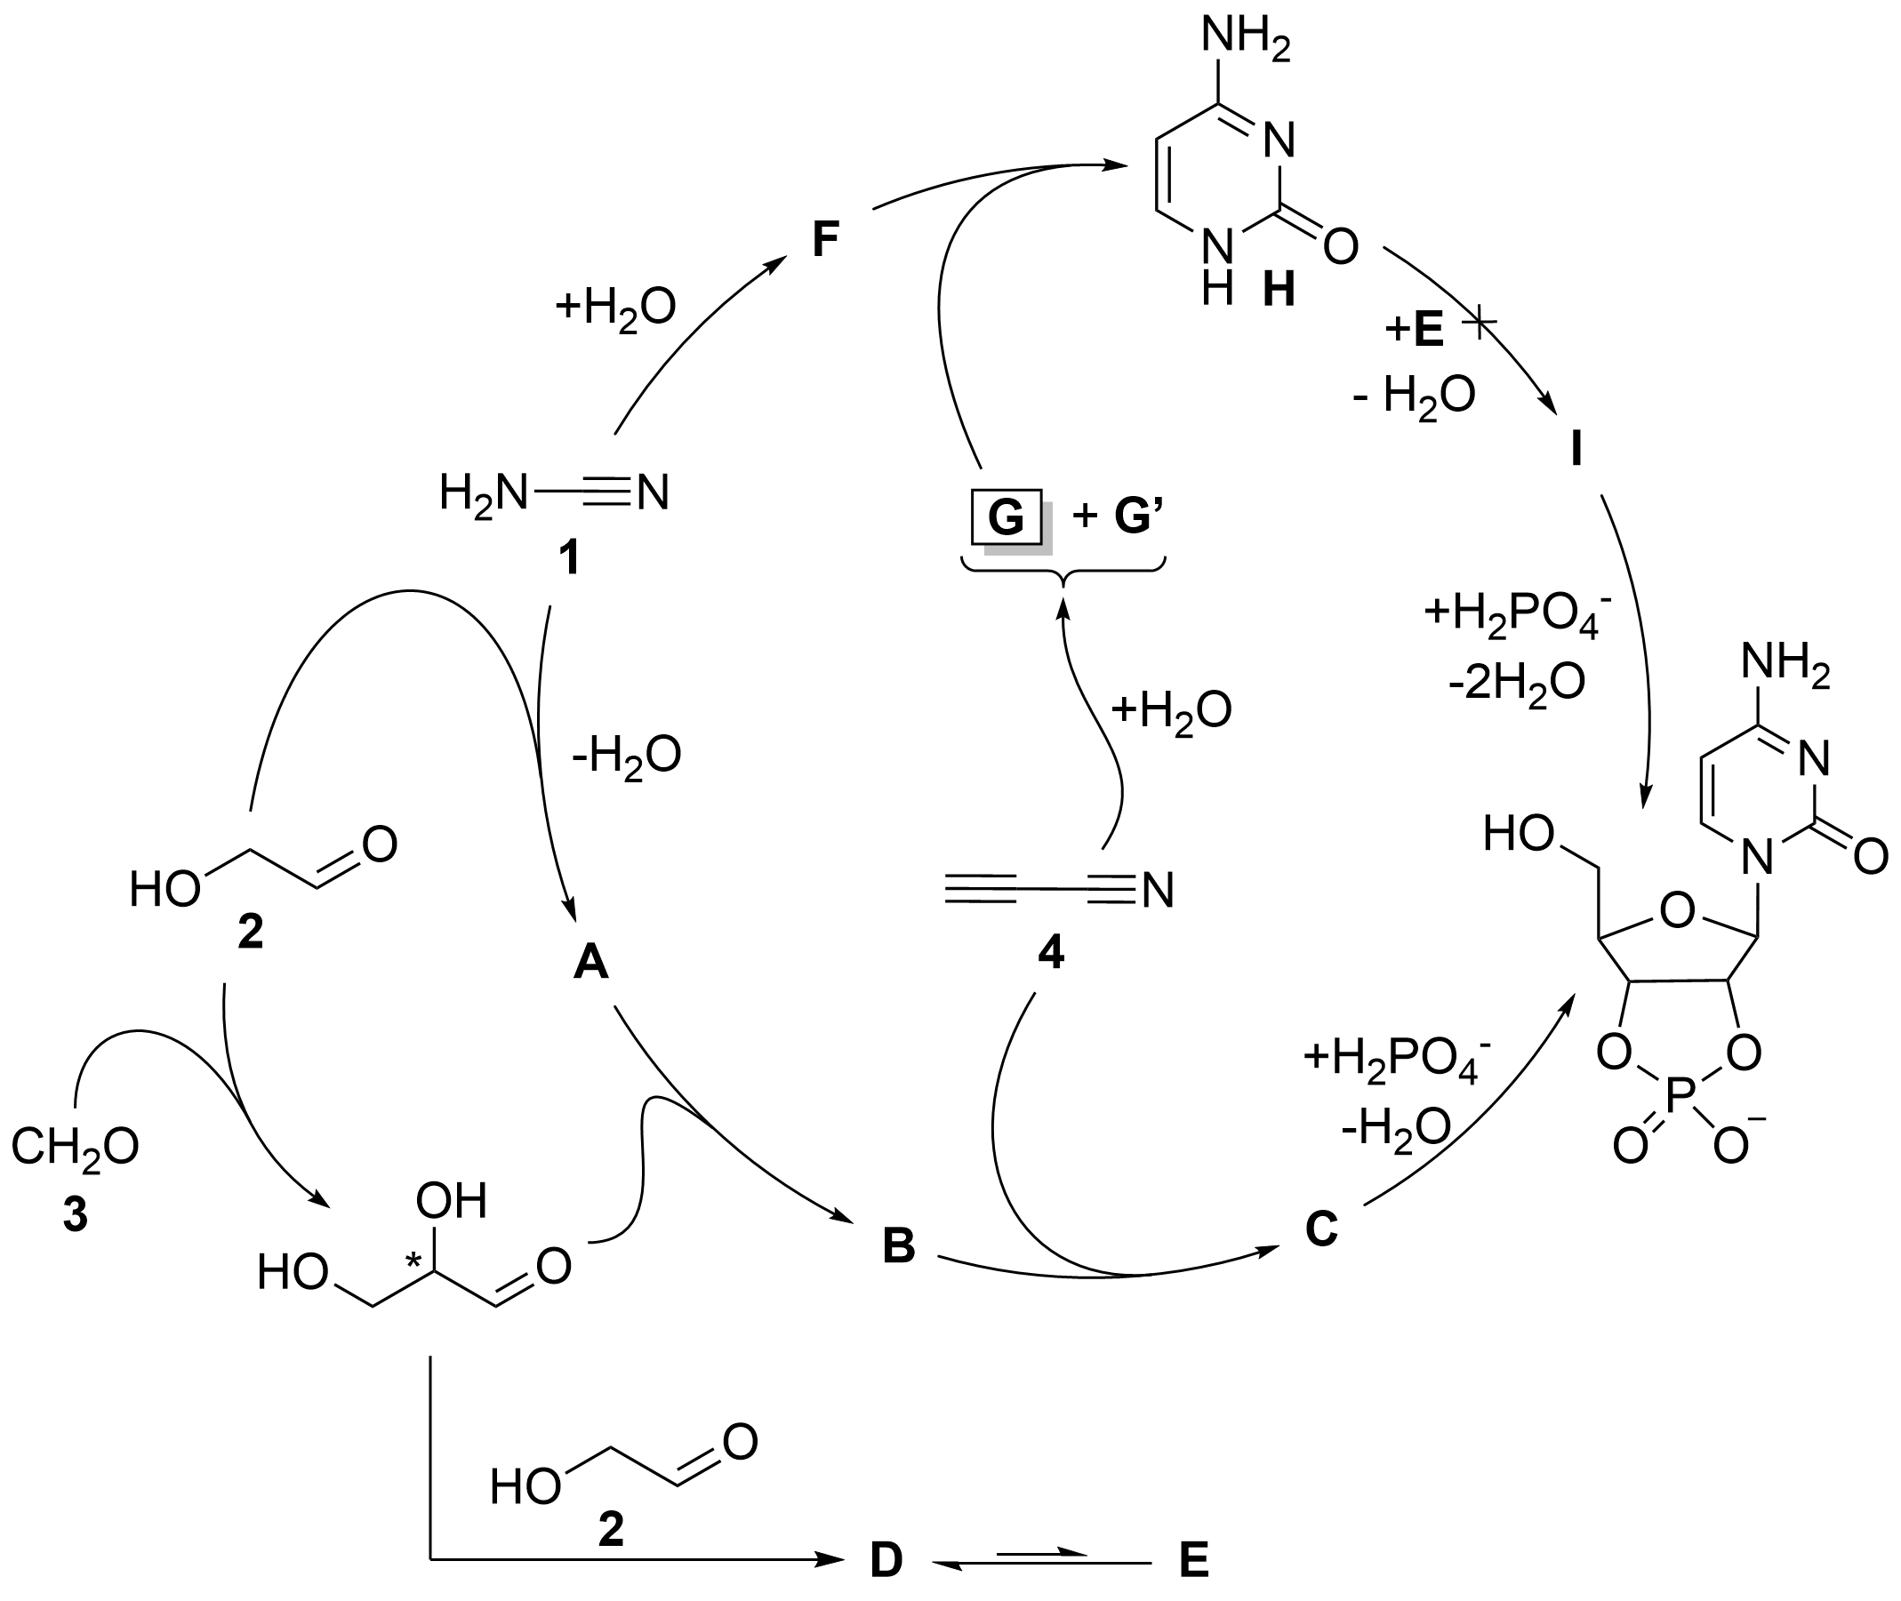
In this scheme, direct reaction between sugar E and cytosine H (which is formed via reaction of G) yields no product I, presumably because of the low nucleophilicity of H. Therefore, the 1 + 2 → A → B → C prebiotic route was suggested by researchers, where in each step the number of rings in the product increases by one.
- Draw molecular structures of compounds A–G, G’ and I.
- What is the reason behind the low nucleophilicity of H? Choose the correct answer(s):
  - electron delocalisation due to the aromaticity of pyrimidine ring;
  - extreme ring strain in cytosine that interrupts the reaction;
  - the positive charge due to the formation of ammonium salts that repels other molecules.
The fact that life relies almost exclusively on single molecular handedness (homochirality) is still not fully understood. It is well established that, in biological systems, most amino acids in proteins occur in the so-called l-configuration, while most sugars adopt the d-configuration.
- In the scheme above, glycoaldehyde 2 and formaldehyde 3 react to form glyceraldehyde – the simplest sugar molecule that contains a stereocentre. Depict the structural formulae of l- and d-glyceraldehyde with the shown absolute configuration of the stereocentre.
There are several hypotheses about the origin of such a unique property as homochirality. A plausible early Earth scenario involves shallow lakes with magnetite deposits. UV light (200-300 nm) shining on magnetite can generate spin-polarised electrons – special electrons with aligned spins – that act as reducing agents. These electrons interact differently with left- and right-handed molecules due to the chiral-induced spin selectivity (CISS) effect, changing reaction rates selectively. This spin-based interaction could break chiral symmetry in prebiotic chemistry, favouring one enantiomer and possibly leading to life’s homochirality.
In this case, it is useful to present the term of electron helicity, which is a physical property describing the direction of the electron’s spin relative to its direction of motion. For example, if helicity is right-handed, then the electron’s spin is parallel to its momentum, and vice versa.
Consider a process that occurs in a prebiotic lake of reactants:
LX + De⁻ → LY
DX + De⁻ → DY
The l-/d- isomer of X reacts with a right-handed electron donor De⁻ and produces the l-/d- isomer of compound Y. The spin-chirality coupling hypothesis states that the interaction of the l-isomer with the d-electron is more kinetically favoured. The amount of this preference can be expressed via the rate constant formula:
$$k_{(L)}=A⋅\exp\left(-\frac{\left(E_{a}-H_{SO}\right)}{k_{B}T}\right),$$
$$k_{(D)}=A⋅\exp\left(-\frac{\left(E_{a}+H_{SO}\right)}{k_{B}T}\right),$$
where k_{L/D} is the rate constant of the reaction, E_{a} is the activation energy of the process, and H_{SO} is the spin-orbit energy.
The enantiomeric excess, ee, is a measure of the purity of a chiral substance in terms of the predominance of one enantiomer over the other in a mixture:
$$ee=\frac{\left[LY\right]-[DY]}{\left[LY\right]+[DY]}$$
- Given H_{SO} = 0.5 meV, considering that the A factor is equal for l- and d-isomers and the substrate is a racemic mixture ([LX] = [DX]), determine the ee of the reaction product Y at T = 313 K (~40 ℃), which is a good assumption for the average surface temperature of water bodies during the prebiotic era.
- Consider some racemic solution of l-/d-isomers in water with a total concentration of 1 M, where symmetry breaking (i.e. conversion of one isomer into another) occurs, resulting in overall chiral amplification of the system. Depict possible symmetry-breaking trajectories in a phase portrait of the system.
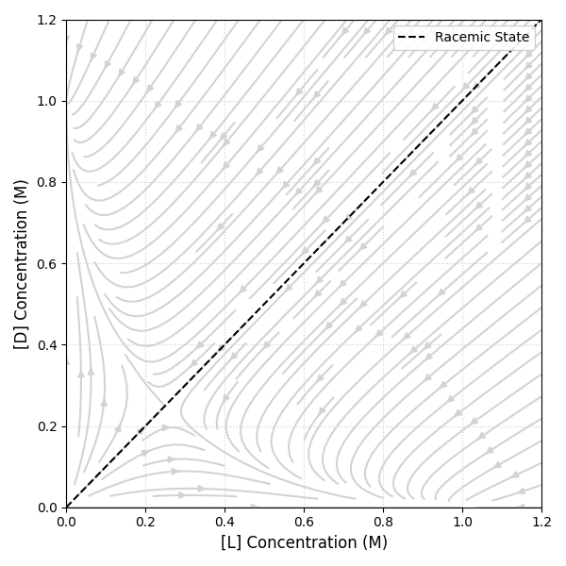
This example of kinetic resolution has demonstrated the chiral amplification of single monomeric units. However, the origin of life requires processes for the ligation of monomers into the homochiral polymeric molecules that constitute proteins and enzymes and the genetic polymers of RNA. Can a pool of partially enantioenriched monomers successfully produce homochiral polymers?
Let’s consider two amino acids in their l- and d- forms. The possible reactions between them are listed below:
L₁ + L₂ → L₁L₂, r = k_{homo}[L₁][L₂]
D₁ + L₂ → D₁L₂, r = k_{hetero}[D₁][L₂]
L₁ + D₂ → L₁D₂, r = k_{hetero}[L₁][D₂]
D₁ + D₂ → D₁D₂, r = k_{homo}[D₁][D₂],
where k_{homo} and k_{hetero} denote the homochiral and heterochiral dimer formation rate constants, respectively.
- Considering that k_{homo} = k_{hetero} and thus neglecting kinetic control, derive that:
$$ee_{homochiral}=\frac{\left[L_{1}L_{2}\right]-\left[D_{1}D_{2}\right]}{\left[L_{1}L_{2}\right]+\left[D_{1}D_{2}\right]}=\frac{ee_{1}+ee_{2}}{1+ee_{1}ee_{2}}$$
where ee₁ and ee₂ stand for:
$$ee_{1}=\frac{\left[L_{1}\right]-[D_{1}]}{\left[L_{1}\right]+[D_{1}]}, ee_{2}=\frac{\left[L_{2}\right]-[D_{2}]}{\left[L_{2}\right]+[D_{2}]}$$
- Calculate ee_{homochiral} for the prebiotic lake system from question 4 with ee₁ = ee₂ = ee_{q4}.
Note: If you could not solve question 4, consider ee_{q4} = 0.05 (5%).
- Now, considering that only homochiral oligomers are responsible for chain propagation, find the smallest number of amino acid residues needed for a resulting polymeric chain to have ee_{homochiral} > 0.99. For initial amino acids, assume each amino acid has an ee = 0.05.
The mathematical model above was found valid for a real biochemical system, where the initial transamination reaction with pyridoxamine catalysed by a strictly homochiral dipeptide molecule aa₁-aa₂ yields a racemic amino acid molecule aa and pyridoxal. The amino acid molecules formed react with another amino acid’s derivative molecule K, which results in a dipeptide derivative. The latter yields the dipeptide aa₁-aa₂, thus looping the cycle:
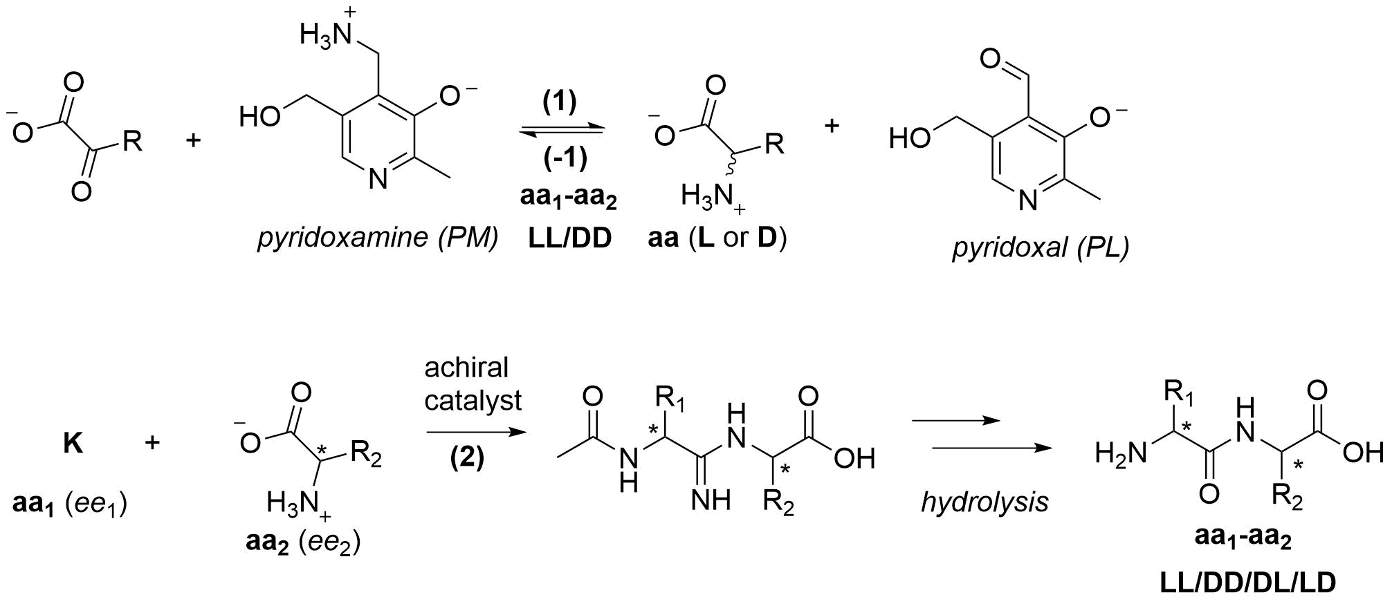
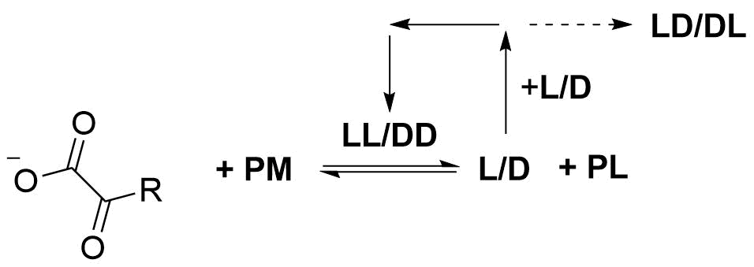

- Draw the structure of K.
The role of the dipeptide catalyst in reaction (1) is based on promoting a hydrogen atom transfer (HAT) reaction. For instance, Yu et al. proposed the mechanism below for the l-prolinyl-l-valine-catalysed alanine synthesis reaction from pyruvate:
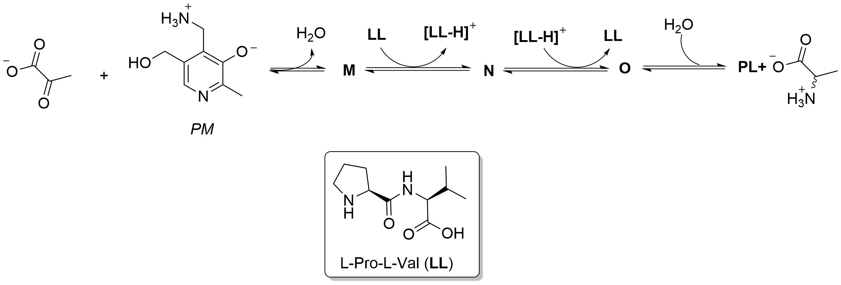
- Mark the functional group(s) in the LL molecule involved in the hydrogen atom transfer process.
- Draw the structures of compounds M–O.

Yu et al. also discovered that in the reverse reaction (−1), which leads to pyruvate from alanine, d-alanine reacts faster than l-alanine, thus enriching the prebiotic system with the l-enantiomer.
- Which intermolecular forces (or their absence) between alanine and PL-LL in the corresponding transition state could be behind the faster reaction of d-Ala compared to that of l-Ala? Choose the correct statement(s):
- Hydrogen bonds
- π-stacking
- Steric repulsion
- Alignment of stereocentres
Constructive and destructive mechanisms, where the corresponding amino acid was formed or destroyed, respectively, were investigated in open systems with a flow rate, φ, of corresponding reactants in each case.
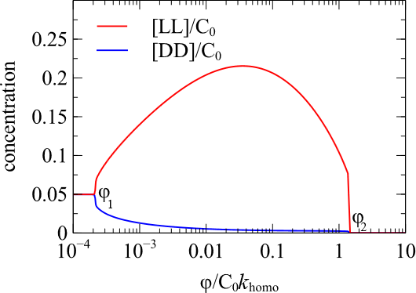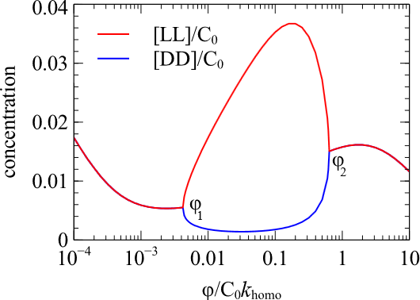
Figure 2. Concentration of homochiral dipeptides vs flow rate of a) ketoacid (left, constructive mechanism); b) amino acid (right, destructive mechanism)
- Deduce the value of φ, at which the maximum chiral asymmetry is observed.
- Explain the concentration behaviour of [LL] and [DD] when:
- φ < φ₁;
- φ₁ < φ < φ₂;
- φ > φ₂.

Problem 11. Fluorescence, phosphorescence and quenching
Molecules can exist in different electronic spin states known as singlet and triplet states. A singlet state has all electron spins paired (total spin, S = 0), while a triplet state has two unpaired electrons with parallel spins (S = 1). Transitions between these states govern important luminescence processes such as fluorescence (singlet → singlet) and phosphorescence (triplet → singlet). Understanding the decay kinetics of these excited states is essential for interpreting emission lifetimes, nonradiative losses, and designing efficient photonic materials.
When a molecule absorbs a photon (hv), an electron is promoted to a higher energy level, called an excited state (S₁). This process is called excitation (Exc. with rate I_{abs}). From this excited state (S₁), the molecule can lose energy in different ways. It can undergo internal conversion (IC with rate constant k_{IC}), where energy is lost non-radiatively as heat through changes in vibrational states. Alternatively, it can return to the ground state (S₀) by emitting a photon (hv); this process is called fluorescence (Fluo. with rate constant k_{F}). The excited singlet state (S₁) can also convert to an excited triplet state (T₁) through intersystem crossing (ISC with rate constant k_{ISC}). The triplet state has a longer lifetime, and the molecule may return to the ground state (S₀) by emitting a photon (hv), known as phosphorescence (Phos. with rate constant k_{P}), or by losing energy as heat through non-radiative decay (Non.rad. with rate constant k_{N}). If a quencher is present, it can accept the excitation energy, causing the molecule to return to its ground singlet state (S₀) without emitting light.
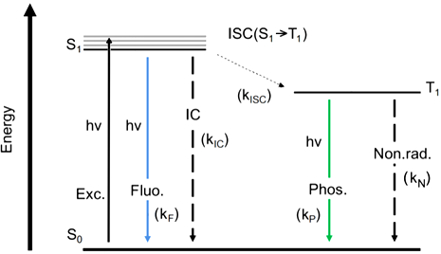
- Choose the correct option: “For electron excitation, the wavelength of the absorbed photon must be …”:
- higher than that of the fluorescence wavelength
- equal to that of the fluorescence wavelength
- lower than that of the fluorescence wavelength
Internal Conversion (IC) is usually more common than Intersystem Crossing (ISC) because it is the spin allowed process (singlet → singlet).
- Choose the correct option: “To increase k_{ISC} the energy gap between S₁ and T₁ states should be …”:
- higher
- lower
To predict light emission (e.g., fluorescence) quantum yield, it is necessary to know the decay mechanism of the excited singlet state:
Absorption: S + hv → S* r_{abs} = I_{abs}
Fluorescence: S* → S + hv r_{F} = k_{F}[S*]
Internal conversion: S* → S r_{IC} = k_{IC}[S*]
Intersystem crossing: S* → T* r_{ISC} = k_{ISC}[S*]
- Find the order of [S*] and the observed rate constant (k_{obs}) for the rate of decay of the excited singlet state, and the emission lifetime (τ₀) after the incident light is turned off. Note: Emission lifetime (τ₀) is the time required to reduce [S*] by e (≈ 2.72) times.
Fluorescence quantum yield (φ₀) is the fraction of the excited singlet state molecules that emit a photon (fluoresce).
- Derive φ₀ as a function of the rate constants (k_{F}, k_{IC}, and k_{ISC}).
To control fluorescence efficiency in devices (e.g., LEDs, sensors), quenching is very helpful. Fluorescence quenching is the promotion of non-radiative decay of the excited state. In a collision quenching, an excited fluorophore collides with a quencher, and due to the energy loss, there is no light emission:
S* + Q → S + Q r_{Q} = k_{Q}[S*][Q]
- Derive the fluorescence quantum yield (φ) as a function of the quencher concentration.
- In the Stern–Volmer equation, the relationship between φ₀/φ and [Q] is linear. Derive this relationship.
In one experiment, quenching of tryptophan fluorescence in a solution by dissolved O₂ gas was monitored by measuring emission lifetimes at 348 nm in aqueous solutions.
[O₂] / M | 0 | 2.3 × 10⁻² | 5.5 × 10⁻² | 8 × 10⁻² | 10.8 × 10⁻²
τ₀ / s | 2.6 × 10⁻⁹ | 1.5 × 10⁻⁹ | 0.92 × 10⁻⁹ | 0.71 × 10⁻⁹ | 0.57 × 10⁻⁹
- Determine the quenching rate constant (k_{Q}) for this process.
- Calculate the concentration of O₂ at which half of the excited tryptophan molecules are quenched.

Phosphorescence can also be influenced by singlet state quenchers. There are several approaches to reducing the likelihood of collisions between quencher and phosphorescent molecules. One effective method is to increase the rigidity of the molecule. This rigidity also reduces non-radiative decay by limiting additional vibrational modes and suppressing vibrational relaxation pathways.
Phosphorescence molecule DA1 was heated at 120 ℃ with PFMA and the product obtained suppressed the non-radiative decay (k_{N}) of the triplet state.
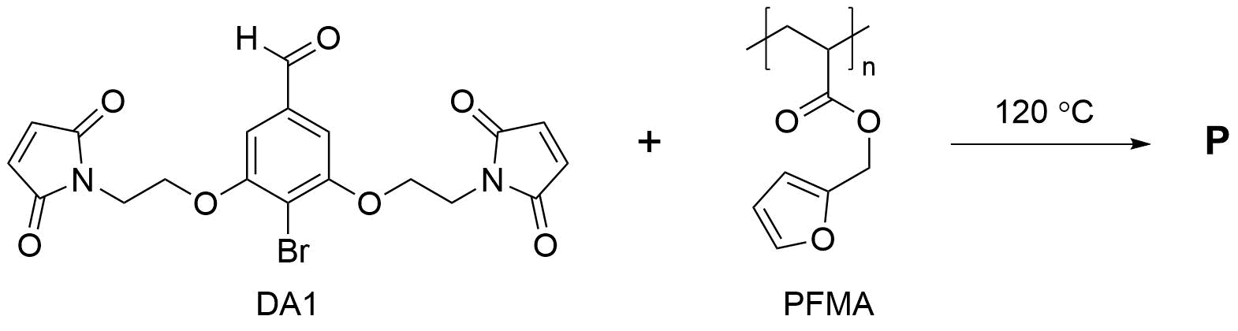
- Draw the structure of P, which is an adduct of the following [4+2] cycloaddition reaction:
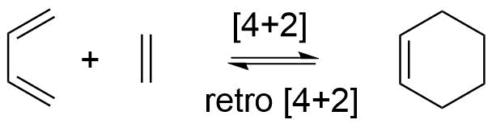
At low temperatures, the process of quenching is limited by an energy barrier:
$$∆E={E(T}_{1}^{Host})-{E(T}_{1}^{Guest})$$
Therefore, non-radiative decay can be suppressed by maintaining rigidity with a polymer matrix under this condition. At higher temperatures, vibrations increase and triplet energy transfer from the triplet state of the phosphorescent guest molecule to the polymer matrix (host) becomes possible:
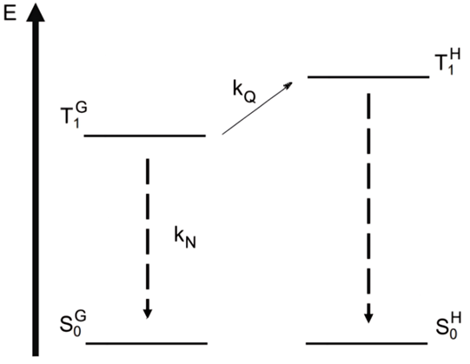

ln(k_{N}+k_{Q}) as a function of (1/Temperature) is given below:
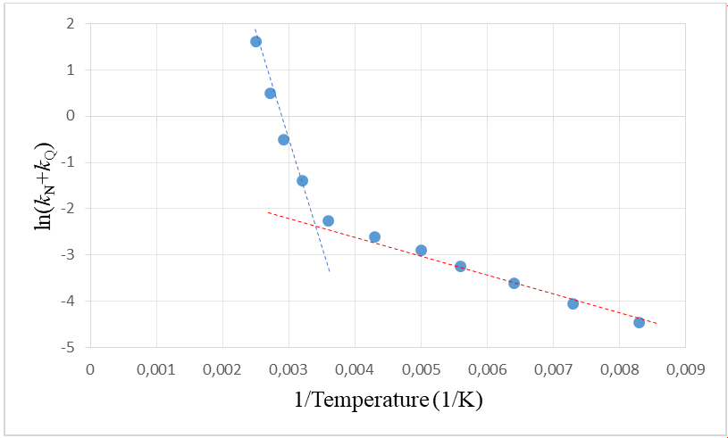
k_{N} – rate constant of the non-radiative decay of the triplet state.
k_{Q} – quenching of the triplet state by T–T energy transfer from the guest to the host molecule.
- Estimate the energy barrier ΔE of T–T energy transfer.

Problem 12. Photoacids
Photoacids form a unique class of molecules that undergo a major change in their pK_{a} values between their ground and excited states. The loss of a proton is facilitated by light excitation. This phenomenon is also called excited state proton transfer (ESPT).
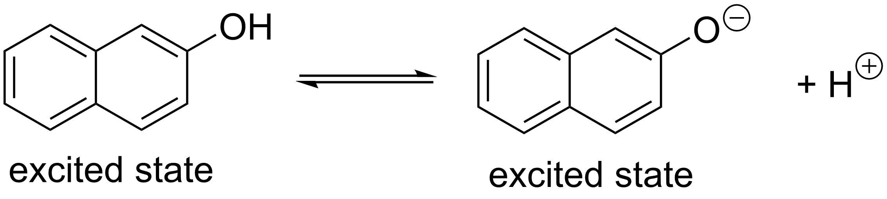
Once, Khoja Nasreddin, who was bored with his usual routine, decided to investigate 2-naphthol, a simple molecule that exhibits the ESPT phenomenon. He prepared five 2-naphthol solutions (each of 25 mL) in different pH media, using a 2.1 mM 2-naphthol solution (solution Z) and measured light absorbance (l = 1.0 cm) at 344 nm:
Solution | 1 | 2 | 3 | 4 | 5
Composition | 5 mL Z +  20 mL 0.02 M HCl | 5 mL Z +  20 mL 0.02 M NaOH | 5 mL Z +  20 mL NH₄Cl/NH₃ (3:1 buffer) | 5 mL Z +  20 mL NH₄Cl/NH₃ (2:1 buffer) | 5 mL Z +  20 mL NH₄Cl/NH₃ (1:1 buffer)
Absorbance | 0.219 | 0.440 | 0.256 | 0.273 | 0.300
- Find the final concentration (mol·L⁻¹) of 2-naphthol in solutions 1–5.
- Calculate the molar extinction coefficients, ε_{ArO⁻} and ε_{ArOH} at this wavelength.
- Plot the graph pH vs $\log{\frac{\left[ArO^{-}\right]}{\left[ArOH\right]}}$. Estimate the pK_{a} of 2-naphthol if pK_{b}(NH₃) = 4.75.

To check the ESPT phenomenon in 2-naphthol, Khoja Nasreddin recorded the fluorescence spectra of solutions 1 and 2:
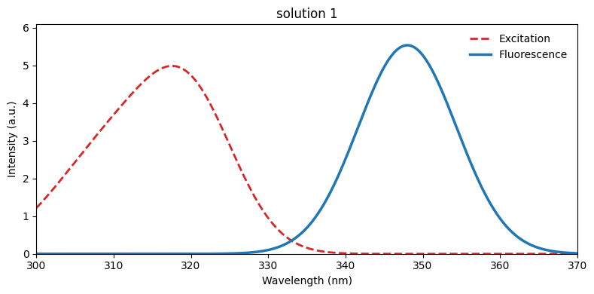
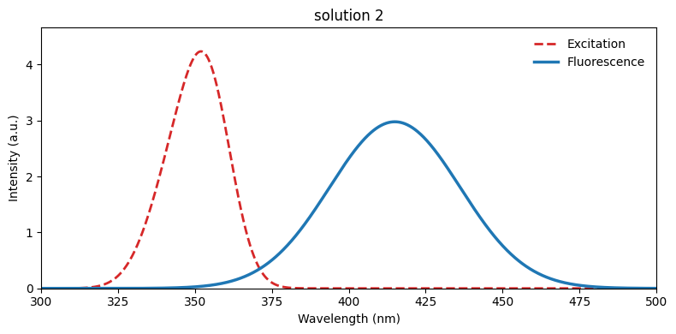

Dissociation of a photoacid in the ground and excited states can be described with a combined Förster and Jablonski diagram:
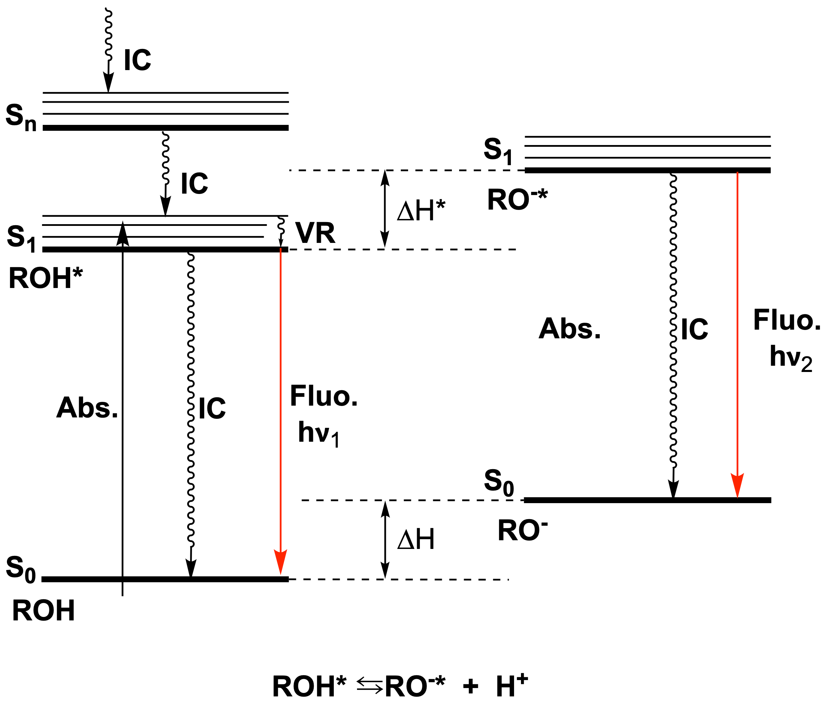
S₀, S₁, …, S_{n} stand for different electronic states, each of them having multiple vibrational levels. ΔH and ΔH* indicate changes in the enthalpy of dissociation in the ground and excited states, respectively. ν₁ and ν₂ are the frequencies of S₁ to S₀ (0–0) transitions for the photoacid and its deprotonated form, respectively. Internal conversion (IC) is a spin-allowed non-radiative transition from a higher to a lower electronic state and does not show any peak in the spectra. Fluorescence, on the other hand, is the emission of a photon during a transition between the states with the same spin quantum number (for example, S₁ → S₀). Vibrational relaxation (VR) is a non-radiative transition from a higher vibrational level to a lower one in the same electronic state of the molecule. VR is very fast, so it occurs right after light absorption and precedes other radiative processes like fluorescence.
In practice, transition wavelengths λ₁ and λ₂ are commonly used instead of corresponding frequencies.
- Assuming ΔH°* − ΔH° = ΔG°* − ΔG°, derive the relationship between ΔpK_{a}, λ₁, λ₂, and temperature. ΔpK_{a} = pK_{a} − pK_{a}*.
- Determine the pK_{a}* of the excited state (ES) of 2-naphthol at 298 K. Calculate [ArOH*]/[ArO^{−*}] at pH = 5.
Khoja Nasreddin wondered whether every acid decreases its pK_{a} in its excited state. After consulting with Prof. Beruni, Khoja found out that this might relate to Baird’s rules – the analogue of Hückel’s aromaticity rules for excited states. According to Baird’s rules, in the excited state, planar conjugated structures with 4n π-electrons are considered aromatic, and (4n + 2) π-electrons are considered antiaromatic. In this terminology, photoacidity is the result of Baird-antiaromatic molecules “relieving stress” through deprotonation. This is made possible because of the excess charge redistribution from the anionic centre to the ring.
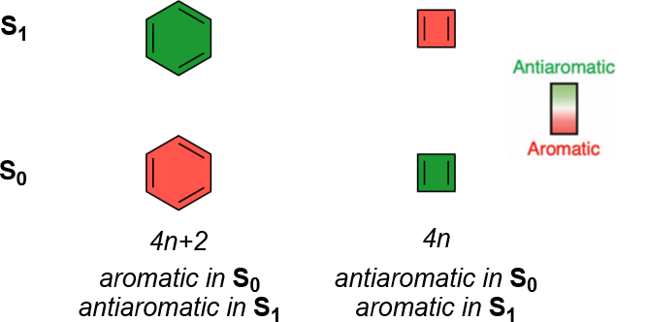
- Classify the structures below as Baird-aromatic and Baird-antiaromatic. Identify those that could be used as potential photoacids.
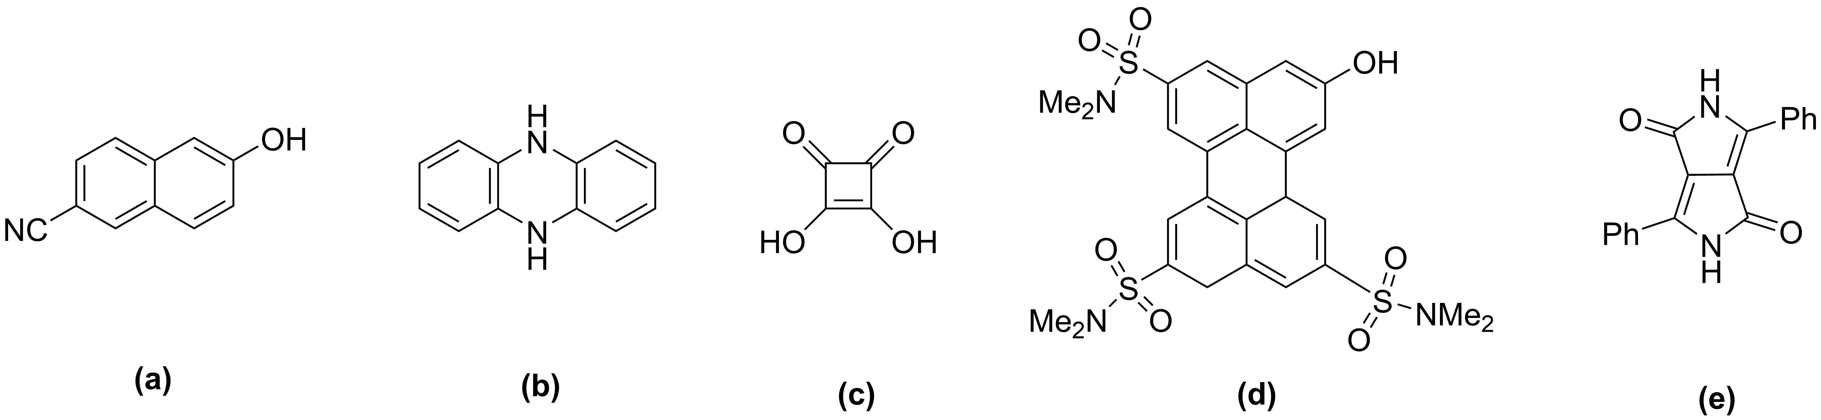
- 2-Naphtalenecarboxylic acid behaves the opposite way when treated with light – its ΔpK_{a} = pK_{a} − pK_{a}* < 0. Explain this phenomenon.
Merocyanines are an excellent example of photoacidity, turning into spiropyrans under light irradiation.
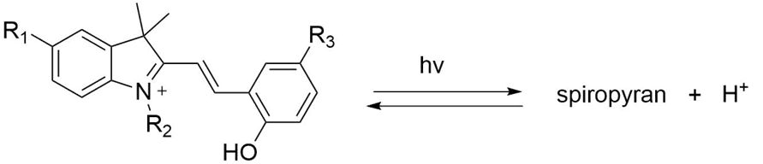
- Draw the structure of the spiropyran.

The synthesis of a merocyanine photoacid polymer is given below.
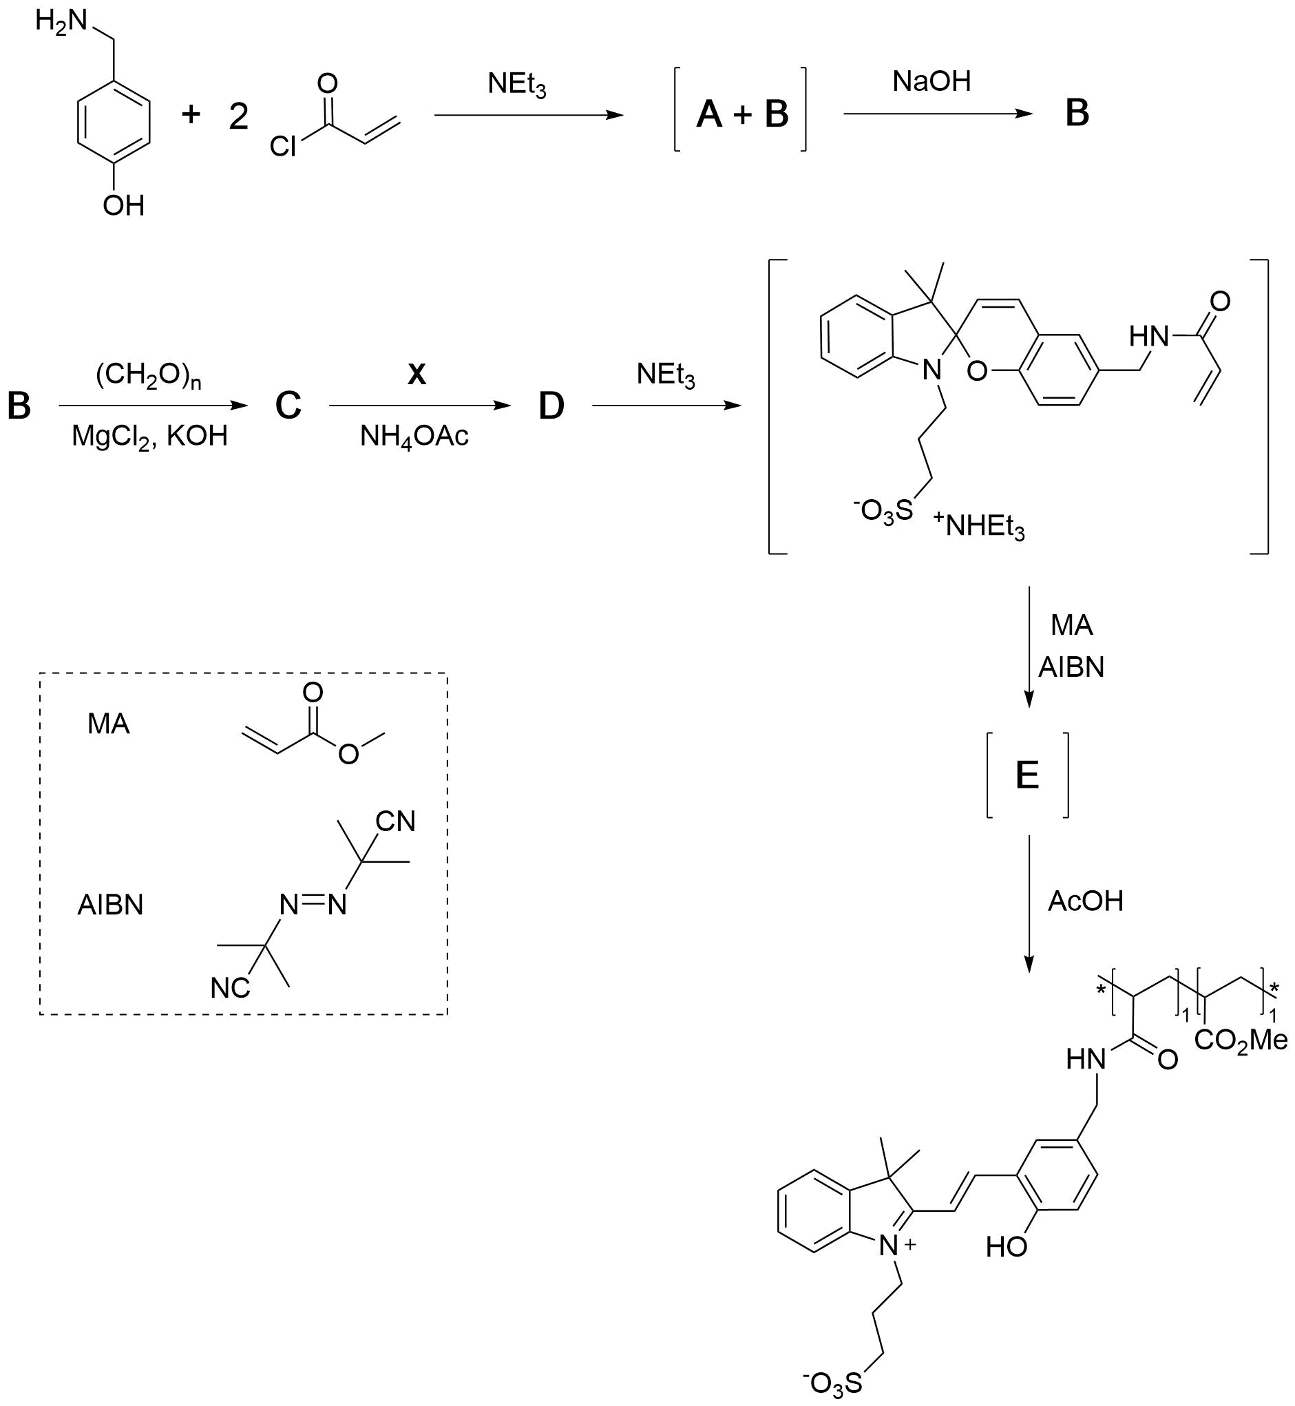
Hints:
- Hydrolysis of compound A results in compound B.
- C can be converted into C’ with a carboxylic acid moiety under NaClO₂.
- Draw the structures of A–F and X.

Problem 13. Interested in micelles?
Part 1. The forms of micelles
The form of a micelle can be described by the surfactant packing parameter, N_{S}. The packing parameter considers the volume and the length of the hydrophobic chain (V_{C} and L_{C}, respectively), and the equilibrium hydrophilic area per molecule at the aggregate interface, a₀:
$$N_{S}=\frac{V_{C}}{a_{0}×L_{C}}$$
The table below shows the relationships between the surfactant packing parameter and the form of the structure:
Form of micelle | Sphere | Cylinder | Bilayer
N_{S} | $$≤\frac{1}{3}$$ | $$\frac{1}{3}<…≤ \frac{1}{2}$$ | $$\frac{1}{2}<…≤ 1$$
- If there are cone (a), rectangular wedge (b) and cylinder-shaped (c) surfactants, match them with their appropriate form of structure. Prove your answers by calculation.
Note: It is only an assumption. In fact, surfactants themselves are more complicated structures and can have shapes which are different from these three below.
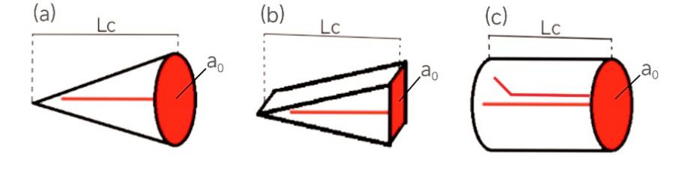
The phosphorus dendrons G₁ and G₂ act as charged surface active substances, although their structure differs from that of classical surfactants with a well-defined polar head and non-polar tail. They aggregate into clear structures and can be synthesised through the scheme below.
A₁ is a cyclic compound with a threefold symmetry axis, with mass fractions of P, N, and Cl of 26.73%, 12.09%, and 61.18%, respectively. With the addition of an appropriate number of equivalents of 4-hydroxybenzaldehyde to A₁, A₂ is produced as the main product with only one Cl atom.
Note: A threefold symmetry axis is an imaginary line through an object around which it can be rotated by 120° and appear unchanged. For example, it is present in the molecule of ammonia.
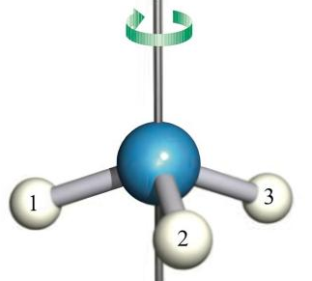
- Identify structures A₁–A₄, I₁–I₂, and G₁–G₂.
- Based on the synthesis pattern for G₁ and G₂ shown in the scheme, calculate how many cationic groups will be present in G₁₀ if the same reaction stages are repeated.
- By analysing the structure, determine which type of surfactants the G₁ and G₂ molecules resemble. Indicate the type of assembly they most likely show. Specify without calculations.
- Choose the main purpose of adding HCl at the end of the synthesis:
- to hydrolyse unreacted P–Cl bonds for purification;
- to make the fluorescent label brighter;
- to create a water-soluble, positively charged form that will show biological activity;
- to rigidify the dendron structure via cyclisation.
In contrast to G₁ and G₂, in a series of amphiphilic polystyrene (PS)-poly(propylene imine) dendrimer diblock copolymers Gen1–Gen3, varying in head group size, the form of micelles within a polar medium depends on the generation number.
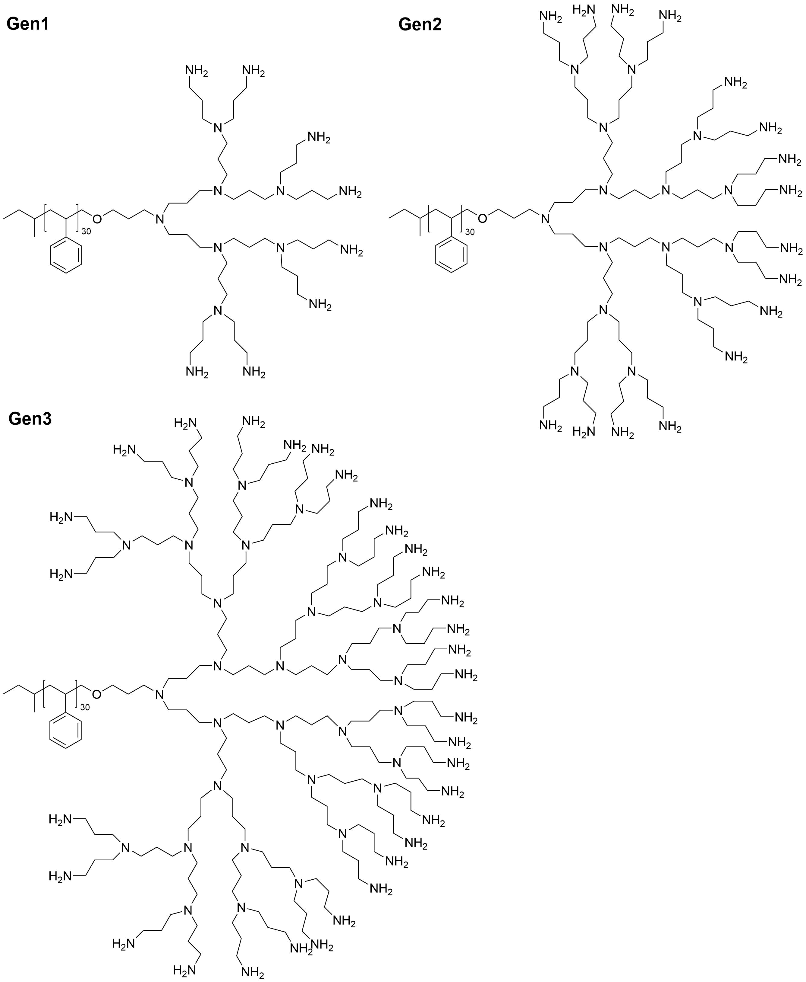
- Propose the forms of micelle in which Gen1, Gen2 and Gen3 are assembled in water, if each generation forms a distinct micelle type.

Part 2. Thermodynamics of micelle formation
The micelle formation process can be seen as an equilibrium between two states:
n[M](surfactant) ⇌ [M_{n}](micelle)
$$K_{n}=\frac{[M_{n}]}{[{M]}^{n}}=e^{\frac{-∆_{r}{G°}_{micelle}}{RT}}$$
where n is the aggregation number, i.e. the number of surfactant molecules (further referred to as monomers) in the micelle; [M], [M_{n}] reflect the concentrations of monomers and micelles, respectively.
- Derive the equation for the fraction of monomers present in micelles as a function of [M], n and K_{n}.
- Choose which of the suggested conditions would lead to the maximum number of monomers inside the micelles. Assume that in all conditions the equilibrium constants are the same and the monomer concentration is lower than 1 mol·dm⁻³.
- Low concentration of monomers with low aggregation number.
- Low concentration of monomers with high aggregation number.
- High concentration of monomers with low aggregation number.
- High concentration of monomers with high aggregation number.
At the critical point, the monomers inside the micelles start to account for the largest fraction. This is the so-called “critical micelle concentration (CMC)”, above which the monomers will mostly be within the micelles.
- Describe CMC as a function of aggregation number.
The dependence of specific conductivity on the concentration of surfactant monomers is shown in the picture below at temperatures T₁ and T₂:
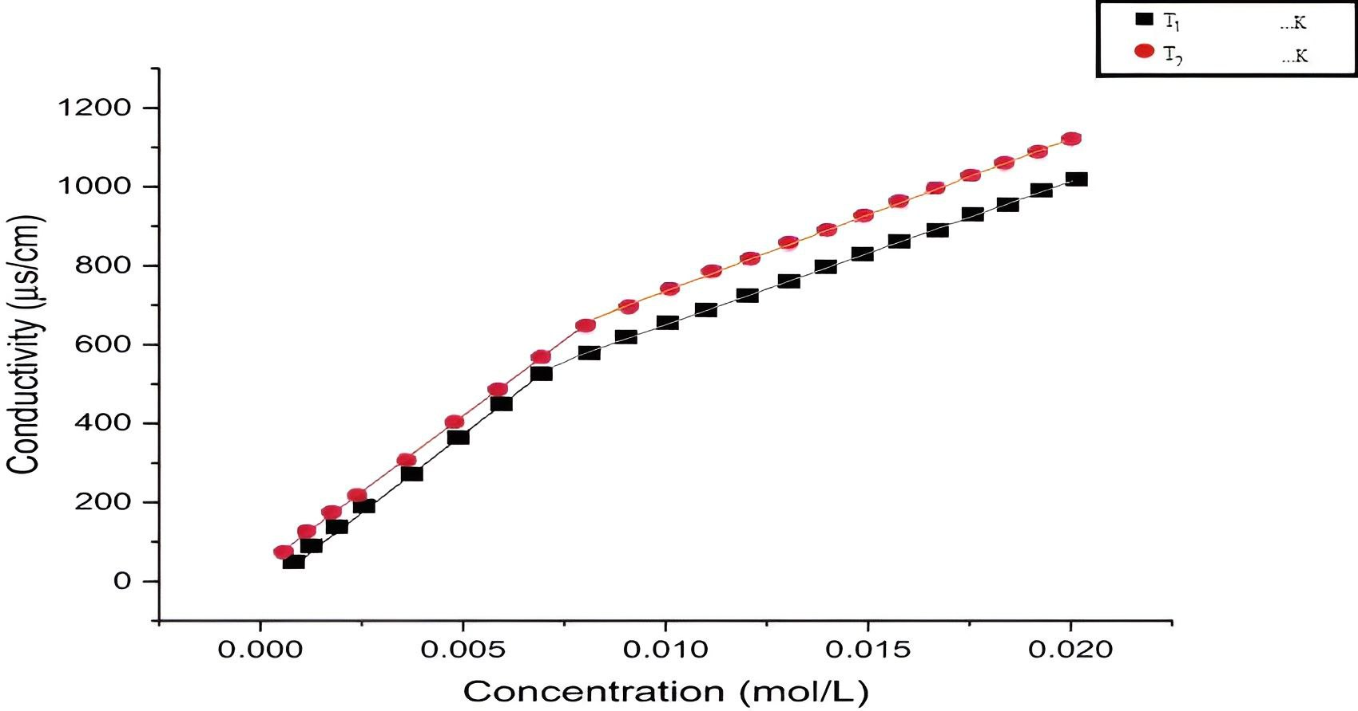
- Assuming that the Gibbs energy of micelle formation, Δ_{r}G°_{micelle}, and the aggregation number remain constant, compare T₁ and T₂.

Problem 14. The basics of Metal–Organic Frameworks
The 2025 Nobel Prize in Chemistry was awarded to Susumu Kitagawa, Richard Robson, and Omar M. Yaghi for the development of Metal–Organic Frameworks (MOFs). MOFs are crystalline, nanoporous coordination polymers formed by linking metal nodes (ions or metal oxide clusters – secondary building units) with multidentate organic ligands. Their hallmark is the combination of molecular-level tunability with permanent porosity, producing materials whose structural and functional diversity exceeds that of classical zeolites or activated carbons. MOFs are 3D frameworks with a complex structure. Thus, building models is useful to understand elementary units. For that, please follow the instructions from J. Chem. Educ. 2025, 102, 2, 877–881 (https://doi.org/10.1021/acs.jchemed.4c01312). Normal paper, glue, and tape can also be used as alternatives. One of the famous materials in this field is MOF-5 constructed from zinc oxo-clusters (Zn₄O) and 1,4-benzenedicarboxylate (BDC) ligands.
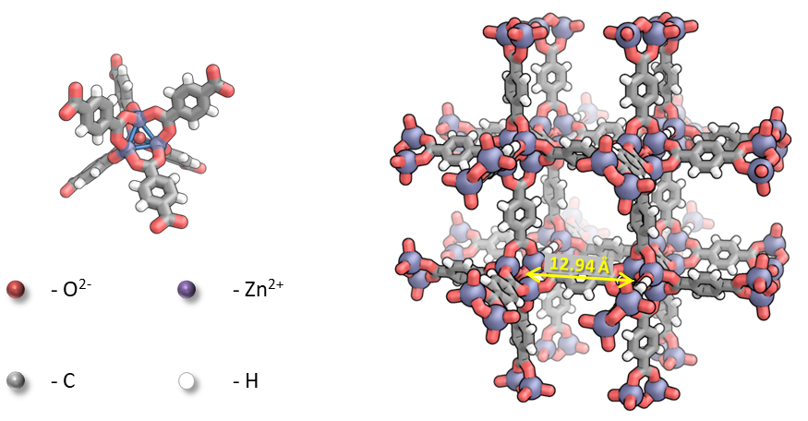
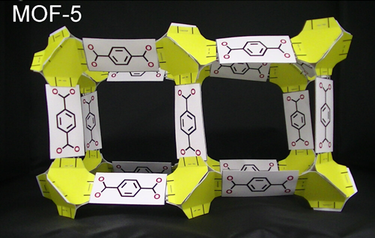
- From the figure above and/or constructed model, write down the empirical formula for the repeating unit.
The first synthesis of MOF-5 was carried out by mixing Zn(NO₃)₂, H₂BDC (benzene-1,4-dicarboxylic acid), and triethylamine in a N,N-dimethylformamide/chlorobenzene mixture. Small amounts of water were added to initiate oxo-anion formation. The crystals formed were filtered and activated (dried) in a vacuum oven.
- Write down the chemical equation of MOF-5 formation.
Elemental analysis of the crystals before activation showed elemental content (by mass):
C – 44.21%, H – 5.02%, N – 7.64%. In mass spectra of crystals during heating up to 350 ℃, four m/z signals were detected: 73, 77, 112, and 114. The relative intensity of the latter two signals was 3:1.
- Write down the empirical formula of the crystals before activation.
MOF-5 has a high surface area of 2900 m²·g⁻¹. The distance between oxygen atoms in the cluster centres was found to be 12.94 Å.
- Find the free volume (which is not occupied by framework atoms) and experimental surface area (m²) of one cubic cell. Account only for Van der Waals radii of atoms (r), which are as follows:
Element | Zn | H | C | O
r / Å | 1.5 | 1.2 | 1.7 | 1.5
- To be correct, there are two pores with diameters of 11.0 Å and 15.1 Å. Find the elementary unit cell parameter a.
- MOF-5 has been tested for hydrogen uptake. It was found that 10 g of the material can take up to 1 wt% of H₂ at 20 bar, 298 K. Assuming all the material is an ideal crystal, calculate excessive hydrogen uptake (how much excess hydrogen can be stored compared to pure hydrogen of the same volume without MOF-5 under the given conditions).
- Suggest the ligands which might change the cubic cell volume down to 69.3%. The distance between the 1- and 4-carbons of a benzene ring is 2.69 Å.

Problem 15. Microscopy in chemistry
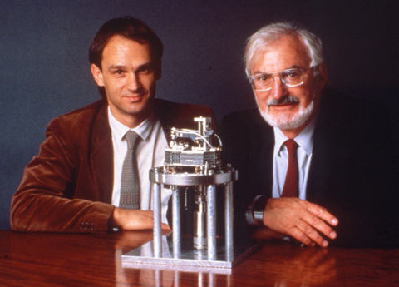
Scanning tunnelling microscopy (STM) is a microscopy method that lets us see individual atoms and molecules on the surface. It works by moving a sharp metal tip very close to the surface and applying a small voltage. In 1986, Binnig, Quate, and Gerber combined the principles of STM with a stylus profilometer to create Atomic Force Microscopy (AFM). While STM can only be used to image conductive samples, AFM does not require a current flow between the tip and the sample and can map a surface regardless of its conductivity.
Figure. 40 years ago, in 1986, Gerd Binnig and Heinrich Rohrer shared a Nobel Prize in Physics "for their design of the scanning tunneling microscope".
In 2012, an article was published reporting that British chemists from the University of Warwick, together with a group of scientists from IBM Research, had captured an AFM image of a hydrocarbon molecule called X (see the image below). This image was subsequently recognised as the smallest logo for the London 2012 Summer Olympics.
The synthesis of this hydrocarbon began with pyrene-4-carbaldehyde:
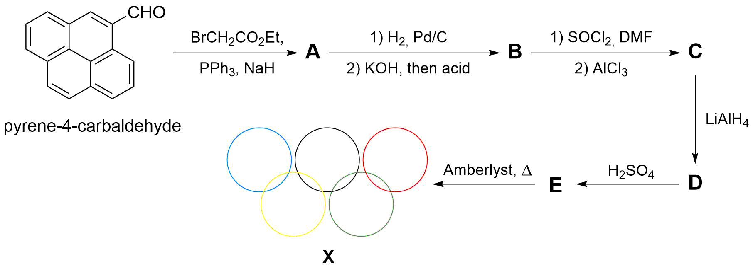
DMF – dimethylformamide, Amberlyst – protonic ion exchange resin. Initially obtained hydrocarbon molecule E easily isomerises to more symmetrical X under proton migration conditions.
- Draw the structures of A–E, X. Note: Molecule X possesses a twofold symmetry axis.
- Compound X was named as ...cene. Suggest its full name.

X-based units can be used as building blocks of 1D quantum magnet chains via the formation of stable radical centres:
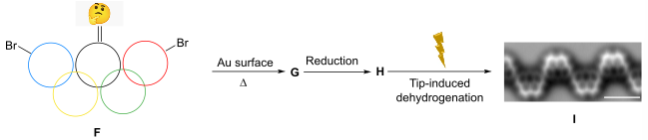
- Draw the structures of compounds F–I, based on the following information about compound F:
- A peak with m/z 411.89 was registered as the main peak in the mass spectrum;
- Only 4 types of protons exist in F;
- Compound F has a twofold symmetry axis.
The beauty of such systems is that for finite chains like these, the lowest spin excitation energy, Δ_{LEE}, is inversely proportional to L:
$$Δ_{LEE}≤J\frac{2π^{2}S^{2}}{L}$$
where J is an exchange coupling parameter between the nearest neighbours, S is a spin number, and L is the number of repeating units in the quantum chain. Therefore, for a considerably large L, we can design spin fluids with a very low excitation gap, which can be considered gapless.
- Calculate the value of L for which the quantum chain H becomes gapless at room temperature (T = 298 K), i.e. Δ_{LEE} becomes comparable with the average thermal energy k_{B}T. Use J = 38 meV and S = 1.
AFM can be used to study the transformation of individual molecules during complex transformations. AFM was performed for the products of the thermally induced isomerisation reaction of Q. It is known that compound S has a twofold symmetry axis, R and T contain only 5- and 6-membered fused rings.
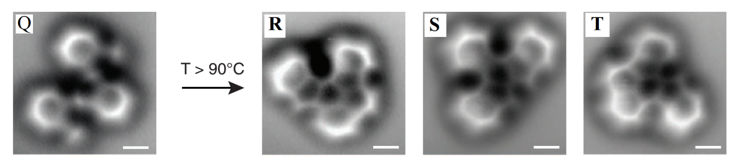
- Draw the structures of R–T.
The molecule Q itself is obtained from U according to the following scheme:
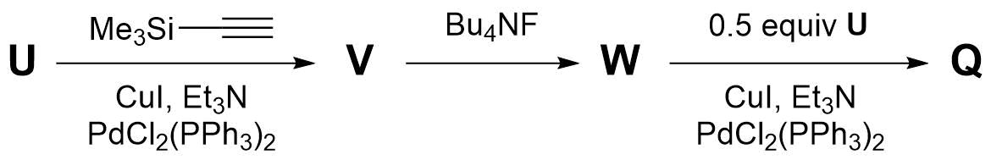
Additionally:
- In the mass spectrum, compound U has a molecular ion cluster of three peaks at
m/z 234, 236, and 238 in an intensity ratio of 1:2:1;
- U has 2 types of protons in the aromatic region.
- Based on the given AFM image and additional hints, draw the structures of Q and U–W.

Problem 16. Kinase inhibitors
Kinases are enzymes controlling many processes in living things, including cell growth. Kinase inhibition has become an important direction for anticancer drug development. Two synthetic approaches to the class of Lck-kinase inhibitors are discussed.
A synthesis of promising inhibitor F is shown below:
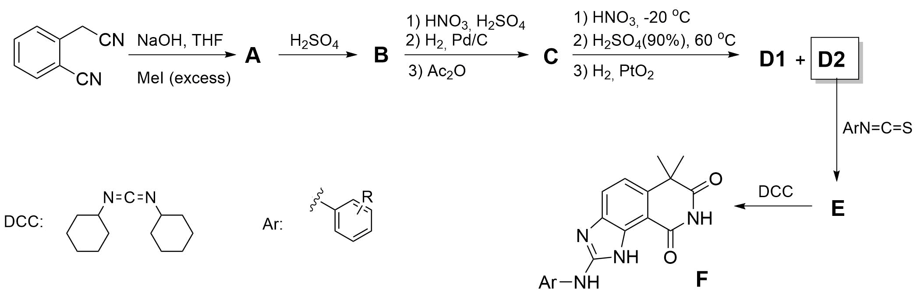
- Draw the structures of compounds A–E. Note: Nitrogen content (by mass) in B is 7.40%. D2 is separated from D1, and only D2 is transformed into F.
Another promising molecule M was synthesised. Compound M has a similar core to F but has a molecular mass lower than that of F by 42 atomic mass units. The first two steps were a benzylic oxidation by N-chlorosuccinimide and oxidation by NaClO₂. The transformation of H to I1 and I2 proceeds in the same manner as B to C, but with the formation of a mixture of isomers. The transformation of I2 to the desired product J2 is analogous to the conversion of C to D2. However, the order of the hydrolysis and reduction steps is switched. This change in order results in the formation of additional side products K1 and K2.
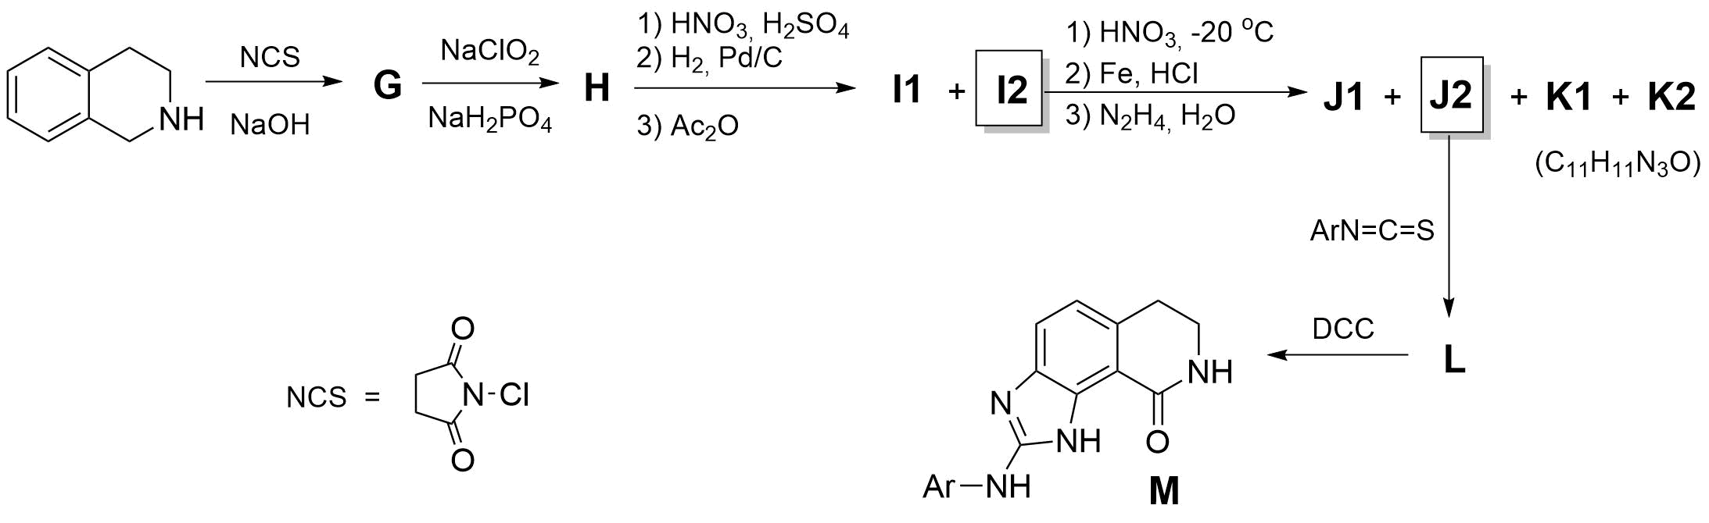
- Draw the structures of G–L, including all isomers shown on the scheme.
- Explain why only one product is formed during the reaction of B.
In the reaction of I2 to J2, changing the order of the reduction and hydrolysis steps compared to the previous scheme was crucial to obtain J. The compound W could have formed following the sequence with the original order.
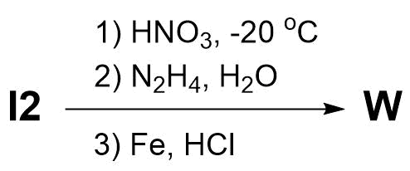
- Draw the structure of product W (21.52% nitrogen by mass).
The molecules obtained showed high potency with a specific kinase enzyme. However, two transformations of F were also carried out to give molecules X and Y, the molecular formulae of which differ only by two hydrogen atoms.
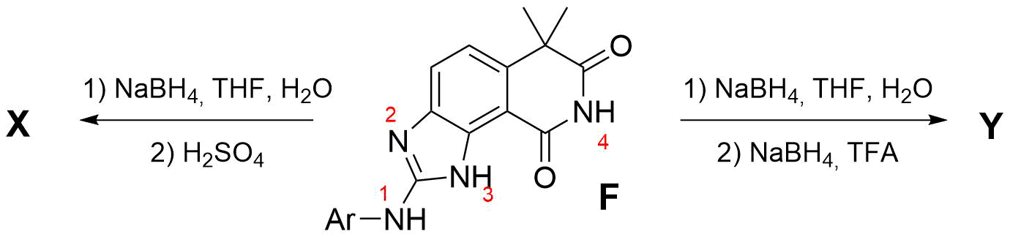
- Draw the structures of X and Y. Y is a homologous compound to M. Note: The number of sp²-hybridised carbons in X increased by one.
The synthesised molecules were evaluated by IC₅₀ (half-maximum inhibitory concentration), which is a quantitative measure that indicates how much of a particular drug is needed to inhibit in vitro a given biological process or biological component by 50%. The results are shown in the table below:
Compound | R | IC₅₀ / μM |  | Compound | R | IC₅₀ / μM
F | 2,6-Cl₂ | 0.46 |  | F (N3-Me) | 2,6-Cl₂ | 1.1
F | 2-Cl | >40 |  | F (N1-Me) | 2,6-Cl₂ | 12.5
F | 2,4-Cl₂ | >40 |  | F (N4-Me) | 2,6-Cl₂ | 9.6
F | 4-Cl | >40 |  | Y | 2,6-Cl₂ | 1.1
F | 2,6-Me₂ | 0.46 |  | M | 2,6-Cl₂ | 0.38
F | 2,6-Et₂ | >40 |  | X | 2,6-Cl₂ | 0.026

- Explain the effect of the substituents in the aromatic ring if the coordination of F in a simplified enzyme pocket looks as follows:
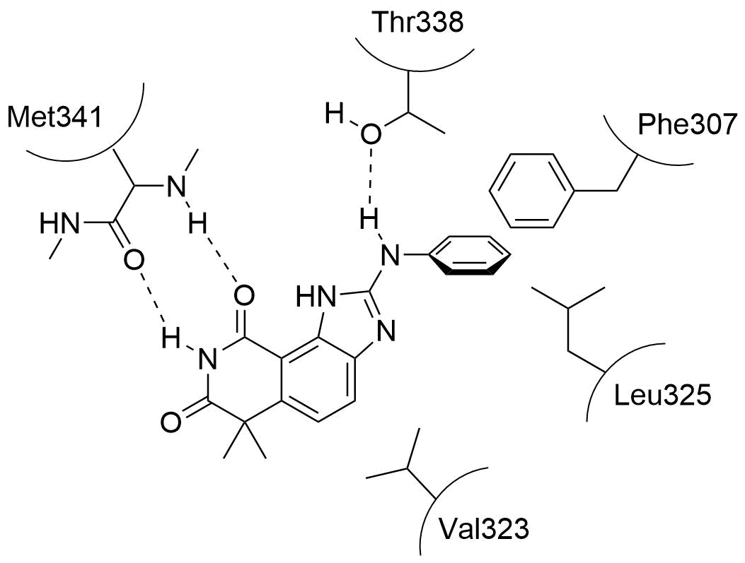

Problem 17. Carbohydrate chemistry
Carbohydrates are an essential class of chemicals that fuel living organisms with energy. The common saccharide glucose (Glc) exists in either a linear or cyclic form. It can undergo some common chemical transformations:
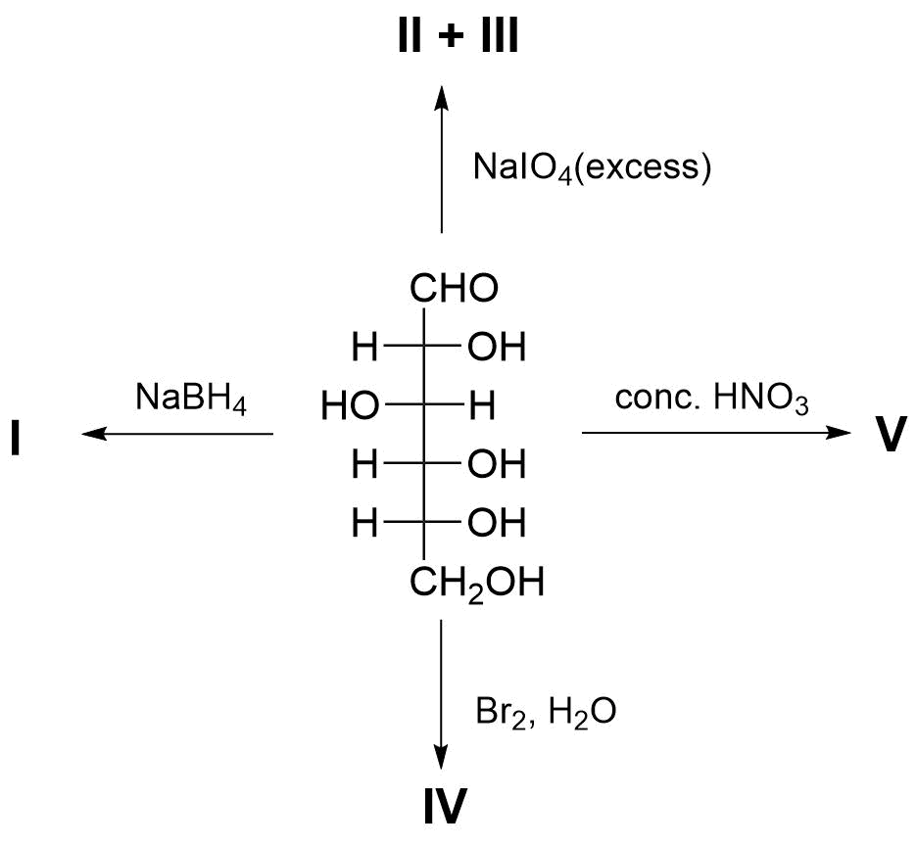
- Identify products I–V.
In its cyclic form, glucose contains five hydroxy groups. Regioselective transformation of each position represents a challenge for chemists. Some synthetic transformations of α-glucopyranose are shown below:
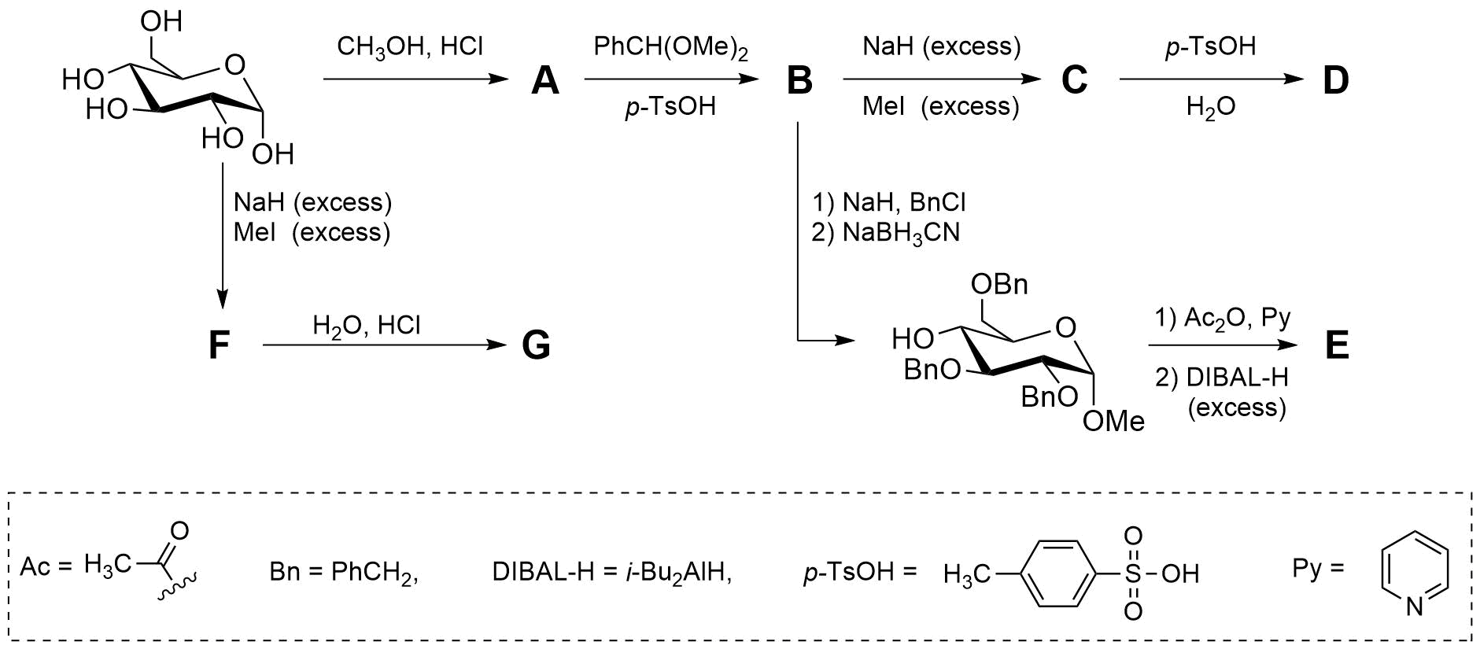
It is known that A, G, and D contain the same functional groups; G and D differ in formulae by CH₂; B and C contain three six-membered rings in their structures; there are two different CH₃-groups in E.
- Draw the structures of A–G.
However, these transformations cannot differentiate neighbouring 2,3- and 3,4-diols, since in both cases the hydroxy groups are in a trans-configuration and occupy equatorial positions. A brilliant solution to this challenge was found by using the common tetrahydropyranyl protecting group in chiral form:
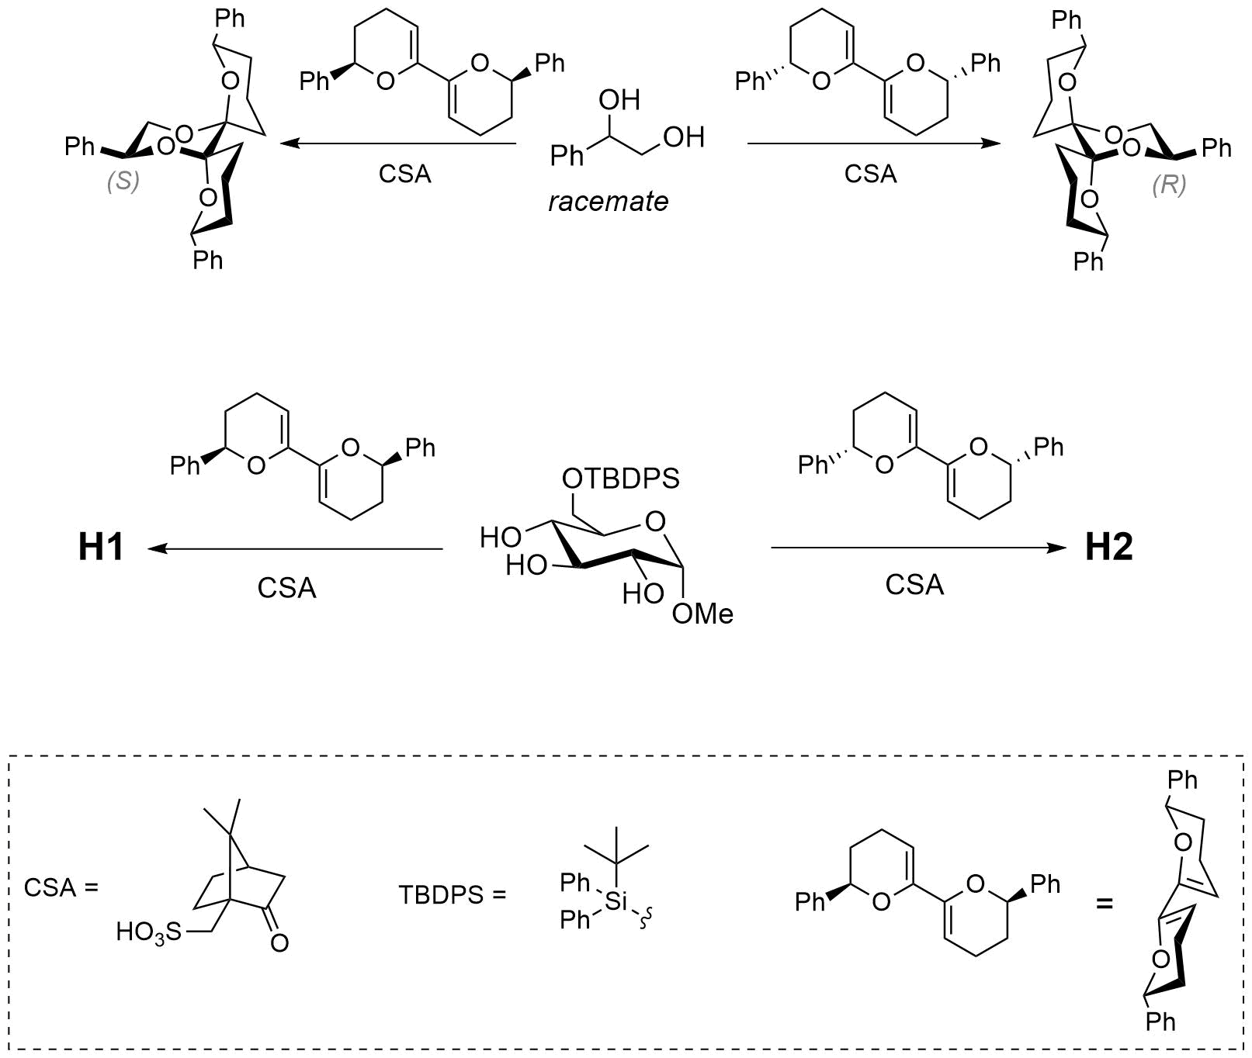
- Based on the given example and considering that sterically bulky groups tend to occupy equatorial positions in chair conformations, draw the structures of H1 and H2. For drawing H1 you need to redraw the glucopyranose ring so that the 2,3-hydroxy groups are on the right side of the drawing. Use a chair conformation of the protecting group.
A very interesting example of a glucopyranose transformation led to adamantane-type cyclic compound K stepwise blocking three hydroxyl groups with only one protecting group:
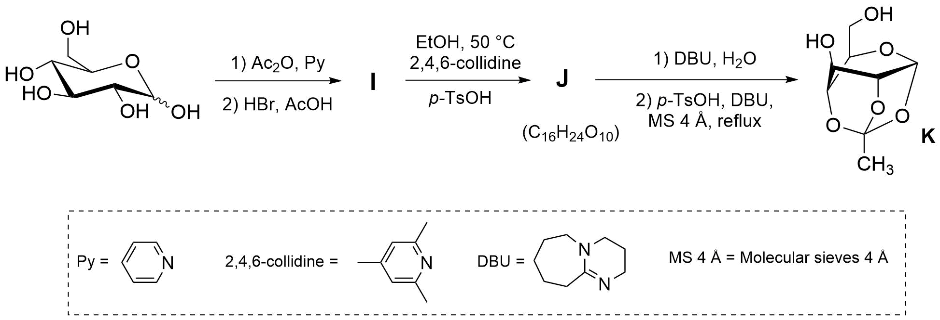
- Draw the structures of I and J.
Another class of reagents that can form cyclic acetal-type structures is boronic acids. Their chemistry was successfully used to synthesise the trisaccharide “Gal-Gal-Glc” derivative:
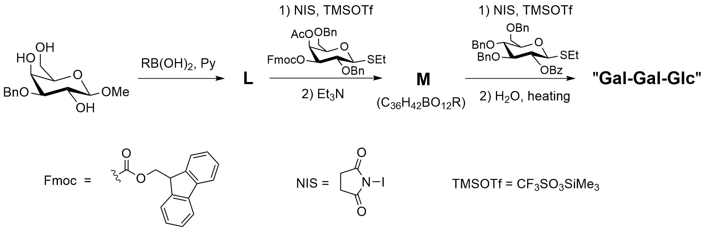
- Draw the structures of L, M, and trisaccharide “Gal-Gal-Glc”. Do not specify the configuration of the newly formed anomeric centres.

Problem 18. Inositol
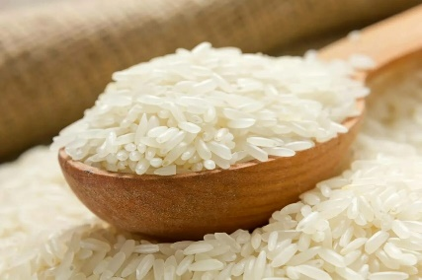
In Uzbekistan, people greatly appreciate foods that are both rich in flavour and highly nutritious. Rice is one of the main ingredients in Uzbek cuisine and forms the basis of many traditional dishes, such as pilaf and mastava.
Cooked rice consists of approximately 29% carbohydrates by mass, primarily in the form of α-amylose, which is a polysaccharide composed of α-d-glucose units linked through α(1→4) glycosidic bonds. Carbohydrates are the primary source of energy for humans and occur in nature in a wide variety of forms.
- a) Draw the most stable chair conformation of D-glucose.
b) Draw the structure of the repeating unit of α-amylose in Haworth projection.
- Calculate the number of repeating units that one amylose chain with a molar mass of 243 kDa contains.
Glucose, which is a well-known representative of carbohydrates in living organisms, can be converted into many different biomolecules.
One such compound is myo-inositol (one of the isomers of inositol), whose biosynthesis pathway is shown below:
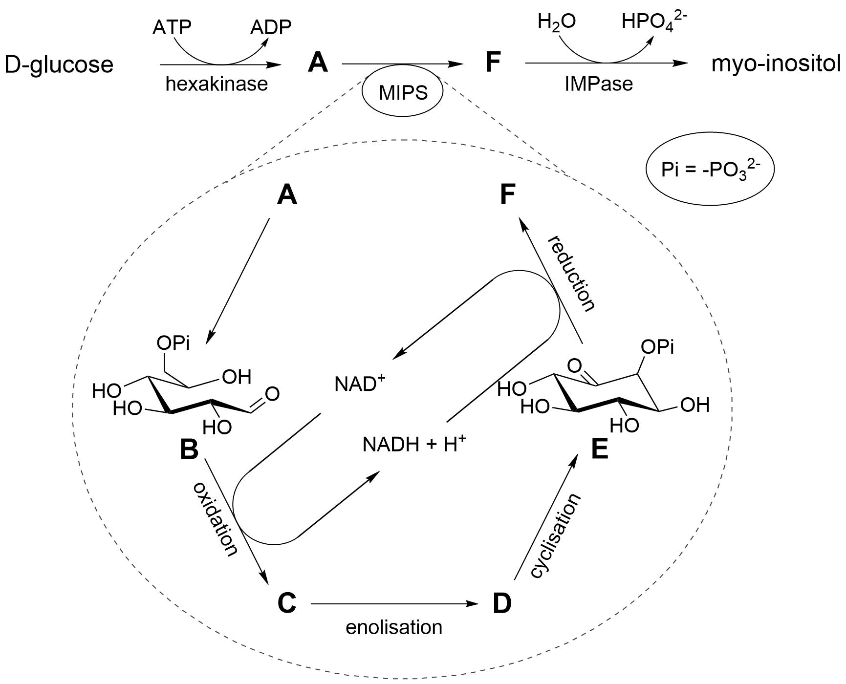
ATP = Adenosine Triphosphate, ADP = Adenosine Diphosphate
- Draw one of the chair conformations for each of A–F and myo-inositol.
Note: Molecules of F and myo-inositol contain a plane of symmetry.
- Draw the structures of all inositol stereoisomers and indicate which of them are chiral.
Many plants synthesise myo-inositol hexaphosphate (IP6) as a phosphorus storage compound. Studies of various plant species have revealed that the biosynthesis of IP6 proceeds through stepwise phosphorylation of compound F.
Below is the biosynthesis pathway of IP6 that occurs in Dictyostelium:
- Determine the maximum number of myo-inositol diphosphate (G) isomers that can be formed in this pathway. Draw their structures and indicate which of them are chiral/achiral.
- Determine the maximum theoretically possible number of isomers of myo-inositol diphosphate (that do not necessarily originate from F). Draw their structures and indicate which of them are chiral/achiral.
Phosphorylation of myo-inositol occurs according to the following rule: the most distant accessible hydroxyl group relative to the previously phosphorylated hydroxyl group is phosphorylated.

- Draw the structures of G–J and IP6. Indicate the structures that contain a plane of symmetry.

Problem 19. Carbohydrates as chiral pools
Asymmetric synthesis has attracted significant attention in recent years thanks to advances in asymmetric catalysis. However, using chiral auxiliary groups in the substrate structure remains an efficient approach for chiral total synthesis, especially when chiral substrates are readily available. Different monosaccharides are handy starting materials in natural product synthesis. For example, in 1985, the first synthesis of compound X from l-sorbose derivative A was published.
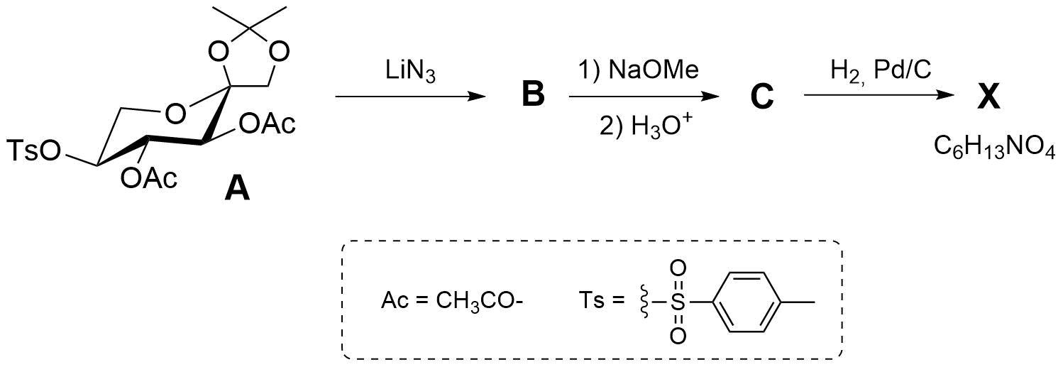
- Draw the structures of compounds B, C, and the most stable diastereomer of X, including stereochemistry. Note: X contains a five-membered heterocycle, and the formation of X proceeds through an imine intermediate.
Thromboxane B2 (TxB2) is a stable, inactive breakdown product of Thromboxane A2 (TxA2), a potent molecule that causes blood platelets to clump (aggregate) and blood vessels to constrict. It was synthesised from d-glucose. The following scheme shows the synthesis of key intermediate I.
- Draw the structures of D–I with stereochemistry. Note: Acetal/ketal formation involves a primary alcohol when it is available.
- Determine in what order the following combinations of reagents (Z₁–Z₄) must be used to obtain Thromboxane B₂ from I:
Z₁ – 1) PCC (PyH⁺‧CrO₃Cl⁻), 2) Ph₃P⁺CH⁻C(O)(CH₂)₄CH₃;
Z₂ – 1) BzCl, 2) BuN₄⁺F⁻;
Z₃ – 1) NaBH₄, 2) K₂CO₃, 3) HCl;
Z₄ – 1) (i-Bu)₂AlH, 2) Ph₃P⁺CH⁻(CH₂)₃COOH, 3) CH₂N₂.
Using compound D, it is possible to synthesise other chiral molecules. (+)-Actinobolin, isolated from the culture fluid of Streptomycin, has a broad antibacterial spectrum and moderate antitumor activity. In the synthesis of (+)-Actinobolin, overall, five new stereocentres were formed using the chiral auxiliary.
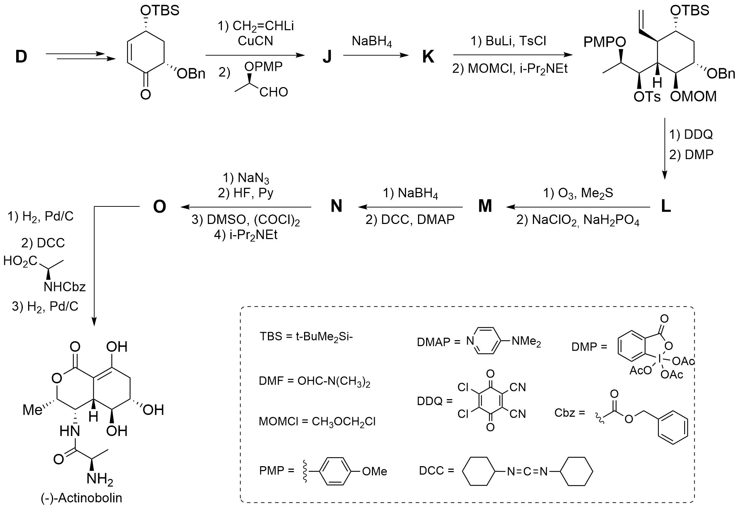
- Draw the structures of J–O, including stereochemistry.

Swainsonine, an indolizidine alkaloid, was synthesised using benzyl-α-d-mannopyranoside. It is a potent inhibitor of Golgi apparatus alpha-mannosidase II, an immunomodulator, and a potential chemotherapeutic agent. The synthesis of (–)-Swainsonine is given below.
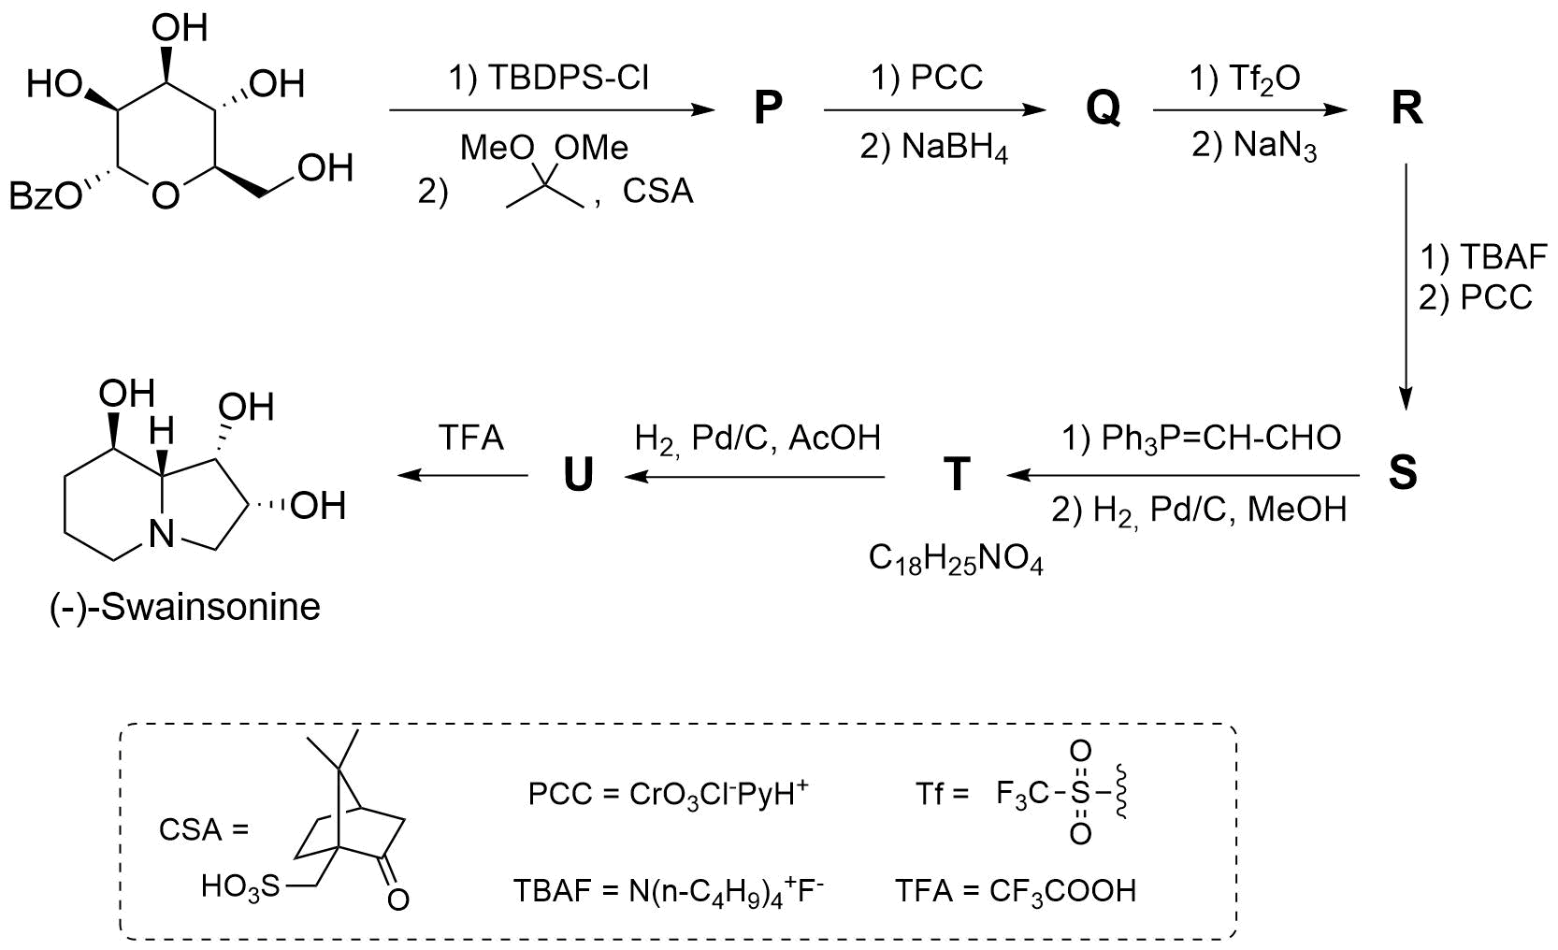
Hint: P and Q are epimers.
- Determine the configurations of all stereocentres in (–)-Swainsonine and the starting material.
- Draw the structures of P–U, including stereochemistry.
- Indicate which stereocentres are preserved and which centres are newly formed.

Problem 20. Pacman, Hangman, Cageman
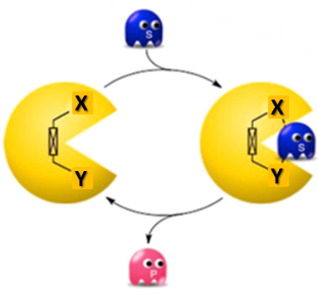
Scientists often look for analogies in culture to explain their discoveries. One example of such a comparison was the arcade video game Pacman, popular in the 1980s and 1990s, where the main task of the yellow ball (Pacman) is to eat all the dots on the map.
The same task must be performed by the molecules Pacman 1 and Pacman 2, which must “eat” small molecules such as CO₂, N₂, or O₂, catalysing their transformations. Pacman molecules are two catalytically active structural fragments connected by a linker at a certain angle. Inspiration for such molecules comes from the active site of natural cytochrome P450, which contains a porphyrin macrocycle. Porphyrin is a macrocycle with an 18 π-electron Hückel aromatic system, which can coordinate metal ions in the middle. The synthesis of Pacman 1 is shown below:
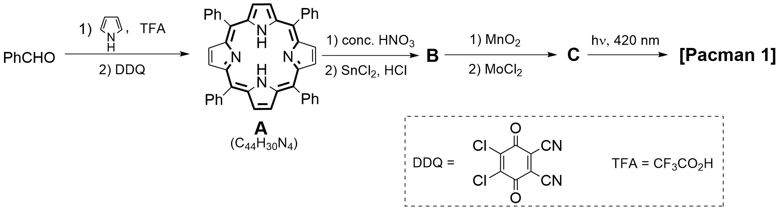
Note: C–H bonds of porphyrin rings are not involved in chemical transformations in this problem.
- Draw the structures of compounds B and С, if it is known that neither of these compounds, nor Pacman 1–2 contain oxygen. The nitrogen content (by mass) in compounds B and C is 11.12% and 9.70%, respectively.
Unfortunately, it was impossible to isolate Pacman 1. As a result, another approach to the stable Pacman 2 with two different porphyrin rings was suggested. In the mass spectrum of this compound, the molecular ion peak was at m/z 1535.04.
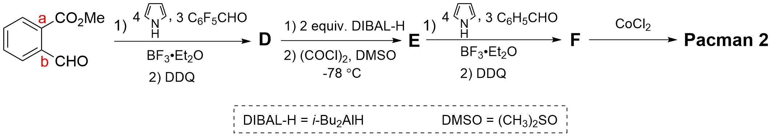
- Draw the structures of compounds D–F, and Pacman 1–2. All molecules can be drawn flat. Pacman 2 contains 7.678% of the metal by weight.
- Calculate the distance between the two metals in Pacman 2, if the distance from carbon atoms a and b to the corresponding metals is the same and equals 4.7 Å. Assume that porphyrin and benzene rings are coplanar, and bond lengths and angles on benzene rings are ideal. Note: The carbon–carbon bond distance in the benzene ring is 1.39 Å.
- Draw a 3D schematic structure of Pacman 2 binding an oxygen molecule. Note: You can simplify the macrocycle as a quadrilateral, only drawing out the linker and metals.
Another version of a binuclear complex was synthesised as follows to yield Pacman 3:
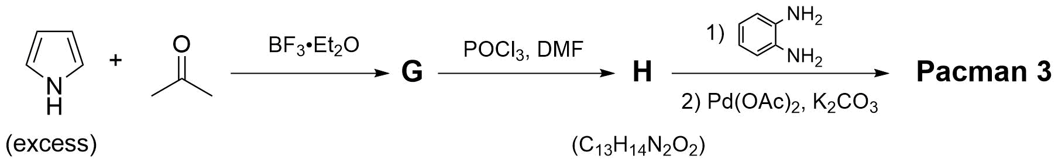
- Draw the structures of compounds G–H and Pacman 3.
In the catalytic centre of cytochrome c oxidase, heme (a porphyrin-based iron-containing compound which forms the non-protein part of haemoglobin) and Cu atoms are placed in close proximity to ease the reduction of oxygen to water. Scientists attempted to mimic this pocket by synthesising a salt called Hangman, bearing two different metal ions:
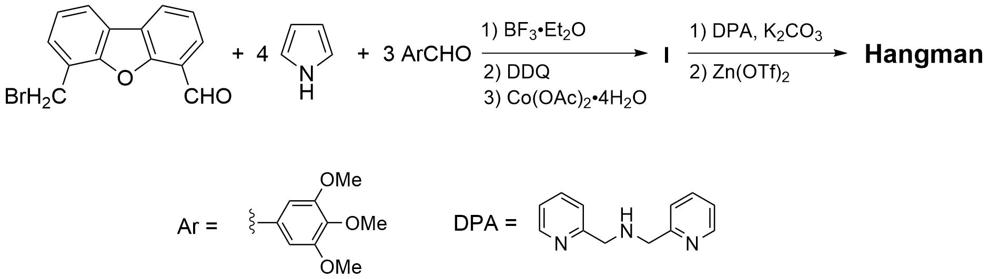
- Draw the structures of I and Hangman.
Another type of binuclear porphyrin complexes can be called Cageman. One of the examples of a Cageman synthesis is shown below. In the mass spectrum of the compound K, a series of signals at m/z 2667.0, 1261.0, 792.3, 558.0, and 417.4 were detected.
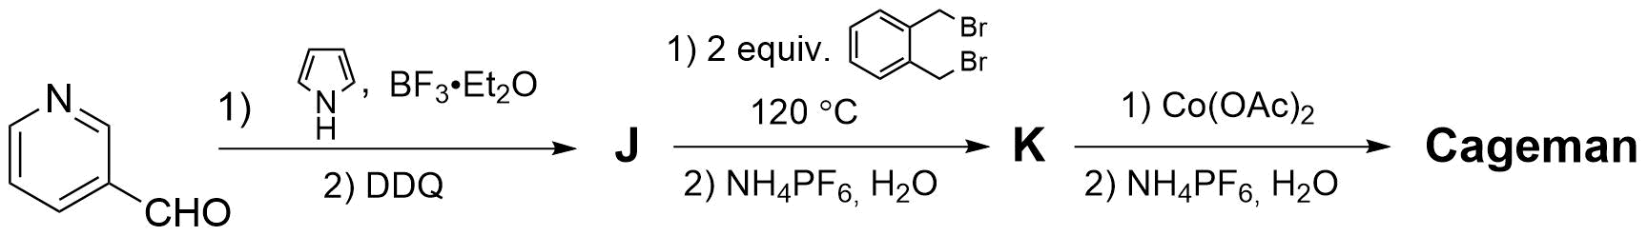
- Calculate the molecular weight of Cageman (use integer values of atomic mass).

Problem 21. Catalyst C
Compound A is a trihydrate which contains a metal of the 5th period, M, with a mass fraction of 39.09%. A 2.00 g sample of A was dissolved in ethanol. This ethanolic solution of A was added to an ethanolic solution of 7.96 g B. Compound B is a well-known ligand, which is composed of three elements: C, H, and P. It has 11.81% of P by mass and a threefold symmetry axis. The resulting mixture was refluxed for about two hours, yielding 6.18 g of a dark red compound C with 88% yield.
Note: A threefold symmetry axis is an imaginary line through an object around which it can be rotated by 120° and appear unchanged. For example, a threefold symmetry axis is present in the molecule of ammonia:
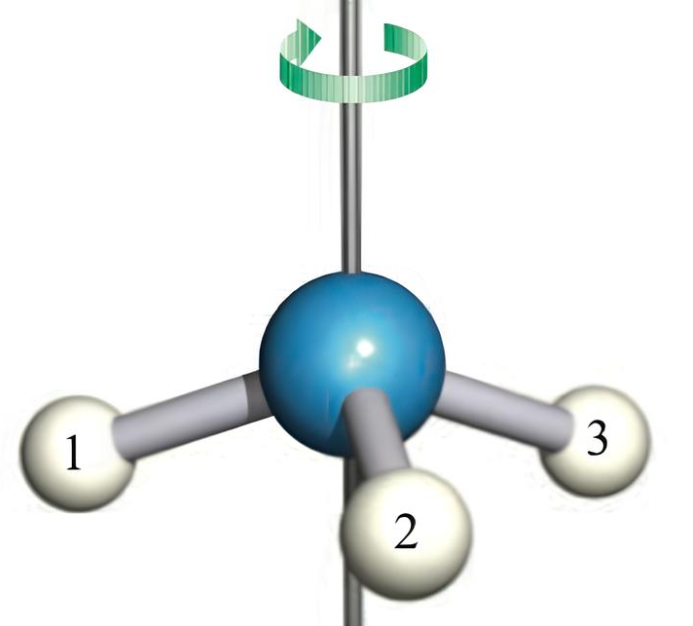

- Identify the formulae of A–C and M, if each coefficient in the synthesis reaction is lower than 5.
- Write the equation for the synthesis of compound C.
Compound C is a well-known catalyst in the hydrogenation of alkenes:
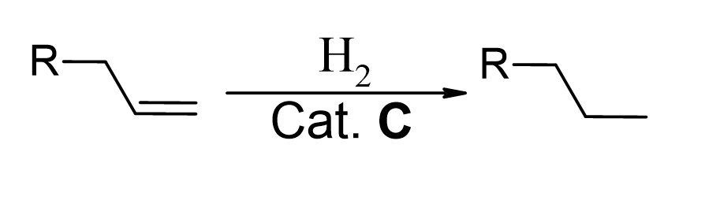
One example of the product (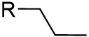) has a maximum of one plane of symmetry.
Note: A plane of symmetry is an imaginary plane that divides an object into two mirror-image halves. For example, the molecule of water has two planes of symmetry:
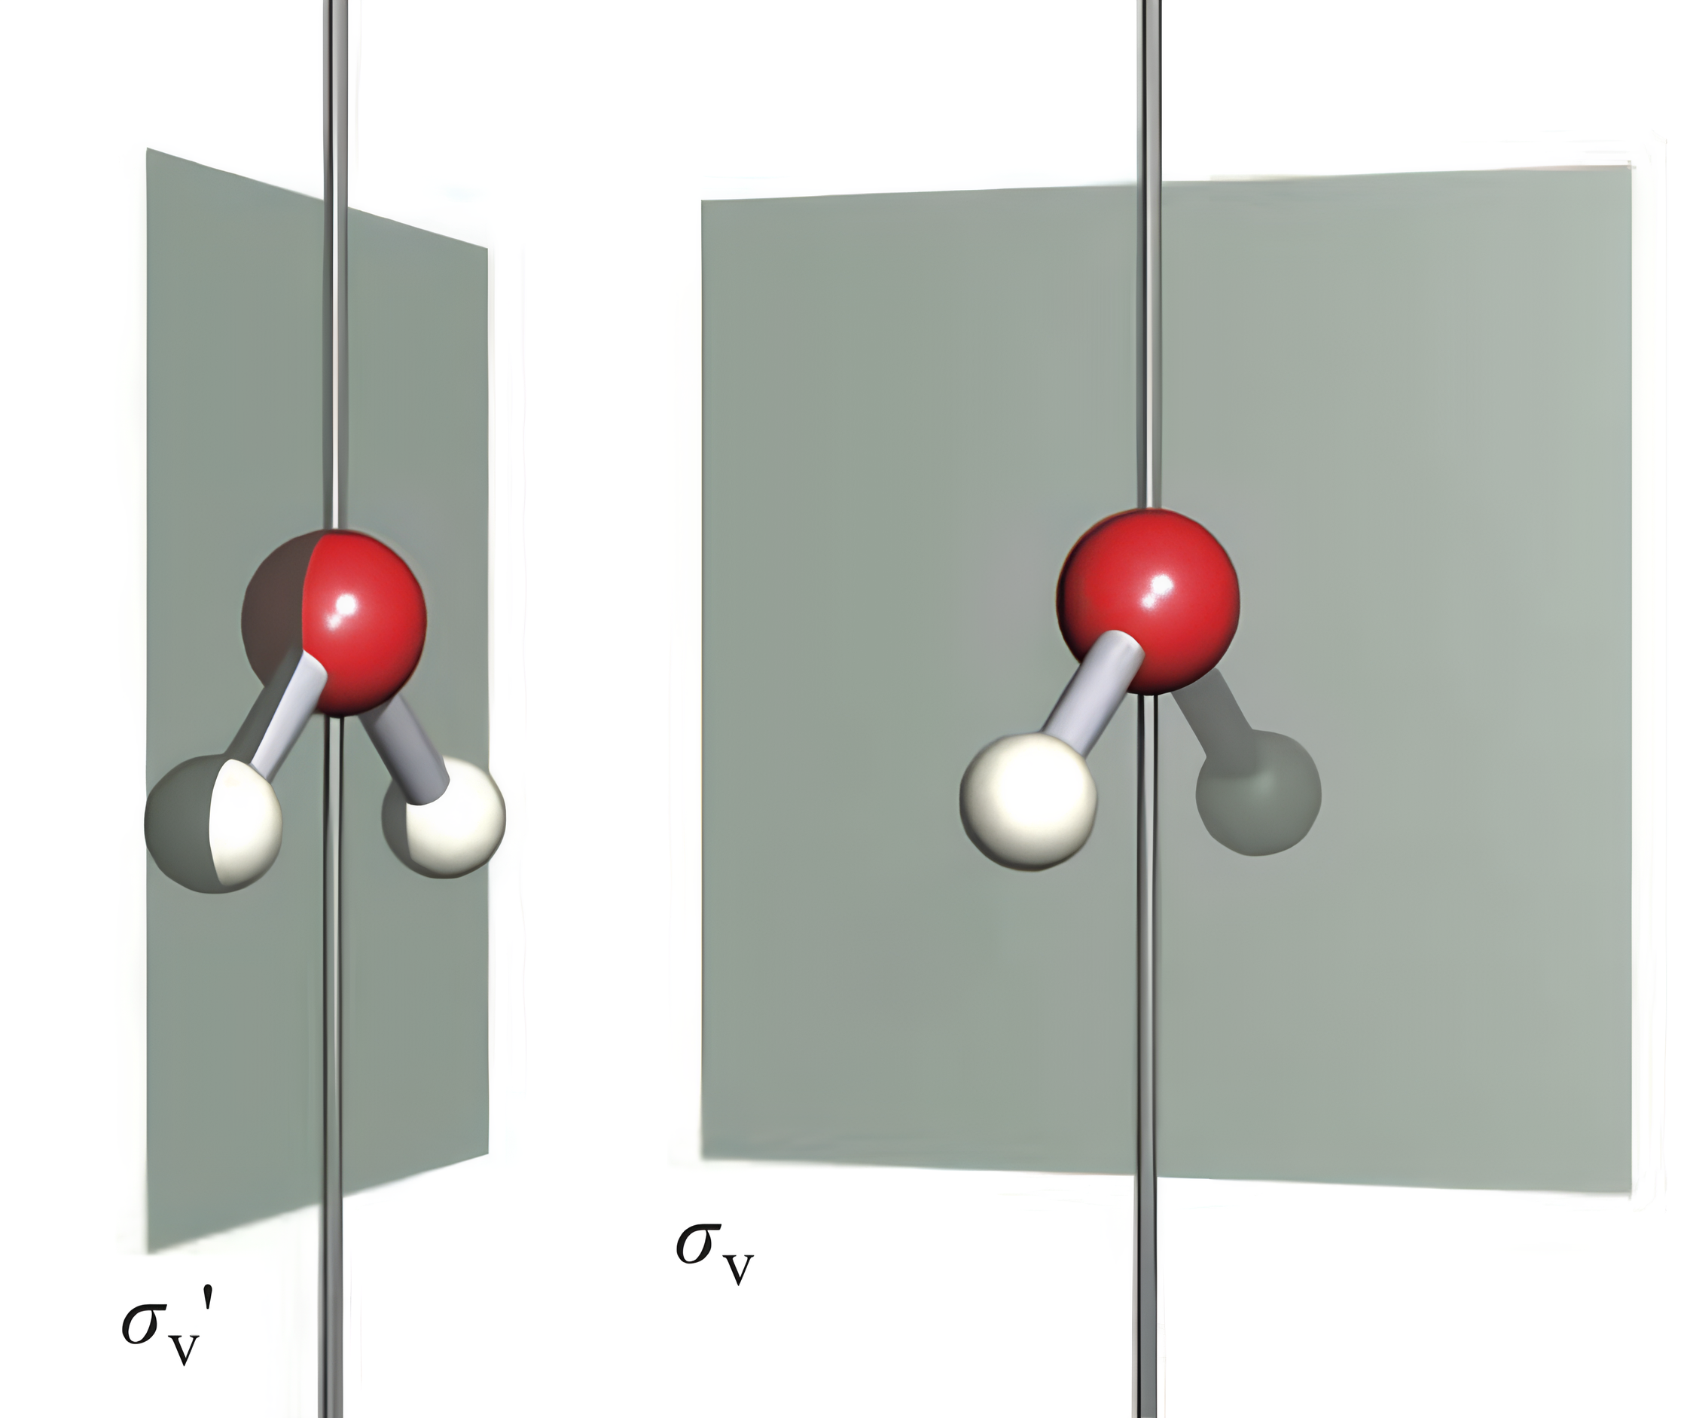
The mass spectrum of this product is shown below. The three peaks at m/z 41, 91, and 119 are noticeably more intense than the others, and two of them correspond to fragments containing different aromatic rings.
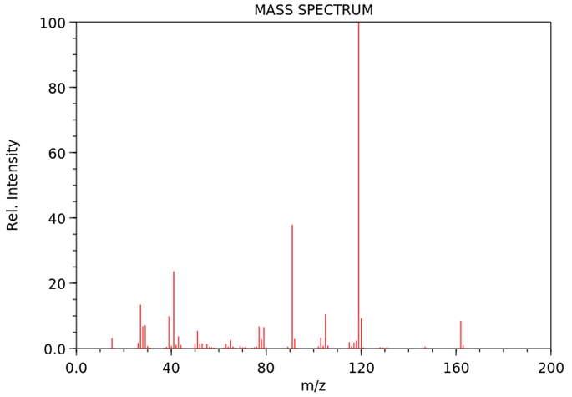
- Draw the structures of the cations that correspond to those 3 peaks.
- Draw the structure of the product.
- Find the intensity ratio [M]⁺:[M+1]⁺ in the mass spectrum if the relative atomic mass of carbon is 12.011 and it consists of two stable isotopes.
In the catalytic system, a minor product D can be formed according to the reaction:
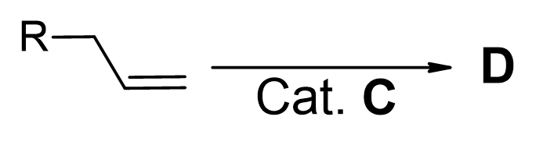
- Draw the structure of D (you do not have to show stereochemistry).
After several catalytic cycles, the catalyst loses its activity due to the decomposition of C, forming products F and M. F is produced by the oxidation of B with atmospheric O₂.
- Identify the formulae of F and write the equation for the oxidation reaction of B.

Catalyst C can catalyse other types of reactions. For example, C was used to catalyse a [2+2+2] cycloaddition reaction in the synthesis of Heilonine:
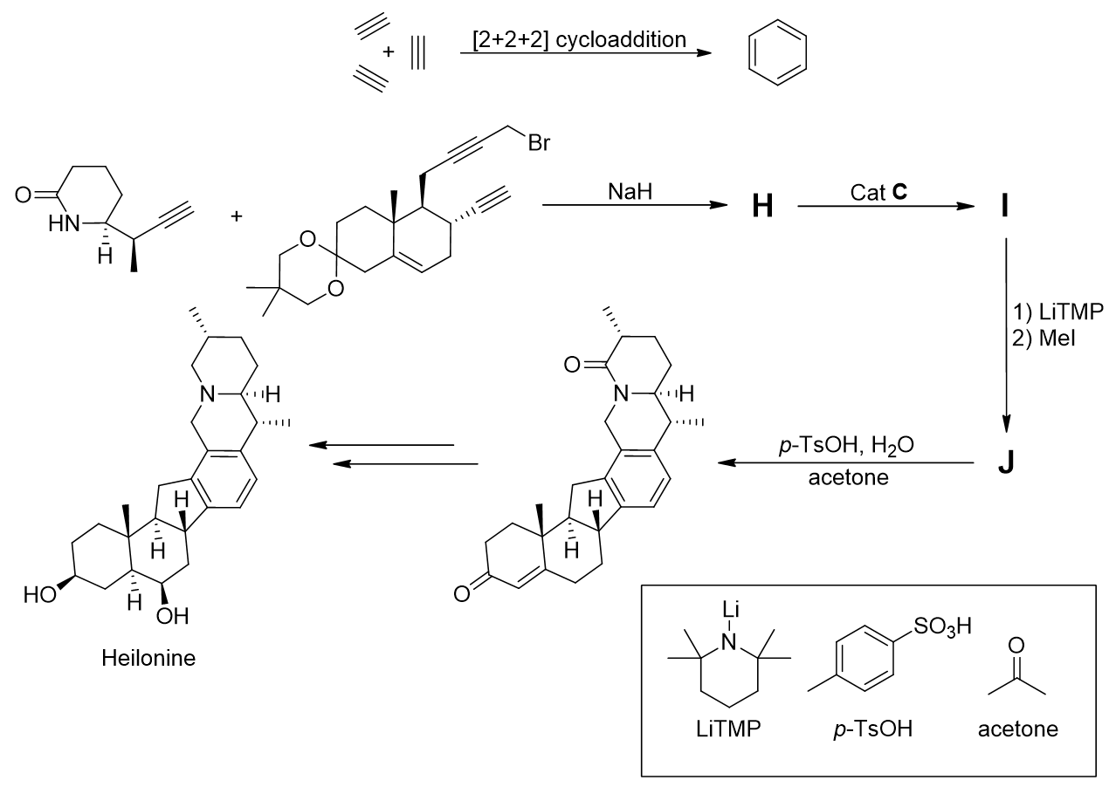
- Draw the structures of H–J (you do not have to show stereochemistry).

Problem 22. Transition metals in organometallic catalysis
Organometallic chemistry studies various aspects of compounds containing a metal–carbon bond. Many transition metal (TM) complexes are of fundamental importance due to their role in industrial catalytic processes.
There are many parameters that should be considered when choosing a TM complex for a particular process, and four significant ones are:
- oxidation state (OS) of the metal in the complex,
- coordination number (CN),
- total number of valence electrons (VE), which is the sum of the number of the metal
d-electrons and electrons provided by the ligands coordinated to the metal,
- overall net charge of the species that contains the transition metal.
- For complexes 1–4, calculate OS, CN, and VE.
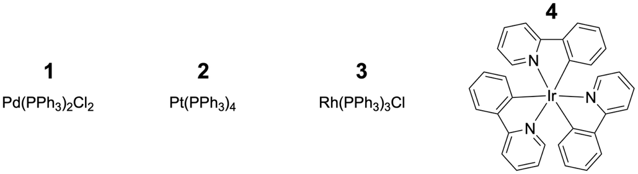
These parameters can change every time a TM complex undergoes different transformations. Below you can find the most important elementary steps that are essential for most TM-catalysed reactions.
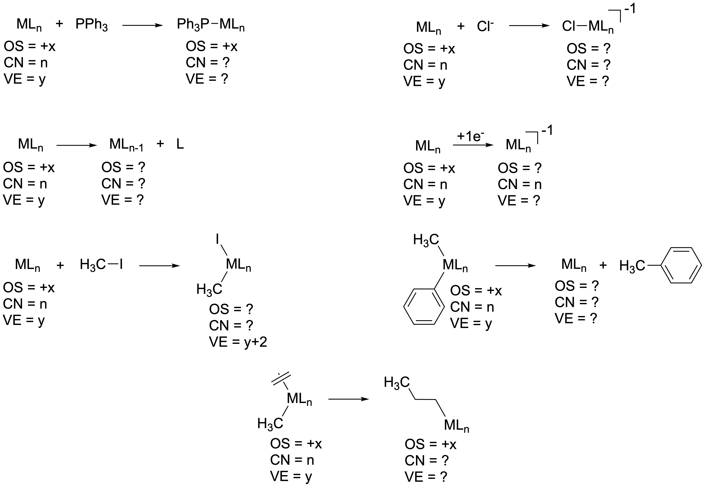
- Find the unknown parameters (OS, CN, VE) for complexes that underwent the mentioned elementary steps.
The parameters mentioned are quite important for catalytic transformations mediated by TM complexes. As such, 3 can catalyse the transformation of n-octene to n-octane via the catalytic cycle depicted below. S is a solvent that can coordinate to a metal with a pair of electrons.
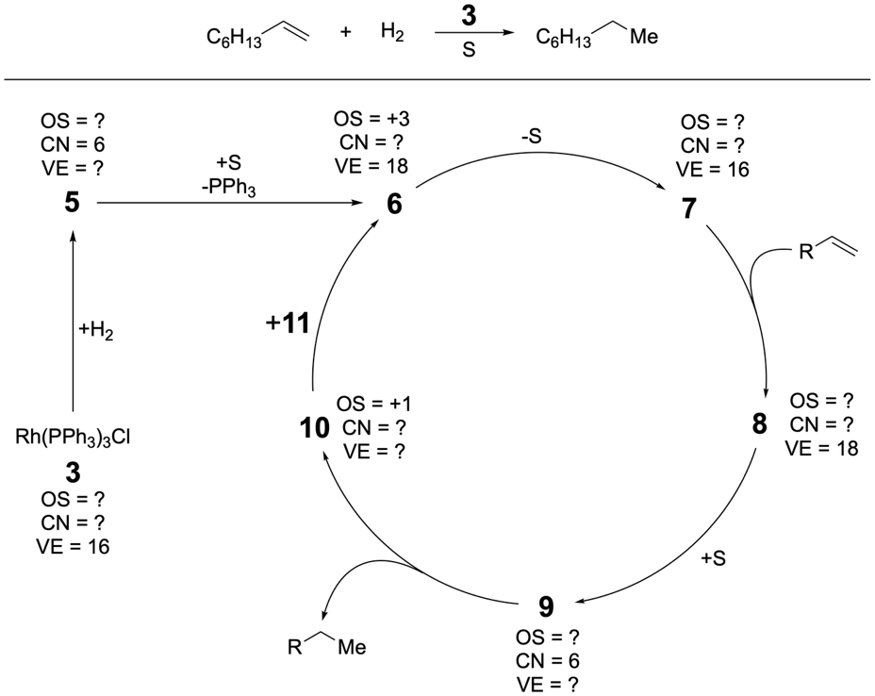
- Decipher the structures 5–10 and specify the unknown parameters (OS, CN, VE) for them if the overall charge is zero for all the metal species.
- Determine the structure of molecule 11.
Oxidative addition of hydrogen can occur not only from complex 3, but also from another complex. This complex is a neutral 14-electron species (which are generally more reactive), and it is obtained after one ligand leaves complex 3. Thus, an alternative catalytic cycle can be proposed for the above transformation.
- Suggest an alternative catalytic cycle that involves the aforementioned 14-electron complex. Specify the unknown parameters (OS, CN, VE) for the intermediates in your catalytic cycle (VE should be equal or greater than 14 for all the intermediates).
Some ligands can coordinate to metals in different ways. One example of such a case is the coordination of alkenes to a metal. Specifically, alkene 12 can coordinate to complex 13 without much disturbance of the C=C bond to produce 14 or via a metallacyclopropane mode to produce 15.
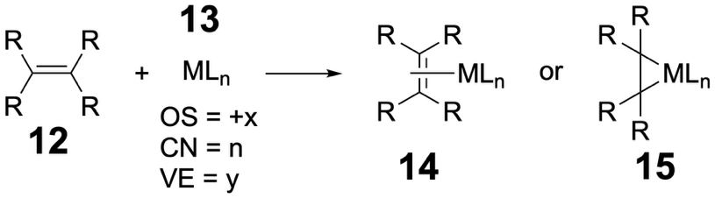
- Find the unknown parameters (OS, CN, VE) for complexes 14 and 15 if the OS, CN, and VE are given for 13 in the scheme above.
The geometry of complex 16 RhCp(H₂CCH₂)(F₂CCF₂) is shown below. The colour codes of the atoms are as follows: Rh – violet, C – grey, F – green, H – white.
Top view  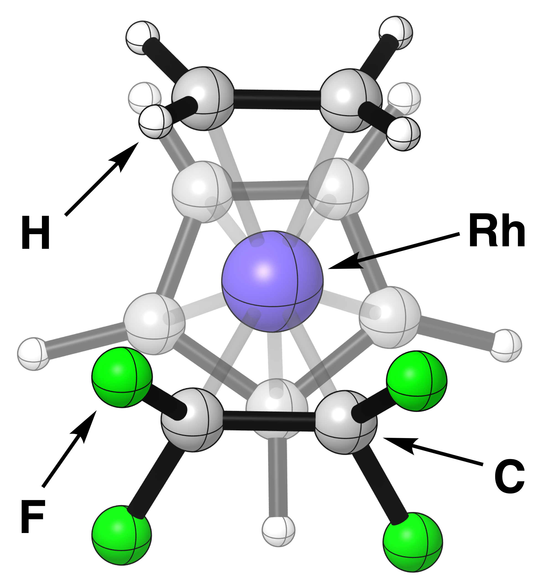 | 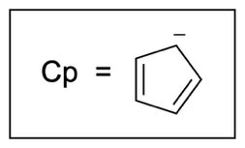
Side view 1  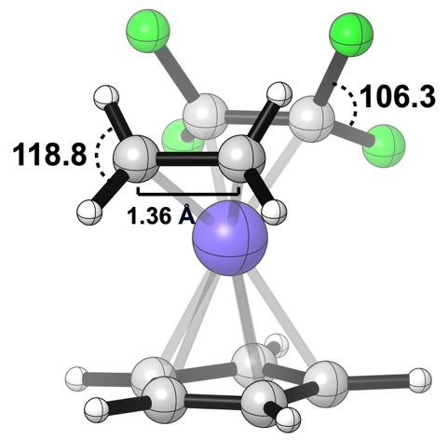 | Side view 2  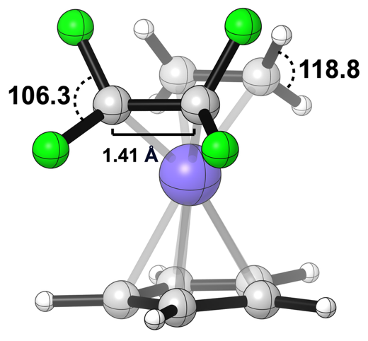
- Based on this geometry, find the unknown parameters (OS and VE) for complex 16.
Hint: the C–C bond lengths for free olefins are shown below.
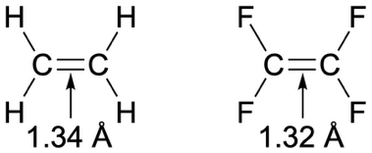
- Specify which mode of coordination is utilised by ethylene and tetrafluoroethylene in structure 16. Choose from the following options:
- alkene coordination (similar to structure 14);
- metallocyclopropane coordination (similar to structure 15);
- no coordination.
Sometimes, the transition metal complex carries an overall charge (positive or negative).
- Compare the following two complexes: IrCl(PPh₃)₃ (17) and Ir(COD)(py)(PCy₃)(PF₆) (18). Calculate the unknown parameters (OS, CN, VE) for 18 if OS, CN, and VE are the same for 17 and 18. Specify the overall charge of the metal part with the charge as presented in the example below for AlCl₄⁻ and AlCl₃.
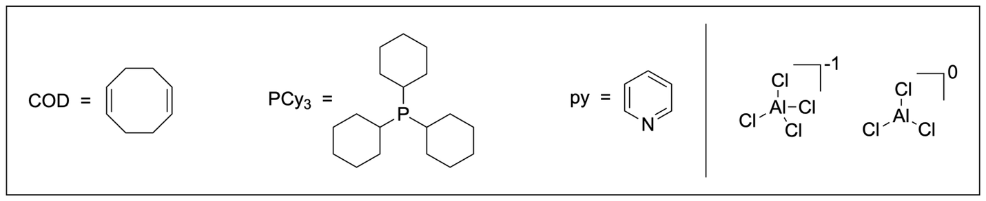
SET is a single electron transfer process and it it known that metal complexes can take part in it. An example of SET is shown below where donor D has a lone pair and during SET it gives one electron to acceptor A. This process produces a radical cation and a radical anion.
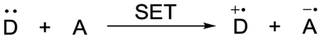
- Find the unknown parameters (OS, CN, VE) for complexes below that underwent SET process. Specify overall charges k and m for the new complexes.
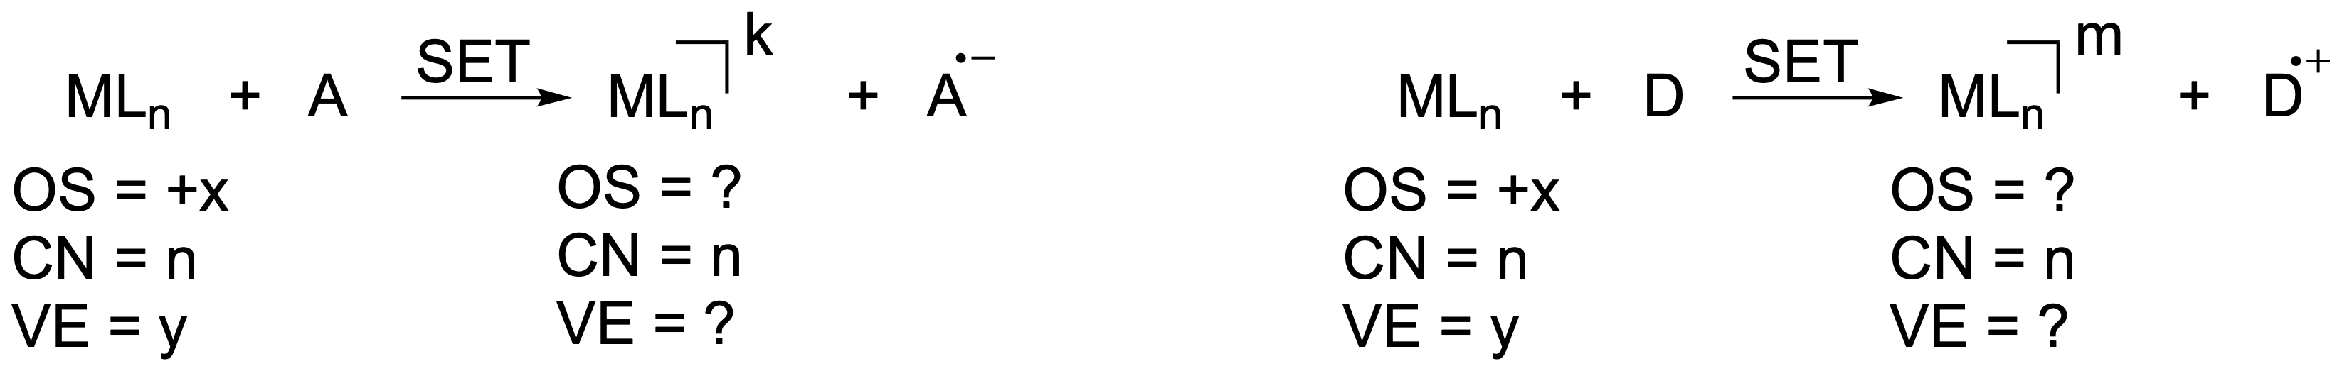

Some of metal complexes are useful photocatalysts. For instance, previously discussed complex 4 can be applied for C–H-functionalisation of tertiary amines such as 20 with electron poor arenes such as 19. The catalytic cycle for the synthesis of 21 is shown below and it consists of two SET processes.
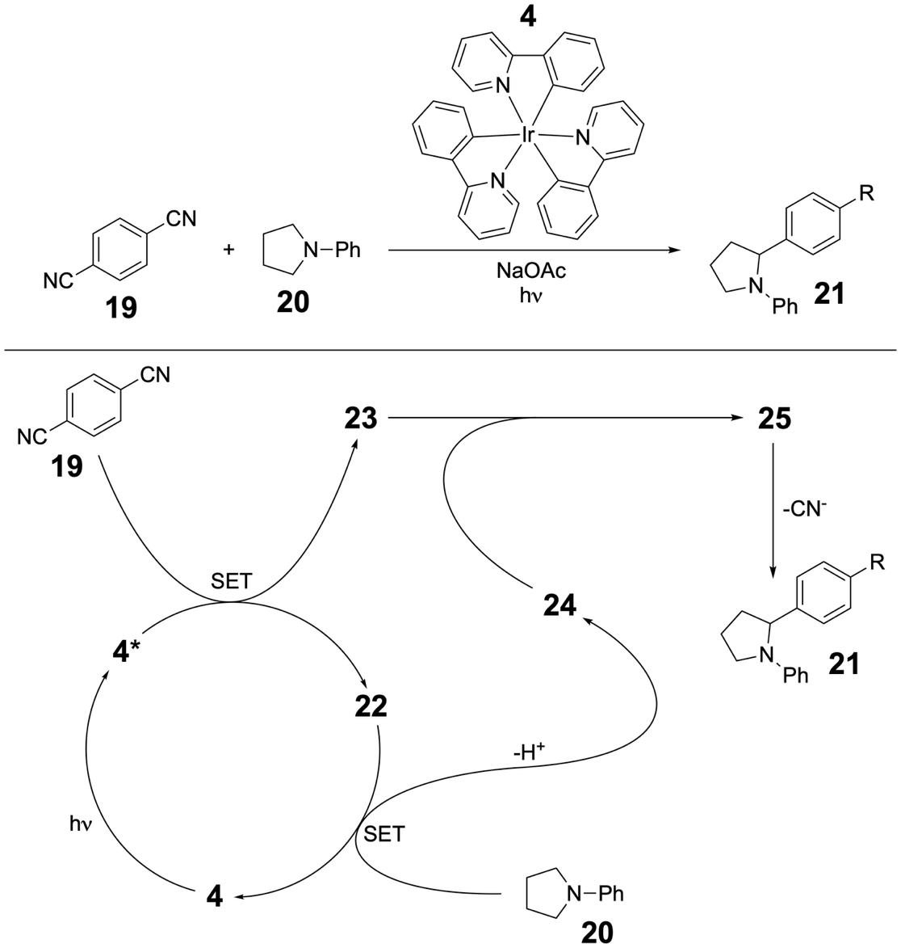
- Indicate which compound (19 or 20) is likely to be a donor in the SET process and which is likely to be an acceptor.
- Determine the unknown structures 22–25. Intermediate 4* is an excited state of complex 4. Calculate OS, CN, and VE for 22, and show the overall charge of 22.
- Identify substituent R in product 21.

Problem 23. HAT and XAT (HalAT)
Note: Natural abundances of some isotopes are given at the end of the problem.
Transition metal-catalysed reactions can be versatile and unique. As such, nickel complex 4 can catalyse the transformation of compounds 1 and 2 into product 3 as described below.
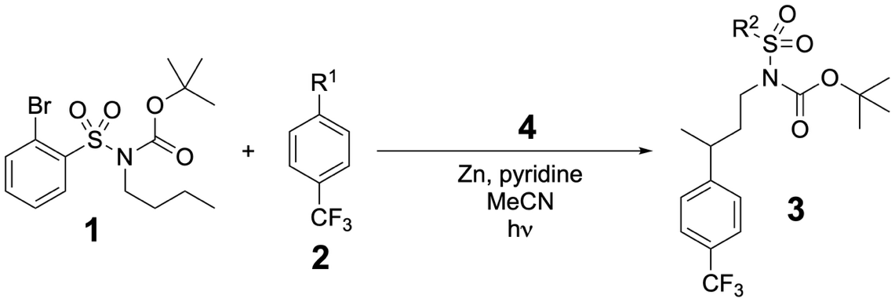
- The mass spectra (MS) of 2 and 3 are shown (electron impact ionisation method). Determine the structures of 2 and 3.
MS of 2
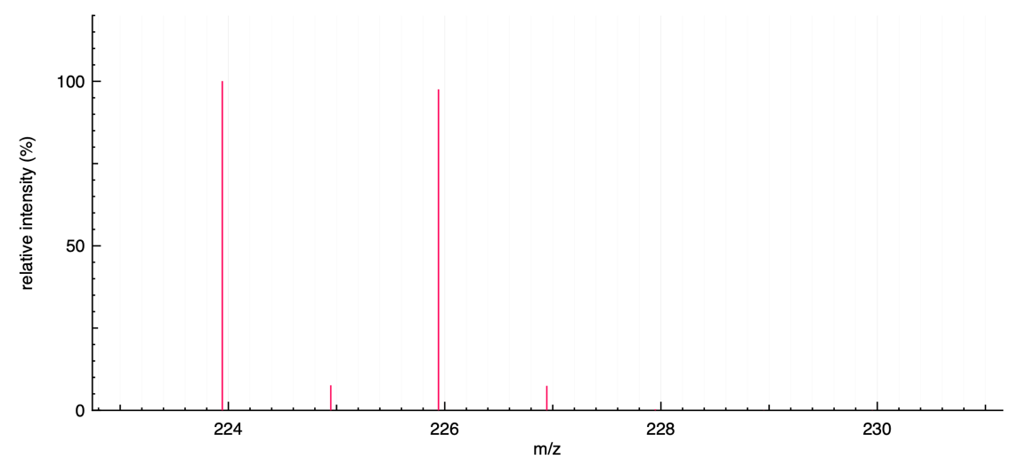
MS of 3
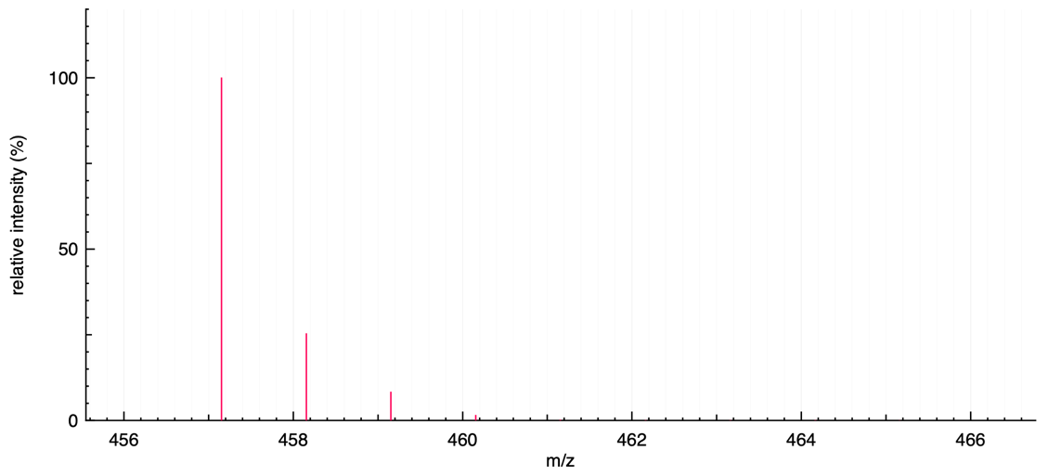
Complex 4 can be obtained via the following reaction. OS is the oxidation state of a metal in a complex; CN is the coordination number, and VE is the total number of valence electrons.
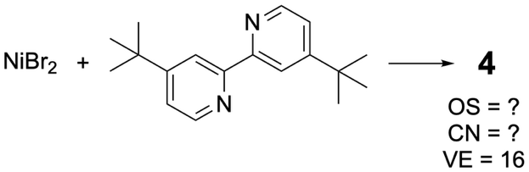
- Draw the structure of 4 and report the OS and CN of the metal in it.
HAT is Hydrogen Atom Transfer, while XAT is Halogen Atom Transfer. If atom transfer is intramolecular, it is called 1,n-AT. An example of 1,5-HAT is presented on the scheme below along with some Bond Dissociation Energies (BDE) useful for this task.
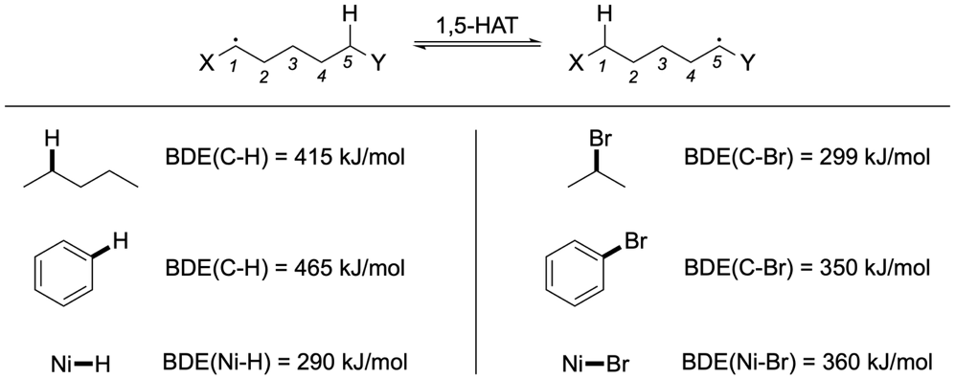
Metal complexes can participate in HAT and XAT processes. Two examples are given below:
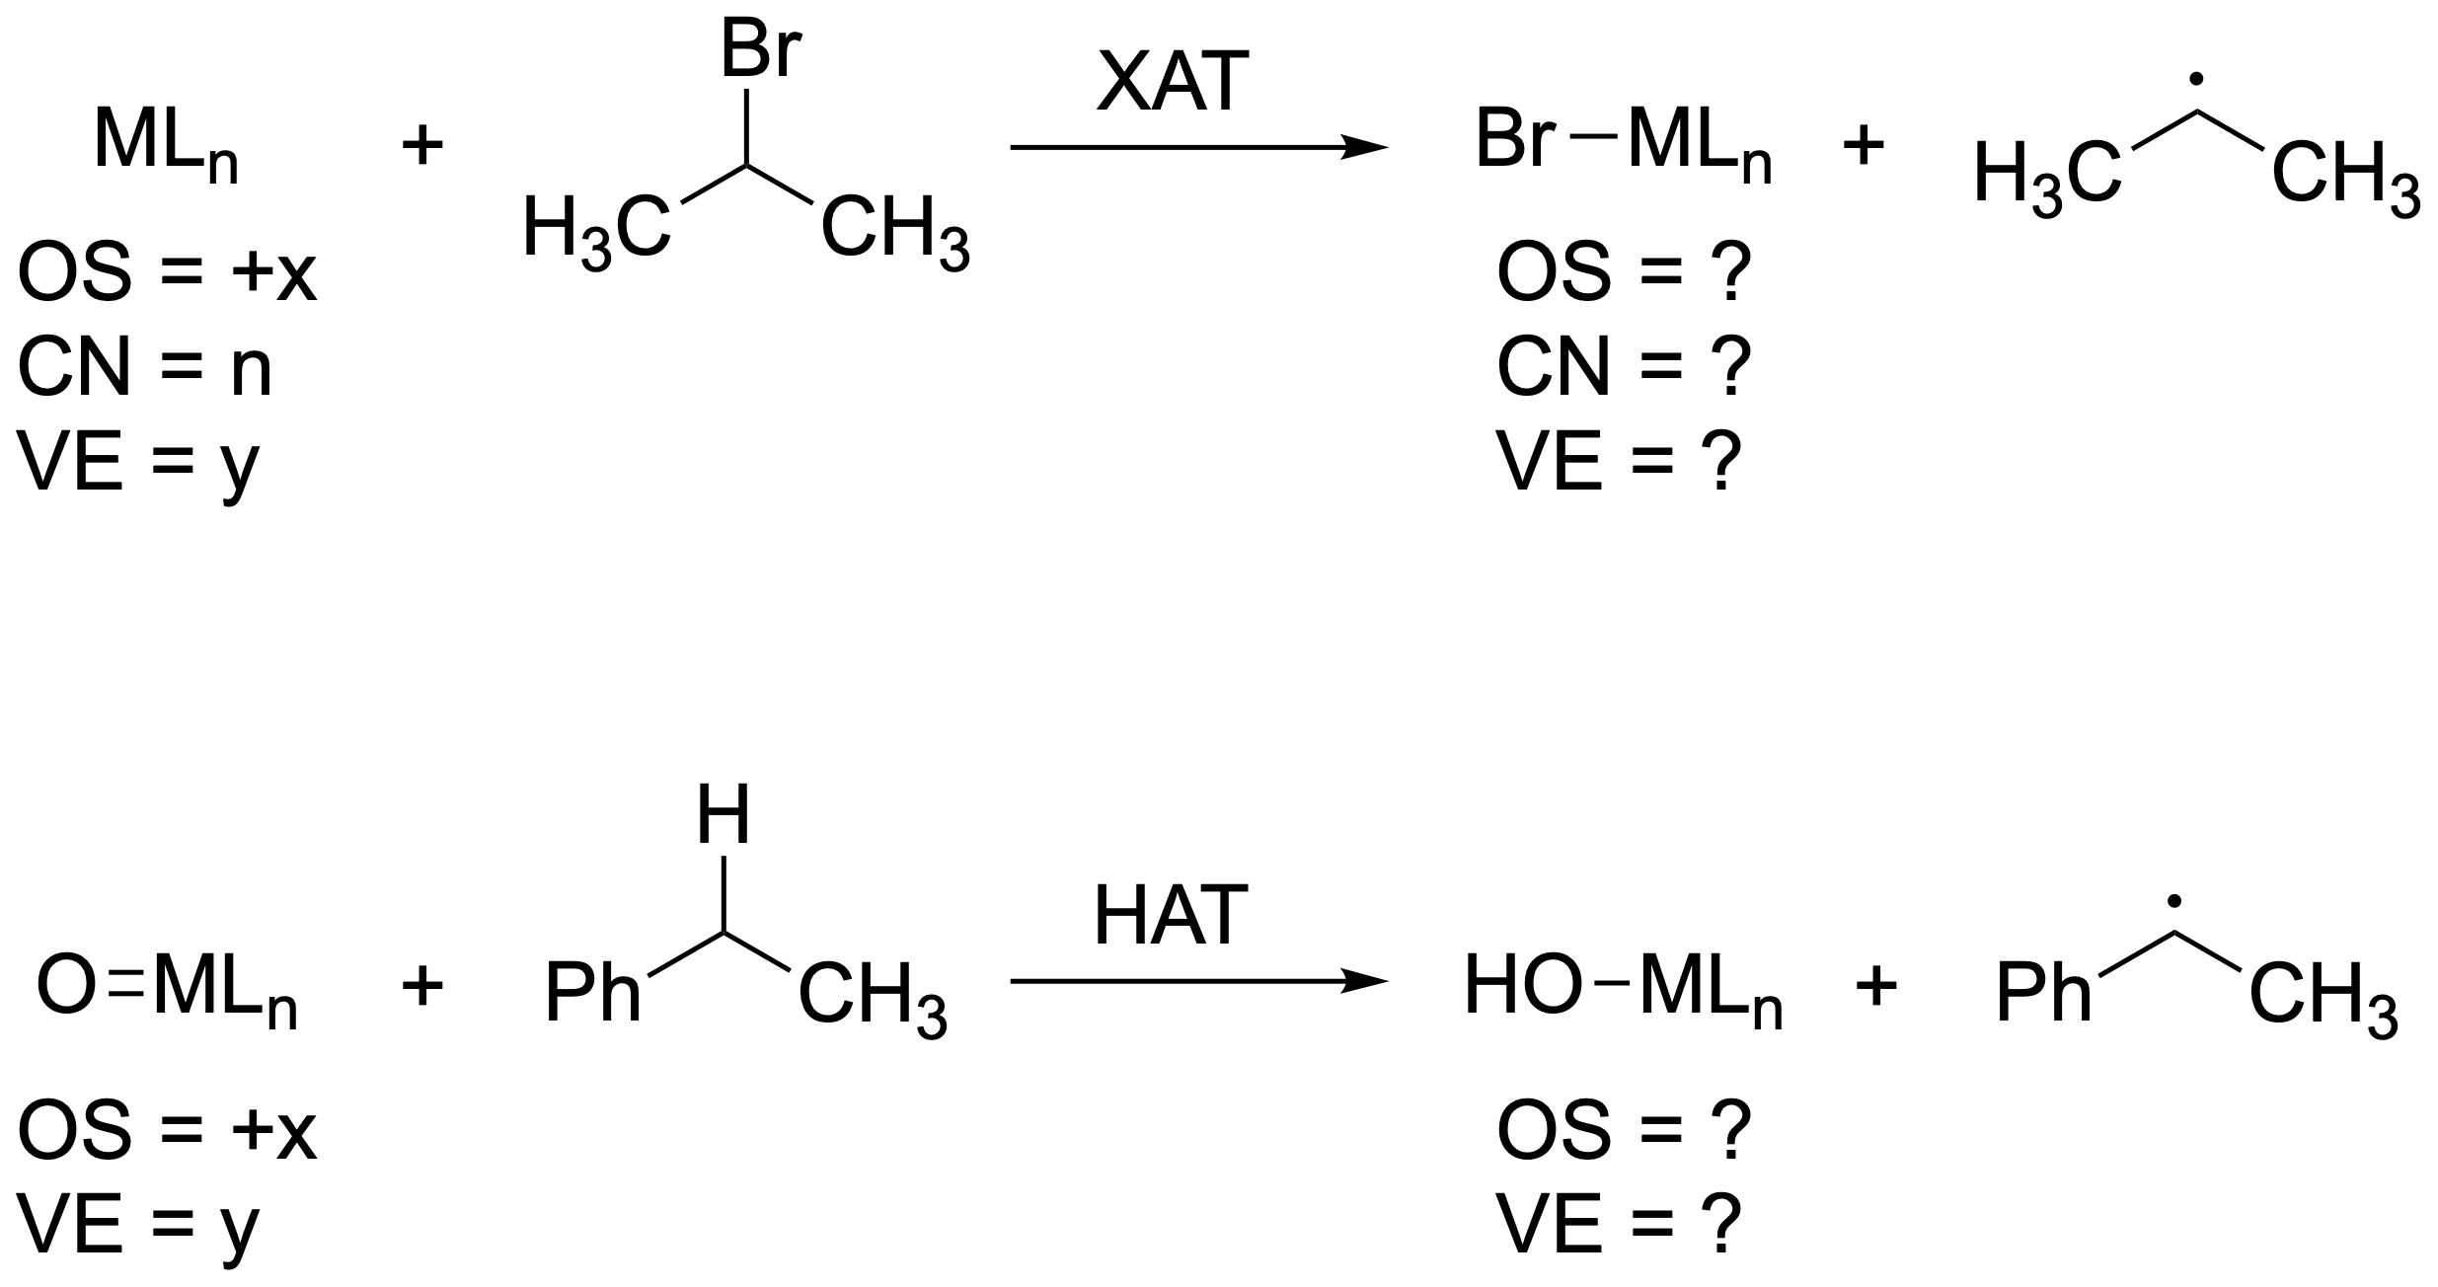
- Find the missing parameters (OS, CN, and VE) for the complexes produced in HAT and XAT processes.

The catalytic cycle for the transformation of 1 and 2 to product 3 is described below:
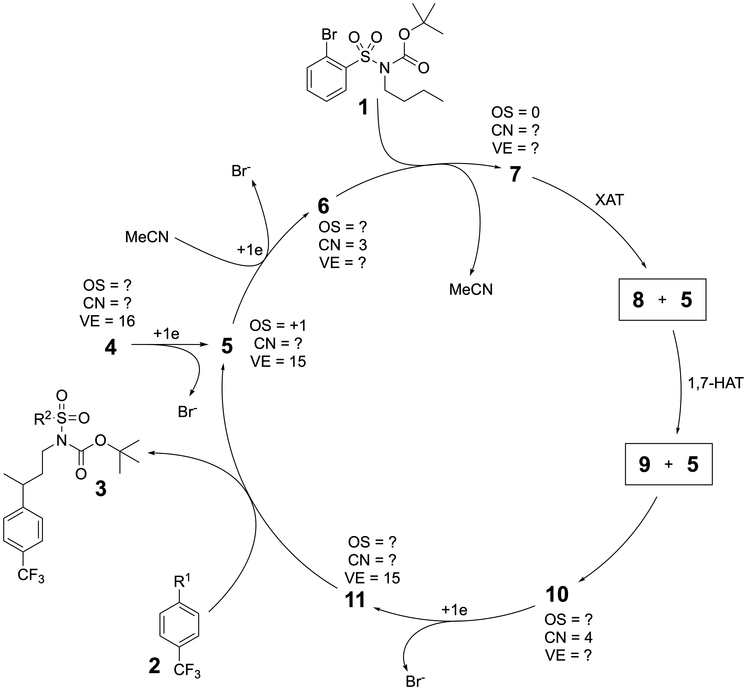
- Find the structures of 5–11 in the cycle. For Ni-containing structures 5–7 and 10–11, find the missing parameters (OS, CN, and VE).
- Analyse the given reaction conditions for the synthesis of compound 3 and determine the electron donor in the above catalytic cycle.

A conceptually similar catalytic reaction is a desaturation of silylated alcohols such as 12. In the example below a deuterium label was installed for mechanistic studies.
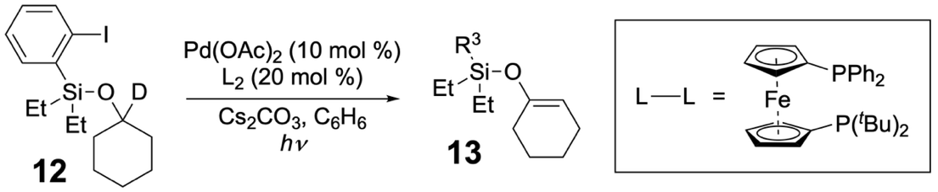
- The mass spectrum of 13 is presented below (electron impact ionisation method). Determine its structure.
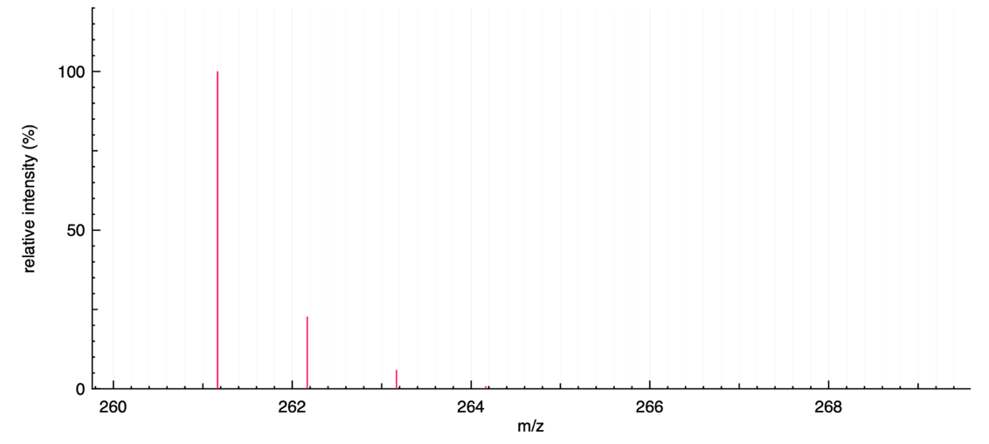
The catalytic cycle for the transformation of 12 into 13 is shown below:
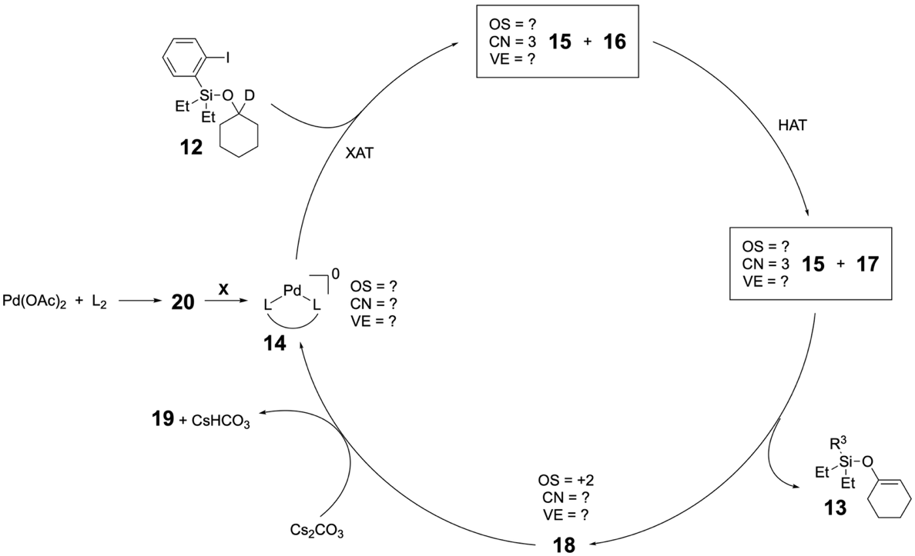
- Determine the structures of 15–19. For Pd-containing intermediates 14, 15, and 18, find the missing parameters (OS, CN, VE).
Active species 14 is not particularly stable, thus, it is practically easier to start the reaction with a bench-stable palladium complex Pd(OAc)₂. The first step towards 14 is reaction with the phosphine ligand.
- Draw a possible structure for 20. Suggest what type of process should occur in the second step marked as X on the scheme. Analyse the given reaction conditions for the synthesis of 13 and suggest what reagent can participate in the step X.
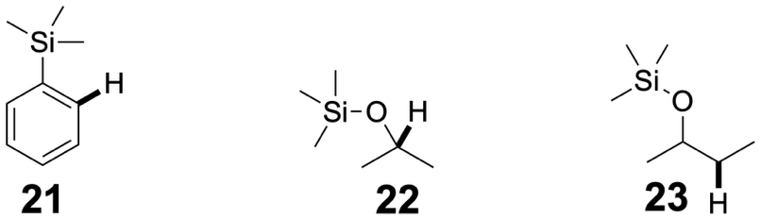
- Based on the information in the task, analyse BDE(C–H) of highlighted bonds in compounds 21–23. Compare the values in pairwise manner using symbols <, > or =:
BDE(C–H)₂₁ ______ BDE(C–H)₂₂
BDE(C–H)₂₁ ______ BDE(C–H)₂₃
BDE(C–H)₂₂ ______ BDE(C–H)₂₃
Table of Natural Abundances
Isotope | Natural Abundance / % |  | Isotope | Natural Abundance / %
¹H | 99.9885 |  | ³²S | 94.93
²H | 0.0115 |  | ³³S | 0.76
¹²C | 98.93 |  | ³⁴S | 4.29
¹³C | 1.07 |  | ³⁶S | 0.02
¹⁴N | 99.632 |  | ³⁵Cl | 75.78
¹⁵N | 0.368 |  | ³⁷Cl | 24.22
¹⁶O | 99.757 |  | ⁷⁹Br | 50.69
¹⁷O | 0.038 |  | ⁸¹Br | 49.31
¹⁹F | 100 |  | ¹²⁷I | 100

Problem 24. Anticancer complexes
The World Health Organisation reports that 20% of population will suffer from cancer in their lifetime. Today, cancer treatment is increasingly personalised being a combination of surgery, radiation, and chemotherapy with biomarker-guided targeted drugs and immunotherapies that can give long-lasting responses for some cancers. In this problem, we will consider some types of drugs used in cancer treatment.
Part 1. Platinum complexes
Platinum complexes show antitumor activity by covalently binding to DNA, thus preventing its replication. The first-generation platinum drug, cis-diaminedichloroplatinum(II) (cisplatin), is efficient against cancer, whereas its trans-isomer (transplatin) is not. One reason for this difference is that cisplatin and transplatin form different types of crosslinks with DNA strands.
There are two possibilities for a complex to bind DNA: intrastrand and interstrand crosslinks through the N7 position of guanine. Intrastrand crosslinks form between two bases of the same DNA strand, while interstrand crosslinks connect one base from one strand to a base on the opposite strand.
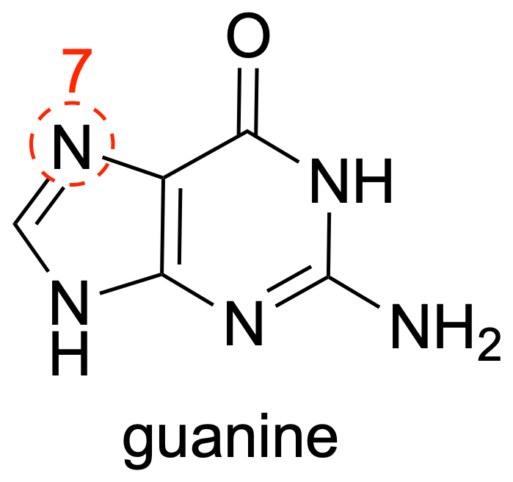
- Using the dot notation shown below, draw the intrastrand and interstrand crosslinks on the given DNA template. State the kind of crosslink that is formed by a) cisplatin; b) transplatin.
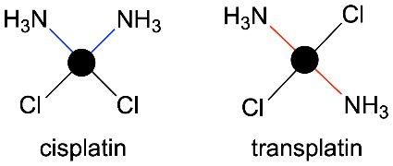 | 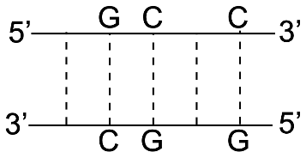
- Deduce the effect of the formation of intrastrand and interstrand crosslinks on the melting temperature, T_{m}. T_{m} is the temperature at which half of DNA duplexes dissociate into single-stranded DNA.

Dicycloplatin, a third-generation platinum-based anticancer drug, was developed to reduce the dose-limiting toxicities that restrict the clinical use of cisplatin. Dicycloplatin crystals precipitate from a saturated aqueous solution containing Pt-4 and 1,1-cyclobutanedicarboxylic acid (H₂CBDCA) in a 1:1 molar ratio. Dicycloplatin was found to have four hydrogen bonds in one structural unit.
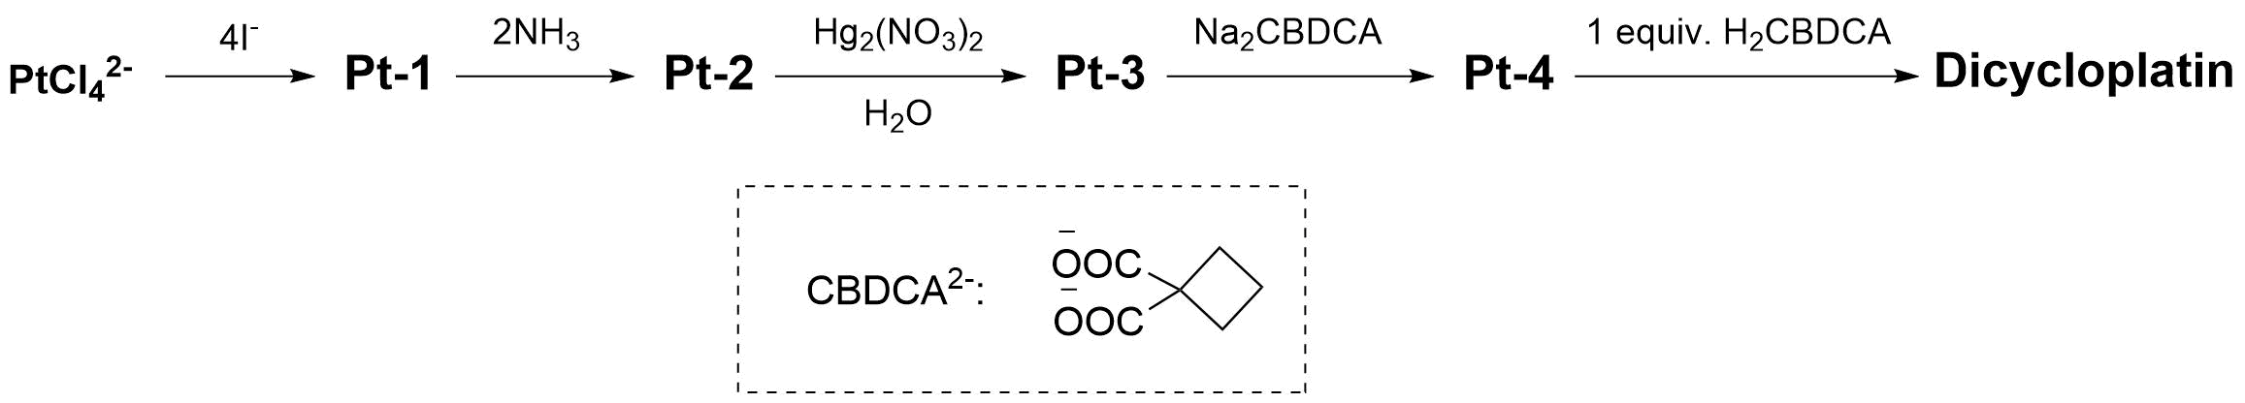
- Draw the structural formulae of particles Pt-1, Pt-2, Pt-3 and Pt-4. The mass percentage of platinum in PtCl₄²⁻ to Pt-4 changes as 57.9% → 27.7% → 40.4% → 73.6% → 52.6%, respectively.
- Draw the structural formula of dicycloplatin showing the hydrogen bonds.
Pt-4 (carboplatin) was introduced into clinical use in the late 1980s and has been widely used in cancer treatment. One practical challenge with platinum-based drugs is that, in aqueous solution, they can undergo hydrolysis, which may affect their stability and reactivity.
- Explain which drug, Pt-4 or dicycloplatin, is more resistant to hydrolysis in aqueous solution.

Part 2. Camptothecin and its derivatives
Alkaloid camptothecin and its derivatives form another group of drugs that show antitumor activity by inhibiting topoisomerase I, the enzyme that ‘untangles’ the DNA helix. Total synthesis of camptothecin derivative, SN-38, was carried out by coupling two building blocks H and N.
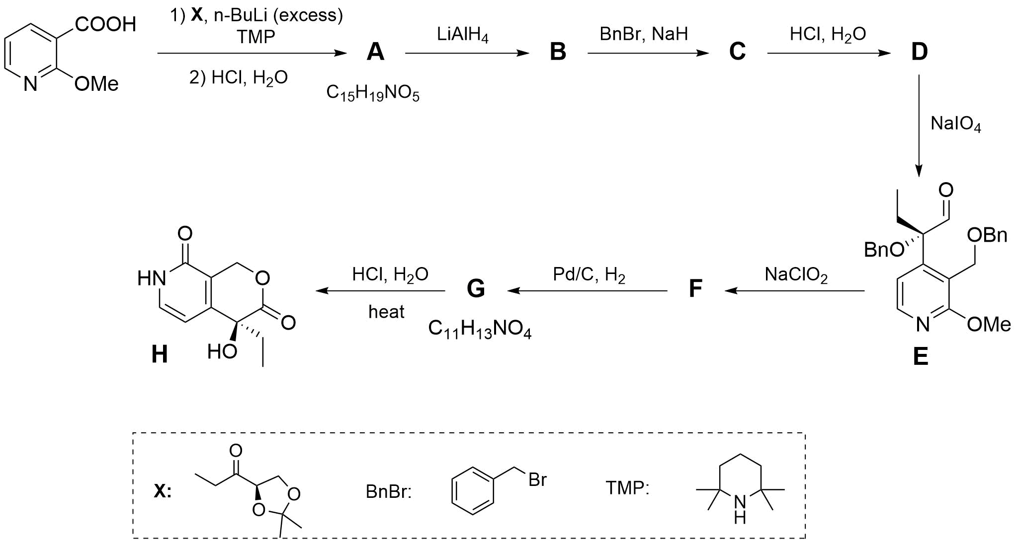
- Draw the structural formulae of compounds A–G showing stereochemistry, if the step from B to C requires an excess of benzyl bromide.
The second part of the synthesis is given below:
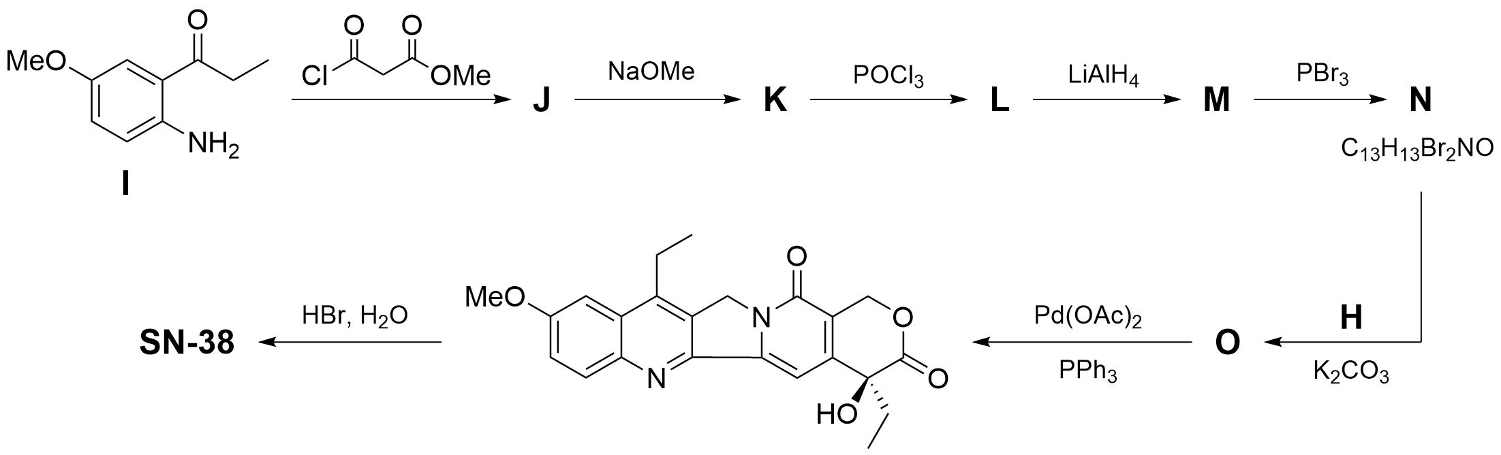
- Draw the structural formulae of compounds J–O and SN-38 showing stereochemistry where applicable.

Problem 25. The equilibria in DNA
A single-stranded DNA (ss-DNA) molecule can dimerise into a double-stranded one (ds-DNA) in the case that the ss-DNA is complementary to itself. Complementarity arises due to the ability of nitrogenous bases to form hydrogen bonds with each other. As shown below, guanine (G) forms three hydrogen bonds with cytosine (C), whereas adenine (A) forms two hydrogen bonds with thymine (T):
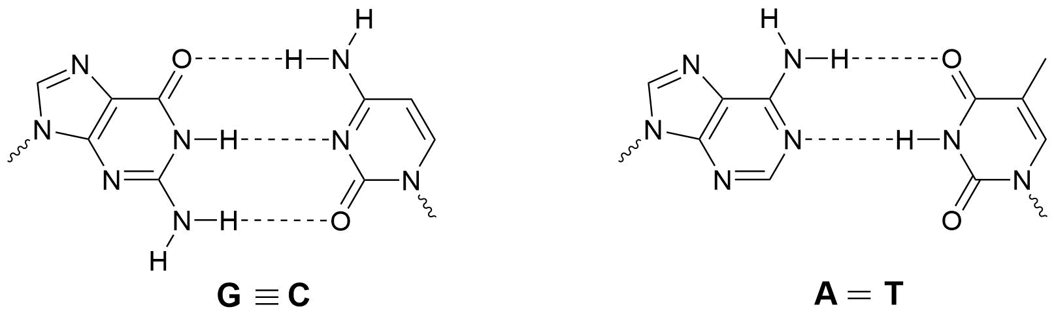
Tetranucleotide 5’-CCGG-3’ can dimerise as follows:
5’-CCGG-3’ |  | 5’-CCGG-3’  ││││  3’-GGCC-5’
+ | ⇌ | 5’-CCGG-3’  ││││  3’-GGCC-5’
3’-GGCC-5’ |  | 5’-CCGG-3’  ││││  3’-GGCC-5’
- Deduce how many tetranucleotides exist that are capable of dimerisation with pairing of all 4 nucleotides in the strands.
Dimerisation of tetranucleotide 5’-CCGG-3’ was studied at different temperatures by measuring the absorbance, A, of solutions at 280 nm, with total initial concentration of single strands
[ss-DNA]₀ = 10 μM. The results of the experiments were as follows: A = 0.89 at 10 ℃ and A = 1.17 at 30 ℃.
- Calculate Δ_{r}H° and Δ_{r}S° values for the dimerisation reaction of tetranucleotide
5’-CCGG-3’, if they are independent of temperature and ε_{ss-DNA} = 2.44 × 10⁴ cm⁻¹·M⁻¹,
ε_{ds-DNA} = 2.93 × 10⁴ cm⁻¹·M⁻¹ at 280 nm for tetranucleotide 5’-CCGG-3’, l = 5 cm.
The melting temperature of ds-DNA, T_{m}, is the temperature at which half of ds-DNA dissociates into ss-DNA.
- Calculate T_{m} for the double strand of tetranucleotide 5’-CCGG-3’ when the total concentration of single strands, [ss-DNA]₀ = 10 μM.
Another driving force for ds-DNA formation is the π-π-stacking between the nitrogenous bases in addition to hydrogen bonds. To estimate the contribution of the π-π-stacking to the stabilisation energy of ds-DNA, the dimerisation of oligonucleotides 5’-ACCGG-3’,
5’-CCGGT-3’, and 5’-ACCGGT-3’ was investigated.
- Deduce what dimers do oligonucleotides 5’-ACCGG-3’, 5’-CCGGT-3’, 5’-ACCGGT-3’ form. Draw them schematically.
The T_{m} of these oligonucleotides has the following dependence on the total concentration of single strands:
$$\frac{1}{T_{m}}=k×\ln{{\left[ss-DNA\right]}_{0}}+b$$
The following table shows k and b parameters for some oligonucleotides:
Oligonucleotide | k / K⁻¹ | b / K⁻¹
5’-ACCGG-3’ | −5.15 × 10⁻⁵ | 2.76 × 10⁻³
5’-CCGGT-3’ | −4.80 × 10⁻⁵ | 2.78 × 10⁻³
- Calculate the Δ_{r}H° values for the dimerisation reactions of oligonucleotides
5’-ACCGG-3’ and 5’-CCGGT-3’, assuming they are independent of temperature.
- Determine the π-π-stacking energies for A-CG and T-GC stackings (see figure below). Assume that there is no π-π stacking in ss-DNA.

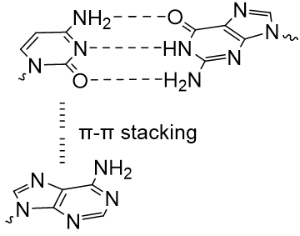 | 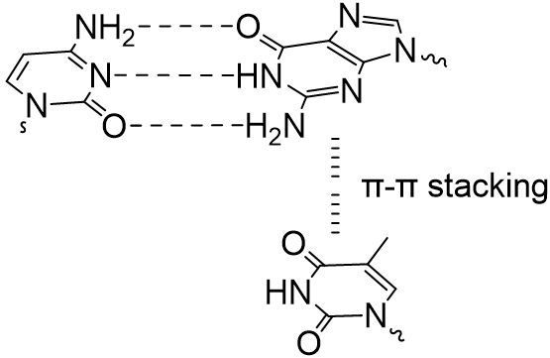
A-CG π-π stacking | T-GC π-π stacking
- Predict the Δ_{r}H° value for the dimerisation reaction of oligonucleotide 5’-ACCGGT-3’, if the total hydrogen bond energy in an A=T pair is 28842.0 J·mol⁻¹.

Problem 26. Sensing of acetaldehyde
Acetaldehyde (AA) is a reactive aldehyde primarily produced in cells as a metabolic intermediate during ethanol oxidation:
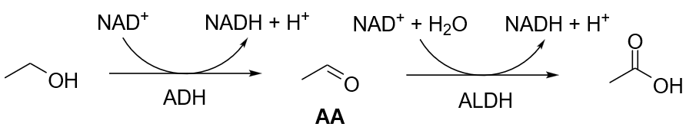
ADH – alcohol dehydrogenase, ALDH – aldehyde dehydrogenase.
Excess AA, often resulting from impaired AA detoxification, leads to aberrant DNA, protein, and/or lipid damage, and increases risk of diseases such as cancer, hepatitis, and cirrhosis. Recently, G. Li, C. Chang et al. reported the development of a highly selective method for the detection of AA in living cells. In this system, AAP-1 reacts with AA to form a fluorescent product P by the following mechanism:
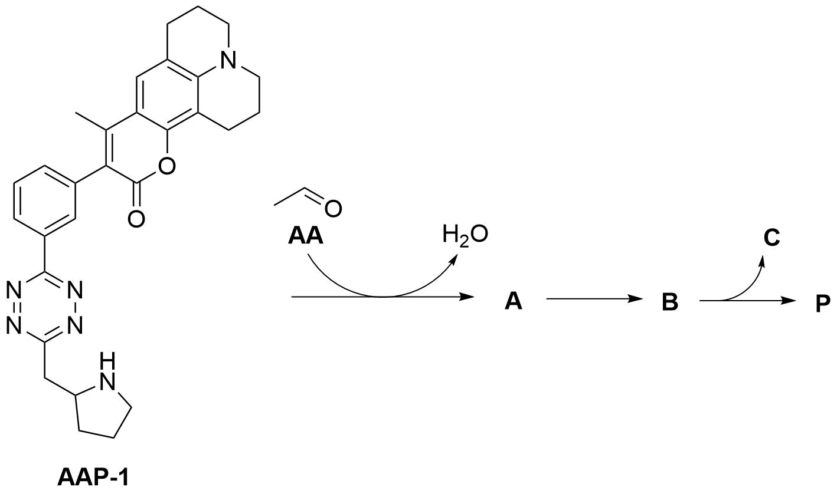
A is an enamine, C is an inorganic byproduct, and P contains the same number of rings as
AAP-1. The above mechanism includes [4+2] and retro [4+2] cycloaddition reactions:
- Draw the structures of intermediates A–B, product P, and determine the inorganic byproduct C. Note: Molecular ions of AAP-1 and P in mass spectra have peaks with masses of 494 and 492, respectively.
Although biological fluids contain different types of aldehydes and ketones, AAP-1 reacts only with AA.
- Give the reason why formaldehyde (methanal) and methylglyoxal (2-oxopropanal) do not react with AAP-1.
Aldehydes and ketones on relatively large molecules also do not react with APP-1 due to the steric effects during transformation of enamine A to [4+2] cycloaddition product B. The following table shows the [4+2] cycloaddition reaction participants’ Gibbs energies relative to reagents for AA (A, transition state #1 and B) and hexanal (A’, transition state #2 and B’):
Species | ΔG / kJ·mol⁻¹ | Species | ΔG / kJ·mol⁻¹
enamine A | −8.36 | enamine A’ | −12.96
transition state #1 | 63.95 | transition state #2 | 68.13
cycloaddition product B | −21.74 | cycloaddition product B’ | −19.23
- Calculate the Gibbs energy changes (kJ·mol⁻¹) for processes A→B and A’→B’. Conclude whether these reactions are spontaneous.
- Calculate the ratio of the rate constants corresponding to the A→B and A’→B’ transformations at 310 K. Assume that in both reactions pre-exponential constant is the same, and that activation energy is equal to activation Gibbs energy.
The excitation and emission spectra of product P are shown below:

- Match the spectral lines X and Y with excitation and emission processes.
The fluorescence intensity, F, of P depends linearly on its concentration: F = F₀ + k[P]. The following table shows the fluorescence intensities (in arbitrary units) of solutions with different concentrations of P:
F / arb.u. | 92.50 | 97.50 | 102.50 | 107.50
[P] / μM | 10 | 20 | 30 | 40
- Calculate the values of F₀ and k.
The lower detection limit of the fluorescence intensity of P is 90.65 arb.u. In the absence of ethanol, the concentration of AA can very quickly decrease due to enzyme ALDH (r_{max} = 4.1 mM·min⁻¹, K_{M} = 0.2 μM).
- Calculate the time needed (in seconds) for the fluorescence intensity of the product of AA with AAP-1 to decrease from 137.50 arb.u. to 90.65 arb.u. in the absence of ethanol. Note: ALDH obeys Michaelis–Menten kinetics.
Adding inhibitors to cell cultures where the concentration of AA is determined using AAP-1 affects the intensity of fluorescence:
Control  (no inhibitor, no EtOH) | EtOH | EtOH + Fomepizole  (ADH inhibitor) | EtOH + CVT-10216  (ALDH inhibitor)
F₁ | F₂ | F₃ | F₄
- Arrange F₁–F₄ in order of increasing fluorescence intensity.

Problem 27. Archaeal metabolism
Archaea, along with bacteria and eukaryotes, constitute a distinct domain of living organisms. Archaea were previously grouped with bacteria, but this classification is now considered obsolete, as it has been established that archaea have their own independent evolutionary history and are characterised by many biochemical features that distinguish them from other life forms. Archaea appeared on Earth 3.5–4 billion years ago during the Archean Eon and have evolved continuously since then.
- Select from the options provided a measurable, planetary-scale quantitative parameter that has not changed within reasonable accuracy throughout the entire evolution of archaea and to changes to which they can quickly adapt:
- Chemical parameters: the concentration of a gaseous substance in the atmosphere (oxygen, nitrogen or carbon dioxide), the composition of the environment (reservoirs) as the ratio of various compounds (salinity, pH, buffer capacity), etc.
- Physical parameters: temperature, atmospheric pressure, radioactivity, gravitational force, total luminosity of the Sun.
To demonstrate the differences between the three main domains of living organisms, one can cite as an example the quinone derivatives that play a role in oxidation-reduction processes in archaea (menaquinone MK-7), bacteria (menaquinone MK-10), and eukaryotes (ubiquinone, presented in the form of coenzyme Q₁₀, CoQ₁₀):
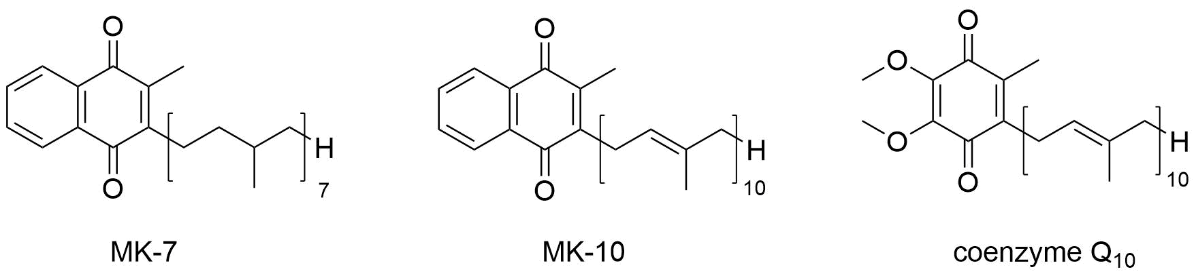
- Draw the structure of the two-electron reduction product of MK-7.
The standard biochemical redox potentials, E°’, of some redox pairs are given in the table below.
Redox pair | E°’ / V
0.5 O₂/H₂O | 0.82
cytochrome с (+3)/ cytochrome с (+2) | 0.22
CoQ₁₀/CoQ₁₀H₂ | 0.10
fumarate/succinate | 0.03
MK-10/MKH₂-10 | –0.07
acetaldehyde/ethanol | –0.20
- Based on the information provided, qualitatively explain why menaquinone was displaced by ubiquinone in the ancestors of modern eukaryotes and is currently not found in eukaryotes, with a few exceptions.
Natural ubiquinol (reduced form of ubiquinone), obtained from eukaryotic cell culture, is a hydrophobic unsaturated compound that can be incorporated into the standard method for determining bromine value (strictly in the dark!).
- Suggest at least two chemical structural features of natural samples of ubiquinol that distinguish it from, for example, the triacylglycerol of linoleic acid, often called linolein, and that should be considered when analysing the obtained results of interaction with molecular bromine.
The unique habitat of archaea, from their very inception, has led some species to possess an enzyme involved in the metabolism of extremely intriguing substrates – substances X, Y, and Z, which exhibit similar chemical properties. Thus, structural isomers X and Y react in vitro with menaquinol (MKH₂-7), catalysed by an enzyme commonly referred to as Z-reductase, according to the following reaction equations:
X + MKH₂ → X1 + X2 + MK (1)
Y + MKH₂ → Y1 + Y2 + MK (2)
For the molar masses of unknown substances rounded to the nearest integer, three strict inequalities hold: M(X) < 250 g/mol; M(X1) > M(X2); M(Y1) > M(Y2).
- Using only the information above, find the upper limit of the range of possible integer molar masses of X2.
X1 and X2 each contain 22% of element E1 and 1.0% of element E2 by mass, while X contains 23.4% oxygen by mass.
- Calculate the percentage by mass of E2 in X to the nearest whole number.
- Without disclosing any elements other than E2, narrow the range of possible whole-number molecular masses of X2 as much as possible, taking into account the mass fractions given above.
- Suggest two potential explanations for the apparent logical inconsistency between the equal mass fractions of elements in two compounds despite different whole-number molecular masses; discriminate against one of them for the purposes of the problem.
Despite the lack of any direct information, the problem statement provides sufficient information to unambiguously determine the structures of Y1 and Y2.
- Draw the molecular formulae of Y1 and Y2, and propose the structural formulae of substrates X and Y.
Compounds X and Y, unlike compound Z, are not found in nature.
- Based on the principles of enzymatic catalysis, propose the molecular formula of Z.
Surprisingly, there is a substrate W that, when catalysed by the enzyme Z-reductase, yields two products with identical molecular masses when rounded to the nearest whole number.
- Suggest two variants of the molecular formula of W, both containing E1.
- Describe the metabolic characteristics and habitat of the archaea species whose metabolic fragment was discussed above.
Most of the IChO 2026 problem authors are recent medalists of the International Chemistry Olympiads. Try testing your skills by creating an Olympiad problem based on the composition you've just solved. Your goal is to simplify this problem somewhat, guiding the participants' thinking toward the correct answers.
- Analyse the reaction equations (1) and (2) and, based on the interesting coincidences/patterns you’ve identified, offer two hints to make the problem easier for the solvers without oversimplifying it.

Problem 28. Non-archea-typal form of life
Molecule A, with the formula C_{x}H_{y}O_{z}, where x, y, z ∈ $N$, is found in some fossil deposits (such as oil), and serves as a biomarker for the presence of archaea in a particular region of the planet in the past.
Molecule A can be represented using a simplified version of knot notation: each covalent bond, regardless of the type of atoms forming it, is represented by a strand, with the atoms themselves being the knots at the ends of one or more strands. The ethane molecule, written in this notation, looks like this:
Using scissors, it takes 123 cuts to completely separate molecule A into individual nodes along the strands (the same operation with ethane requires 7 cuts). Note that two nodes are separated by the number of cuts equal to the number of strands between them (for example, a double bond requires two cuts). It is known that there is a single cut that bisects the molecule A into two identical fragments (similarly to ethane, as shown by the dashed line in the figure above).
- Based on the data presented above, decide whether the indices x, y, and z are even or odd numbers or can be either of these. Is it possible to decide wither x ≤ 60 or not? For x = 60, suggest two fundamentally different theoretically possible structures that meet the conditions (ignore the reality of their existence; this is just a theoretical concept).
Hint: Using the method of incomplete mathematical induction, try to consider the dependence of the number of bonds on the molecular formula for the first members of the homologous series of alkanes or saturated alcohols, as well as the acetylene-ethylene-ethane series.
- Deduce whether there exists a theoretical acyclic form of A that can be divided into two identical fragments: a) by two cuts; b) by three cuts. If you answered yes, propose a molecular formula supporting your choice.
It is known that A has a molecular mass, rounded to the nearest whole number, of 595 g/mol.
- Without guessing, uniquely find the molecular formula of A.
Molecule A, containing 8 stereocentres, can be cut along the strands into two types of fragments (fragments of the same type are defined as those that can be superimposed). Note that the cuts are made at equal distances from each other (the shortest number of strands between them, excluding branches), and one of the cuts coincides in location with the one that bisects A into two identical fragments as described above. Based on the experiment, A can be represented as a sequence of two fragments, c and d, as dccccccccd.
- State whether the hydroxy groups in A can be: a) secondary; b) tertiary? If so, draw the corresponding structural formula(e) representing the cuts by dashed lines. Showing stereochemistry is not required.
- Draw all possible structural formulae of A that form the dccccccccd pattern with cuts spaced apart by at least three intact strands.
- Knowing the prevalence of certain structural biochemical motifs, choose the variant(s) of A (from those found in question 5) that best fit(s) to the metabolites of living things.
A is formed by the hydrolysis of compound B (C_{k}H_{l}O_{m}), which is involved in the formation of membranes in most archaeal species. The number of covalent bonds (n) in B is in the range
261 ≤ n ≤ 265. The hydrolysis process is abiotic in nature and is a classic example of diagenesis (the long-term decomposition of organic material in geological deposits). The reaction equation for the decomposition of B can be written as follows:
B + 4H₂O → 2A + 2C
Note:
- Optically inactive C has a symmetry axis passing through one of the carbon atoms;
- The molecular formula of both C residues in B is the same.
- Prove, without determining the formulae, that l ≤ 2k.
- Find all structural formulae of C that satisfy the above condition.
By combining pairwise the structures of A obtained in question 6 with the structures of C from question 8, we can see that one variant of C yields more structural isomers of B than all the other variants of C combined. This variant of C is found in archaeal lipids.
- Find the final structure of C and determine the number of structural isomers of B. Draw the structural formulae of any two isomers of B.
- Explain why the hydrolysis of B takes long and is not catalysed by enzymes of other microorganisms.
It is known that esterified derivatives of B are located in the membranes of some species of archaea in two fundamentally different ways (O- and U-conformations), shown below:
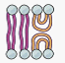
- Of the B isomers proposed earlier, select those that can form similar membrane types. Give the advantage that such membranes have over those formed by bacterial and eukaryotic cells.
- Suggest two explanations why the evolution chose C for the synthesis of B, rather than compounds from the same group with lower molecular weights.
- Based on the information obtained in questions 11 and 12, narrow down as much as possible the range of isomers of B that meet the biological requirements of archaea.
Archaea of the phylum Thaumarchaeota adapt to rising environmental temperatures through a process virtually unique to them. It is known as homeoviscous adaptation, which involves modifying the structure of B by forming saturated cycles of either only five or only six carbon atoms (but not spirocycles) and, as a consequence, the biosynthesis of a separate family of lipids (D).
It is known that this modification of the structure of B is catalysed by two enzymes that are extremely similar in function and structure and exhibit strict positional specificity. Theoretically, based on the number of suitable loci, there could be up to four such enzymes, which would lead to an expansion of the D family (however, the third and fourth enzymes are not present in nature).
- Determine the molecular formula of lipid D1, found in archaea, which withstands extreme temperature conditions better than other members of the family.
It is known that symmetrical molecule D1 contains 26 stereocentres.
- How many structural isomers that meet the condition can be proposed for D1? Draw any one of them. In this case, keep in mind that it is necessary to carefully analyse which carbon atoms can participate in the closure of the hydrocarbon ring, whether this option leads to an increase in the number of chiral centres and, if so, by what value.

Problem 29. Archaea-ology
Structural differences between biopolymers form one of fundamental criteria by which life forms are classified into separate domains. Biopolymers A (found in some archaea) and B (found in bacteria) have molecular weights over 100 kDa. The biopolymer fragments important for formation of spatial structures are shown below as I-shaped sequences of monomers (X₁–X₈) linked by covalent bonds.
Each of the above fragments can be separated from the respective polymers (A or B) by cleaving four bonds.
- The molecular masses of all X_{i} were rounded to the nearest integer. Determine whether the difference between the molecular masses of the fragment from A and the fragment from B is an even or odd number or can be any of these.
The ratio of all monomers forming the biopolymer B is close to equimolar.
- Propose the regular two-dimensional structures of biopolymers A and B. Note that A and B contain no monomers other than those shown in the figure.
Hint: It may be useful to redraw the I-shaped fragments with X₁–X₈ depicted as dots of different colours.
A set of 6 molecular formulae is needed to be able to describe any X_{i} of X₁–X₈. Note: the X₁–X₈ monomers might be both d- and l-compounds.
- Based only on the information given above, choose the theoretically correct statements from the given hereunder:
- X₁–X₈ can belong to different classes of biomolecules;
- Some of X₁–X₈ are isomers;
- Some of X₁–X₈ contain phosphorus;
- Some of X₁–X₈ are interclass isomers;
- 50% of X₁–X₈ are homologs.

In fact, only the first two statements are correct for X₁–X₈.
- State whether it is now possible to determine unambiguously the nature of biopolymers A and B.
Any of the fragments (from A or B) can be divided into three pairs of smaller fragments containing at least two monomers linked together. The molecular mass of any of these resulting fragments (after rounding) belongs to the set: 217, 218, 275, 642 and 700. In A and B, monomers with identical molecular masses do not form covalent bonds with each other, and M(X₆) > M(X₂).
- Determine unambiguously the molecular formulae of as many monomers as possible. If you fail doing so, determine the molecular masses of the monomers without assigning them to specific X_{i}.
The sums of the molecular masses of all fragments formed from A and B, rounded to the nearest integer, are the same, 2270 g/mol.
- Explain why these sums are equal. Choose the correct statement(s):
  - occasionally;
  - because the fragments from A and B are isomers;
  - due to evolution reasons (only polymers with such molecular masses are functional).
- Determine the molecular formulae of the yet unknown monomers.
Monomer X₁ is synthesised from the product of photosynthesis, substance D, via the following biochemical pathway:
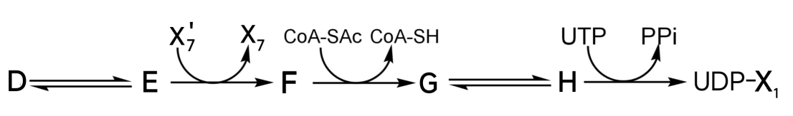
where CoA is coenzyme A, UDP is uridine diphosphate, UTP is uridine triphosphate, and PPi is pyrophosphate.
It is known that:
- F reacts with the Tollens reagent;
- X₁ molecule is formed by atoms of four elements (C, H, N, and O);
- X₁ contains 8 carbon atoms;
- Only two carbon atoms are involved in transformations;
- Three pairs can be arranged from compounds D, E, F, X₇, and X₇’. The molecular masses of these pairs differ by 1.
- Draw the structures of D–H and Х₁. Explain how you decided which isomer is encoded by D and which by E.

To finally identify the structures of polymers A and B, previously unidentified fragments A-1 and B-1 were isolated. They were methylated on alcoholic hydroxy groups, followed by exhaustive hydrolysis. In the case of B, this resulted in the formation of the 3,4,6-tri-O-methyl derivative of Х₁, the 1,4,6-tri-O-methyl derivative of Х₁, and the 6-mono-O-methyl derivative of Х₆. For A, this resulted in the formation of the 1,4,6-tri-O-methyl derivative of Х₁, the 3,4,6-tri-O-methyl derivative of Х₁, and the 4-mono-O-methyl derivative of Х₂.
- Draw the structures of A-1 and B-1, designating the unknown substituents as R_{i}.
Complete acidic hydrolysis of A-1 and B-1, followed by oxidation with HIO₄, leads to the formation of acetaldehyde in the amount equimolar to that of the starting fragment for only one of A-1 and B-1.
- Propose the complete structural formulae of A-1 and B-1.

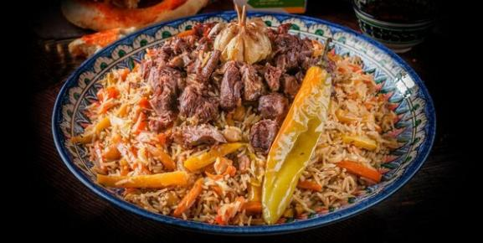
Problem 30. Pilaf ingredients
Pilaf is one of the most delicious, traditional meals in Uzbekistan. We asked a chef who works in Besh Qozon, a famous restaurant, how they make pilaf so delicious. The chef described the procedure as follows:

“Oil is first heated in a kazan. Chopped onions are fried until they reach a uniform golden-brown color. Pieces of meat are then added and cooked until they develop a caramelised surface. Afterwards, sliced carrots are introduced, and the mixture is seasoned with black pepper and cumin. Water is added, whole garlic bulbs are placed on top, and the mixture is simmered until the meat becomes tender. Subsequently, pre-washed rice is added in a separate upper layer without stirring. Additional water is poured carefully to cover the rice. The mixture is cooked until all the water is absorbed. Finally, the kazan is covered, and the pilaf is allowed to steam for approximately 30 minutes. After gentle mixing, the pilaf is ready to be served”.
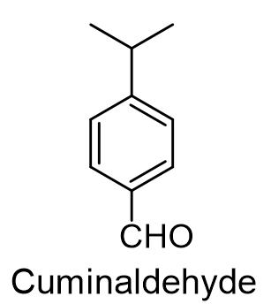
One of the key aromatic components of pilaf is cumin. Its characteristic flavour is largely due to the presence of the compound cuminaldehyde. This aldehyde can be obtained synthetically starting from benzene, isopropyl chloride, dimethylformamide, and appropriate inorganic reagents.
- Suggest the synthesis scheme for cuminaldehyde using the reagents mentioned above.
The monomer X of the major polymeric compound present in rice undergoes several transformations during cooking. These reactions lead to the formation of volatile and non-volatile products that contribute to the characteristic aroma and flavour of the dish. The synthesis of one of these products is shown below:
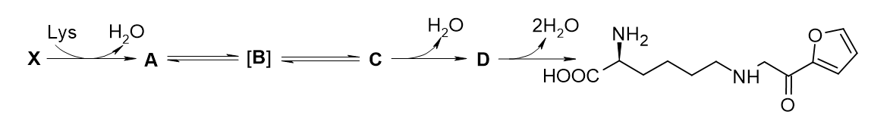
Hints:
- Among A–D only compound D contains a ring.
- D does not have any acyclic tautomers.
- A, B and C are tautomers.
- Draw the structures of compounds A–D and X without stereochemistry details.
The hydrolysis of the amide bond in the main component Z of black pepper produces compounds E and F. Upon oxidative ozonolysis, acyclic compound F, having one oxygen-containing group, yields an equimolar mixture of С_{α}H_{β}O_{γ} (F₁) and C_{δ}H_{ε}O_{α} (F₂), where α ≠ β ≠ γ ≠ δ ≠ ε.
It is also known that:
- The indexes α, β, and γ are members of a geometric progression (not exactly in this order) and δ + α = ε;
- The total number (N) of all atoms in molecules F₁ and F₂ is an even number less than 45.

- a) Using mathematical logic and chemical considerations, rigorously prove that the coefficients in compounds F₁ and F₂ (α, β, γ, δ and ε) are even numbers.
b) Find the molecular formulae of F₁ and F₂.
The F₁ and F₂ structures contain three types of hydrogen atoms and at least one plane of symmetry, while these compounds lack stereocentres and alcohol groups.
- Draw the structures of compounds F₁, F₂, and F.
Combustion of 1.000 g of E at high temperature gives 3.0385 g of a gaseous mixture. Passing this mixture through solid sodium hydroxide increases the mass of the solid by 2.9470 g. E (w(O) = 20.92%) has a trisubstituted aromatic ring.
- Determine the empirical formula of E.
The biosynthesis of E from l-tyrosine is shown below:
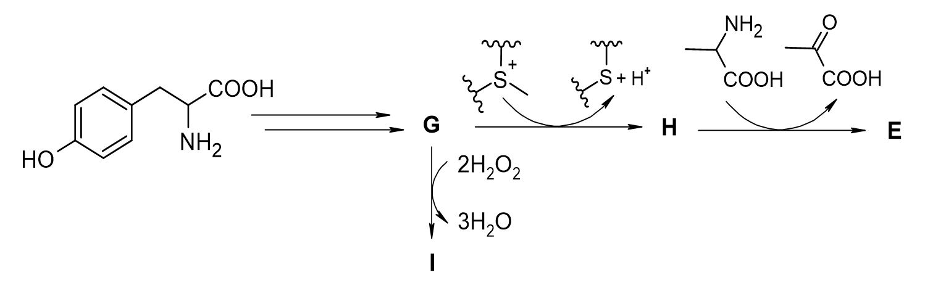
Hints:
- G contains an aldehyde group.
- The initial hydroxy group in l-tyrosine is unchanged during the biosynthesis of E.
- I is an ortho-quinone derivative.
- Draw the structures of compounds G, H, I, E, and Z.

Numerous peptides and amino acids are contained in meat. A non-canonical α-amino acid W is one of these. The reaction of W with NaIO₄ yields a mixture of formaldehyde (CH₂O) and K. The oxidation of K with Fehling`s reagent, gives the anion of acid L. Acid L is achiral and has three different hydrogen atom environments.
- Draw the structures of compounds J, K, L, and W.
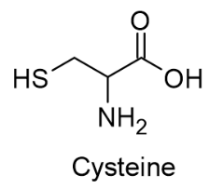
Another notable non-canonical amino acid is alliin, M, found in garlic, which serves as the precursor of the compounds responsible for its characteristic odour. Alliin, which contains a stereogenic sulfur atom, can be synthesised from cysteine in two steps. Firstly, cysteine reacts with allyl bromide under mildly basic conditions. The resulting intermediate, N, is then subjected to oxidation of the sulfur atom with H₂O₂, yielding M.
- Draw the structures of compounds M and N.
Garlic also contains several other interesting molecules, e.g. four compounds P₁–P₄, which exhibit structural similarity. Their molar masses are members of an arithmetic progression, in which the first member is P₁. Molar masses of the second and third molecules are 146 g·mol⁻¹ and 178 g·mol⁻¹ respectively. Each of them contains at least one terminal C=C bond and possesses two planes of symmetry.
- Draw the structures of compounds P₁–P₄, if it is known that P₁ is biosynthesised from alliin.
There are a lot of dishes in the world using the combination of meat, rice, and carrots. However, Pilaf is the only one which utilises yellow carrot. The reason behind the different colour of these carrots is the presence of two pigments – β-carotene and lutein. In plants, they are synthesised from the tetraterpene, lycopene.
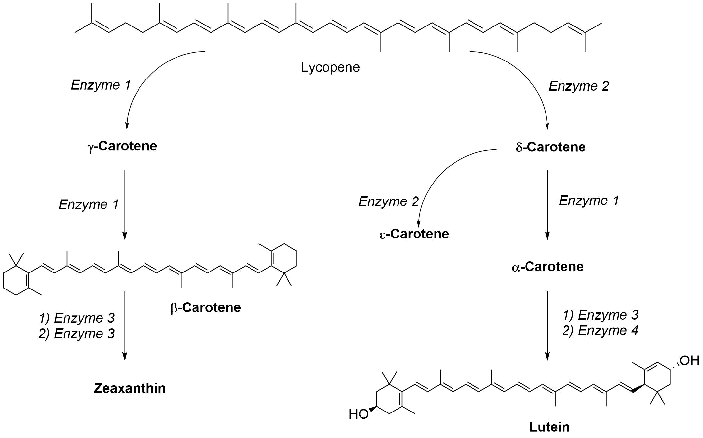
- Draw the structures of α-, γ-, δ-, ε-carotenes and zeaxanthin.
- Determine whether zeaxanthin is optically active or not, justify your answer.
- Classify Enzymes 1–4 according to the main enzyme classes below:
- Oxidoreductases – Oxidation/reduction reactions.
- Transferases – Transfer of a methyl-, acyl-, amino-, or phosphate group from one substance to another; kinases forming a subclass catalyse the transfer of phosphate group(s) from high-energy phosphorylated species to accepting substrate(s).
- Hydrolases – Hydrolytic formation of two products from a substrate.
- Lyases – Non-hydrolytic addition or removal of groups from substrates, with C–C, C–N, C–O, or C–S bonds cleavage in the latter case.
- Isomerases – Intramolecular rearrangement.
- Ligases – Joining together two molecules by formation of new C–O, C–S, C–N, or C–C bonds with simultaneous breakdown of ATP.
The chef in Besh Qozon did not mention the most important spice used in the preparation of pilaf.
- Identify this unmentioned spice in Tashkent’s pilaf.

